**PROJECT REPORT ON**

**“LEARNING EDUCATION”**

**Submitted in partial fulfillment of the requirement for the award of the degree Bachelor of Computer Applications (BCA)**

**SESSION:2022-2025**

|  |  |
| --- | --- |
| **Project Guided By:** | **Submitted By:** |
| **Internal Guide: Mrs. Roopali Agrawal**  (BCA Faculty) | Name of Student: -Rohit Rangile Enrollment No: -AY148134034 Roll No: -  Study Institute code No: -8134  Name of Student: - Sumit Arjhare Enrollment No: -AY148134009 Roll No: -  Study Institute code No: -8134 |

**Submitted to**



**Makhanlal Chaturvedi National University of Journalism and Communication, Bhopal**

**Khandwa Institute of Professional Studies, Khandwa**

**PROJECT CERTIFICATE**

This is to certify that the project report entitled **“LEARNING EDUCATION”** submitted to Makhanlal Chaturvedi National University of Journalism & Communication, in partial fulfillment of the requirement for the award of the degree of **Bachelor of Computer Applications** (BCA), is original work carried out by myself Rohit Rangile with **Enrolment no. AY148134034** under the Supervision of Prof. **Mrs. Roopali Agrawal.**

The matter embodied in this project is genuine work done by myself Rohit Rangile and has not been submitted whether to this University or to any other University / Institute for the fulfillment of the requirement of any course of study.

Date: **Name & Signature of the Student**

Rohit Rangile

([rohitrangile81@gmail.com,](mailto:rohitrangile81@gmail.com,) 8120419098, BHAGWANPURA)

**Name & Signature of the Student**

Sumit Arjhare

([sumitarzare003@gmail.com,](mailto:sumitarzare003@gmail.com,) 9926392497, KHANDWA)

**Verified by The Supervisor**

**Name & Signature of the Supervisor**

Mrs. Roopali Agrawal Date:

**ACKNOWLEDGEMENT**

This Major Project is the result of contribution of many minds. I would like to acknowledge and thank my project guide **Mrs. Roopali Agrawal** for her valuable support and guidance. She guided me through the process from conception and till the completion of this project. I would also like to thanks my class teacher/institute director **Mr. Nilesh Mahulikar** and My all my faculties. I thank to lab staff members and other non-teaching members.

I am very thankful for the open-handed support extended by many people. While no list would be complete, it is my pleasure to acknowledge the assistance of my friends who provided encouragement, knowledge and constructive suggestions.

**Name & Signature of Student**

Rohit Rangile

Roll No: -

Enrollment No: - AY148134034

**Name & Signature of Student**

Sumit Arjhare

Roll No: -

Enrollment No: - AY148134009

**.**

**SELF-CERTIFICATE**

This is to certify that the Major Project report entitled **“LEARNING EDUCATION”** is done by me, and it is authentic work carried out for the partial fulfillment of the requirements for the award of the degree of Bachelor of Computer Application (BCA) under the guidance of **Mrs. Roopali Agrawal.** The matter and software embodies in this project has not been submitted earlier for award of any degree or diploma to the best of my knowledge and believes.

**Name & Signature** **of Student**

Rohit Rangile

Roll No: -

Enrollment No: - AY148134034

**Name & Signature** **of Student**

Sumit Arjhare

Roll No: -

Enrollment No: - AY148134009

# CERTIFICATE FROM PROJECT GUIDE

This is certified that this Major Project entitled **“LEARNING EDUCATION**” submitted in partial fulfillment of the requirements for the award of the degree of Bachelor of Computer Application (BCA) in session **(years 2022 to 2025)** to the Makhanlal Chaturvedi National University of Journalism & Communication, Bhopal done by Rohit Rangile is authentic work carried out by his/ them at “**Khandwa institute of Professional Studies**” (Khandwa) under my guidance. The matter and software embodied in this project work has not been submitted earlier for the award of any degree or diploma to the best of my knowledge and belief.

## Signature of BCA Teacher Project Guide

Mrs. Roopali Agrawal

**TABLE OF CONTENT**

|  |  |  |
| --- | --- | --- |
| **S No.** | **Contents** | **Page No.** |
| 1. | Introduction | 1 |
| 2. | System Analysis | 2 |
| 3. | Feasibility Study | 3 |
| 4. | Software and Hardware  requirement Specification | 4 |
| 5. | System Design  Data Flow Diagram  Use Case Model (Admin)  Use Case Model (User)  Activity Diagram (Admin) Activity Diagram ( User )  Sequence Diagram (Admin)  Sequence Diagram ( User )  Class Diagram  ER Diagram | 7 |
| 6.  7. | Coding  Validation Checks | 24  155 |
| 8. | Testing | 156 |
| 9. | Report & Table Figure | 157 |
| 10. | Screenshots of Project | 159 |
| 11. | Implementation & Maintenance | 165 |
| 12. | Conclusion | 166 |
| 13. | Future Scope & Further Enhancement | 167 |
| 14. | Reference | 168 |

**Definition:**

1. **Introduction**

Learning education is a comprehensive field that examines how individuals acquire knowledge, skills, and attitudes throughout their lives. It encompasses various educational theories, methodologies, and practices aimed at enhancing the learning experience across different contexts. This introduction will explore the foundational concepts of learning education, its significance, and the primary theories that inform educational practices.

The study of learning has evolved significantly over centuries. Ancient philosophers like Socrates, Plato, and Aristotle laid the groundwork for understanding human cognition and knowledge acquisition. However, it wasn't until the 20th century that educational theories began to emerge as distinct fields of study. Early behaviorists focused on observable behaviors as indicators of learning, while cognitive psychologists explored internal mental processes. Over time, these foundational ideas have led to the development of various theories that inform modern educational practices.

**Purpose:**

The purpose of learning education is multifaceted, encompassing a wide range of objectives that contribute to individual development and societal progress. This exploration delves into the various dimensions of learning education, highlighting its significance in fostering personal growth, social cohesion, economic advancement, and lifelong learning.

**Overview:**

Learning education is a broad and dynamic field that encompasses the processes, theories, and practices involved in acquiring knowledge, skills, and attitudes throughout an individual's life. This overview will explore the various components of learning education, including its historical context, key theories, educational structures, and its significance in personal and societal development.

1. **Definition and Scope:**
2. **System Analysis**
   * **Curriculum Development:** Evaluating and improving existing curricula.
   * **Feedback Mechanisms:** Implementing systems for ongoing stakeholder feedback to inform continuous improvement.
   * **Performance Measurement:** Establishing metrics for assessing educational outcomes.
3. **User Roles and Permissions:**
   * Oversee system configuration, user management, and permissions.
   * Troubleshoot technical issues and assist end-users.
4. **Data Modeling:**
   * This high-level overview identifies key entities and their relationships without going into detail about how they will be implemented. It helps gather requirements and aligns with business goals.
   * Data models enable efficient data retrieval and analysis, providing insights that can inform educational strategies and improvements.
   * A well-structured data model serves as a blueprint for database design and application development, ensuring that the educational system meets user needs effectively.
5. **System Architecture:**
   * Involves how data is collected, stored, processed, and retrieved. This includes student records, course materials, and performance analytics.
   * The design of interfaces through which users (students, educators, administrators) interact with the system. It focuses on usability and accessibility.
6. **Course Management:**
   * Video, PDF, and interactive content uploads (JavaScript & PHP) .
   * Course creation and categorization (HTML, PHP) .
   * Progress tracking .
7. **Backend (Server & Database):**
   * **Technologies:** PHP (server-side), MySQL (database) .
   * **Features:** Handles user authentication, course management, assessments .
8. **Feasibility Study**

A feasibility study for a blood bank and donor management system project would assess the viability and potential success of such a venture. Here are the key components typically included in such a study:

1. **Overview of the System:**
   * **Project Name:** Learning Education System .
   * **Objective:** To develop an interactive e-learning platform with multiple topics, user management, assessments, and progress tracking.
   * **Technology Stack:** Frontend (HTML, CSS, JavaScript), Backend (PHP, MySQL), and additional tools for scalability and interactivity.
2. **Security & Data Protection:**
   * Secure login system (PHP sessions, token-based authentication) .
   * Role-based access control (students, teachers, admins) .
   * **Encryption:** Using SSL/TLS for secure communication .
   * **Database Security:** Hashing passwords, preventing SQL injections .
3. **System Performance & Maintenance:**
   * **Caching** (Redis, Memcached) to reduce database queries .
   * **Minification** (CSS/JS) for faster page loading .
   * Regular software updates for security and performance improvements .
   * Error logging and monitoring for debugging issues .
4. **Challenges & Risks in Technical Feasibility:**
   * **High Traffic Load Handling:** Needs efficient database and server management.
   * **Security Threats:** Requires strong authentication and data protection mechanisms.
   * **Maintenance Complexity:** Regular updates and performance monitoring are essential.
   * **Backup & Recovery:** Regular database backups for disaster recovery.
5. **Requirement Specification**

The Software requirement specification is produced at the culmination of the analysis tasks. The function and performance allocated to the software as a part of the system engineering are refine by establish and complete information description, a detail functional description, a represent of system behavior, an indication of performance requirement and design constrain appropriate of validation criteria. The introduction of the software requirement specification states the goal and objective of the software requirement specification state the goal and objectives of the software describing the content of the computer base systems.

**RESOURCE REQUIRED HARDWARE SPECIFICATION RAM:** 4GB

**Processor:** i3 or above

**Hard-Disk:** 1TB

**System Type:** 64-bit Operating system.

**SOFTWARE SPECIFICATION**

**Operating System:** Windows 11. **Web Technology:**PHP,HTML,CSS,JS

**Database:** MySQL 8.0.31

**Server:** Xampp Server.

**Design Tool:** VS Code.

**Documentation Tool:** MS Word.

**UML Diagram:** STAR UML, ONLINE.VISUAL-PARADIGM.COM

**TECHNOLOGY USED PHP:**

PHP stand for PHP: Hypertext Preprocessor. PHP is a server-side scripting language, like ASP, PHP supports many databases (MySQL, Informix, MySQL, Sybase, Solid, Postgres SQL, Generic ODBC, etc.). PHP is an open-source software PHP is free to download and use. PHP sits between your browser and the web server. When you type in the URL of a PHP websites in your browser, your browser sends out a request to the web server. PHP is a server- side, cross-platform, HTML-embedded scripting language. There are over half a million domains running PHP and is freely available for download.

**HTML:**

HTML stands for Hyper Text Markup Language, which is most widely used language on web to develop web pages. HTML refers to the way in which web pages (HTML documents) are linked together. Thus, the link available on a web page is called Hypertext.

**CSS:**

CSS is designed primarily to enable the separation of document content from document presentation, including aspects such as the layout, colors, and fonts. This separation can improve content accessibility, provide more flexibility and control in the specification of presentation characteristics, enable multiple HTML pages to share formatting by specifying relevant CSS in a separate .CSS file, and reduce complexity and repetition in the structural content.

**JAVASCRIPT:**

JavaScript is a high-level programming language commonly used for creating dynamic and interactive web content. It is a versatile language that can be used for both client-side and server-side scripting.

One of the key features of JavaScript is its ability to manipulate the Document Object Model (DOM), which allows developers to dynamically update and change the content and style of web pages in response to user interaction.

JavaScript is often used in conjunction with other web development technologies such as HTML and CSS. It can also be used on the server-side with the Node.js runtime environment, allowing for the development of full-stack web application.

**TOOLS USED:**

MySQL is an open-source RDBMS that relies on SQL for processing the data in database. MySQL provides APIs for the language like C, C++, JAVA, PHP and Python. User can quickly and easily create and access their fir in a secure and easy way, MySQL is most commonly used for web applications and for embedded applications and has become a popular alternative to proprietary database system because of its speed and reliability. MySQL can run on UNIX, Windows and Mac OS.

**DATA FLOW DIAGRAMS**

1. **System Design**

A data flow diagrams is graphical tool used to describe and analyze movement of data through a system. These are the central tool and the basis from which the other components are developed. The transformation of data from input to output, through processed, may be described logically and independently of physical components associated with the system.

These are known as the logical data flow diagrams. The physical data flow diagrams show the actual implements and movement of data between people, department and workstations. A full description of a system actually consists of set of data flow diagrams. Using two familiar notation Yourdon, gene and sarson notation develops the data flow diagrams. Each component in a DFD is labeled with a descriptive name process is further identified with a number that will be used for identification purpose. The development of DFD’s is done in several level.

Each process in lower-level diagrams can be broken down into a more detailed DFD in the next level. The top-level diagram is often called context diagram. It consists a single process bit, which plays vital role in studying the current system. The process in the context level diagrams is exploded into other process at the first level DFD to understand the process.

Larry the idea behind the explosion of a process into more process is that understanding at one level of detail is exploded into greater detail at the next level. This is done until further explosion is necessary and an adequate amount of detail is described for analyst Constantine first developed the DFD as a way of expressing system requirement in a graphical from this lead to the modular design.

A DFD is also known as a “bubble chart” has the purpose of clarifying system requirement and identifying major transformation that will become programs in system design. So it is the starting point of the design to the lowest level of detail. A DFD consist of a series bubbles joined by data flow in the system.

**DATA FLOW DIAGRAM SYMBOLS:**

In the DFD, there are four symbols:

1. A square define a source or destination of system data.
2. An arrow identification data flow. It is the pipeline through which the information flows.
3. A circle or a bubble represents a process that transforms incoming data flow into outgoing dataflows.
4. An open rectangle is a data store, data at rest or a temporary repository of data.

Forms data flow

Source or destination of data

Data flow

**DATA FLOW**

1. Data flow has only direction of flow between symbols. It may flow in both directions between a process and a data store to show read before an update. The letter is usually indicated however by two separate arrows since these happen at different type.
2. A join in DFD means that exactly the same data comes from any of two or more different processes data store or sink to a common location.
3. Data flow cannot go directly back to the same process it leads. There must be least one other process that handles the data flow produce some other data flow returns the original data into the beginning process.
4. A data flow to a data store means update (delete or change).
5. A data flow from a data store means retrieve or use.

A data flow has a noun phrase label more than one data flow noun phrase can appear on a single arrow as long as all of the flows on the same arrow move together as one package.

Flow charts are easy to understand diagrams showing how steps in a process fit together. This makes them useful tools for communicating how processes work, and for clearly documenting ow a particular job is done. Furthermore, the act of mapping a process out in flow chart format helps you clarify your understanding of the process, and helps you think about where the process can be improved. A flow chat therefore be used to:

* + Define and analyze processes.
  + Build a step-by-step picture of the process for analysis, discussion, or communication.
  + Define standardize or fine areas for improvement in a process.

**How to use the tool:**

Most flow charts are made up of three main types of symbols:

* + Elongated circles, which signify the start or end of a process
  + Rectangles, which show instructions or actions
  + Diamonds, which show decision that must be made

Start

**Use Case Model (Admin):**

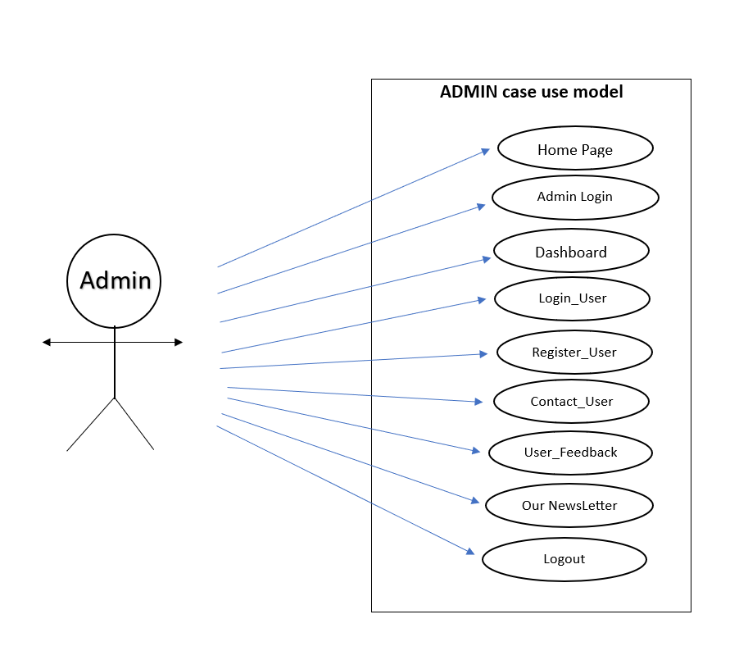

**Figure Use Case Diagram (Admin)**

**Use Case Model (User):**

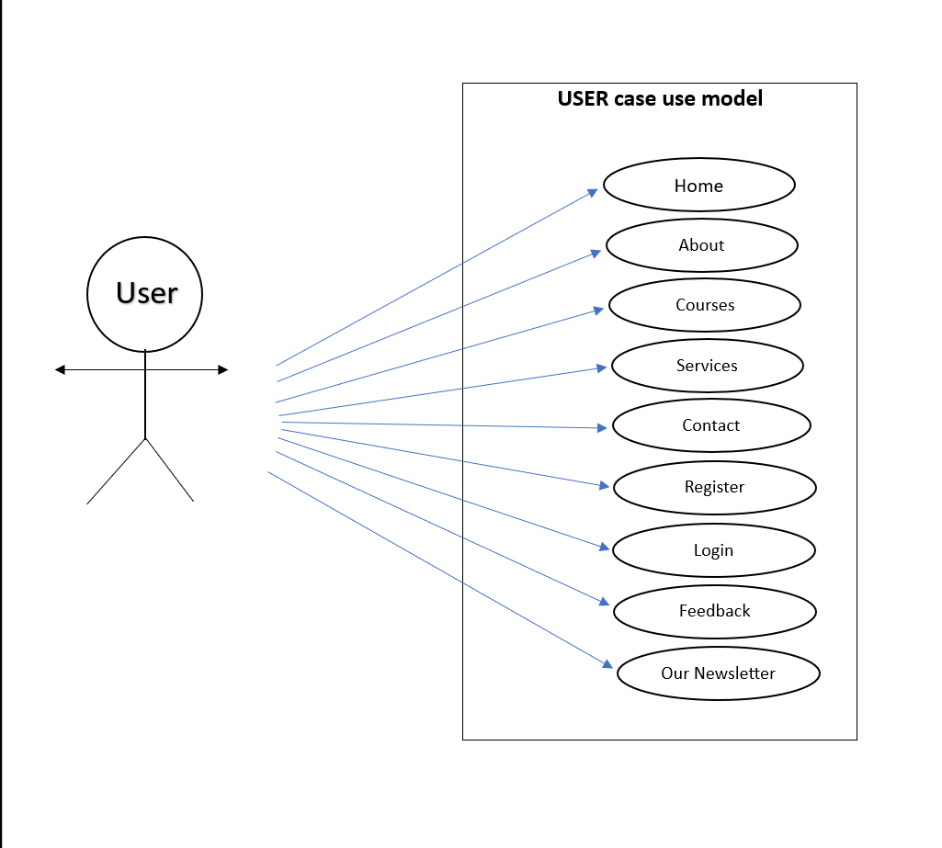

**Figure Use Case Diagram (user)**

**Use Case Diagram Description:**

A use case diagram at its simplest is a representation of user interaction with the system and depicting the specification of case use. A use case diagram can portray the different type of user of a system and the various ways that they interact with the system.

The type of diagram is typically used in conjunction with the textual use case and will often to be accomplished by other type of diagram as well.

With regards to use case diagrams, that are exactly what they are meant to do. While a use case itself might drill into a lot of detail about every possibility, a use-case diagram can help provide a higher-level view of the system. It has been said before that “Use case diagrams are the blueprint for the system”. They provide the simplified and graphical representation of what the system must actually do.

* Always structure and organize the use case diagram from the perspective of the actor.
* Use case should start off simple and at the highest view possible. Only they can be refined and detailed further.
* Use case diagrams are based upon functionality and thus should focus on the “WHAT” and no the “HOW”.

**Actor**

**Use Case**

**Association**

**Activity Diagram (Admin):**

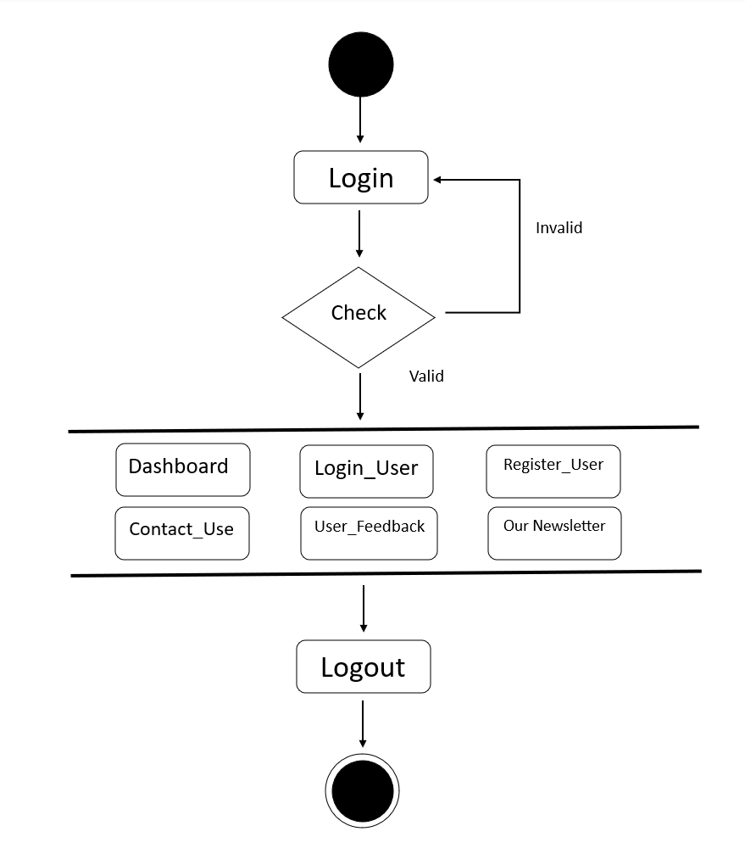

**Figure Activity Diagram (Admin)**

**Activity Diagram (User) :**

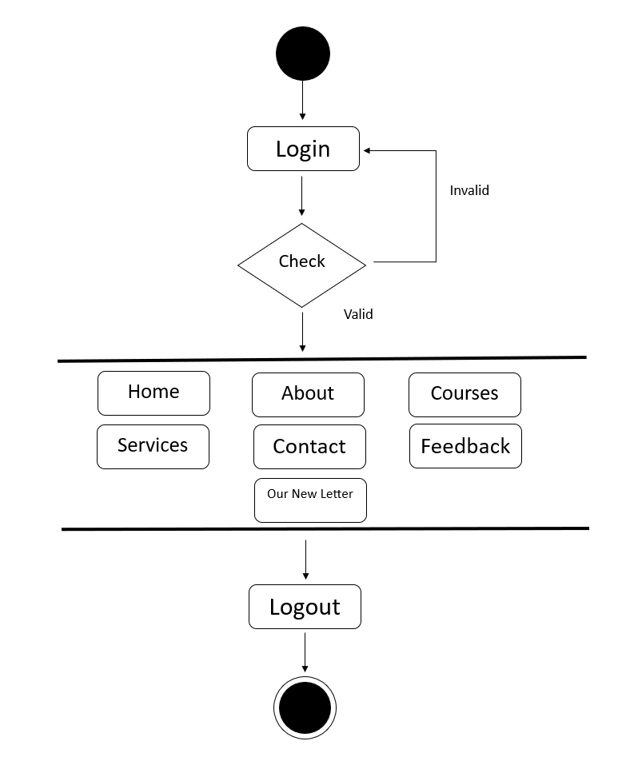

**Figure Activity Diagram (User)**

**Activity Diagram Description:**

Activity diagrams are graphical representation of workflow of stepwise activity and actions with support for choice, iteration and concurrency. In the unified Modeling Language, activity diagrams are intended to model both computational and organizational processes (i.e. workflows). Activity diagrams show the overall flow control. The most important shape types:

* Rounded rectangles represent actions.
* Diamonds represent decisions.
* Bars represent the start (split) or end (join) of concurrent activities.
* The black circle represents the start (initial state) of the workflow.
* An encircled black circle represents the end (final state).

Arrows run from the start towards the end represent the order in which activities happen.

Activity diagrams may be regarded as a form of flow chart. Typical flowchart techniques lack constructs for expressing concurrency. However, the join split symbols in activity diagrams only resolve this for simple cases; the meaning of the model is not clear when they are arbitrarily combined with decision or loops.

It was a specialized from of state diagrams, and it was renormalized to be based on Petri net- like semantics, increasing the scope of situations that can be modeled using activity diagrams.

UML activity diagrams can be used in various domains, i.e. in design of embedded systems, it is possible to verify such a specification using model checking

**Sequence Diagram (Admin)**

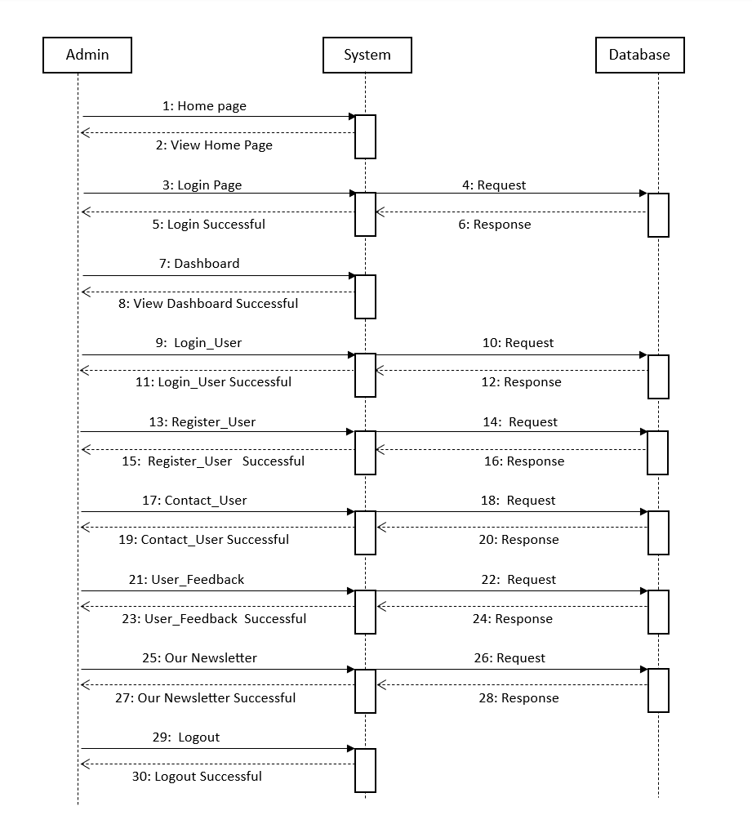

**Figure Sequence Diagram (Admin)**

**Sequence Diagram (User):**

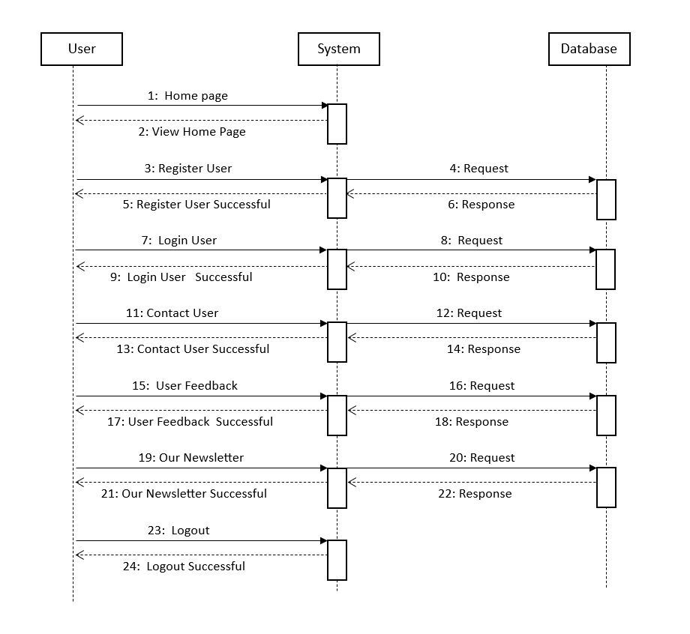

**Figure Sequence Diagram (User)**

**Sequence Diagram Description:**

Sequence diagram description among classes. These interactions are modeled as exchange of messages. This diagram focuses on classes and the messages they exchange to accomplish some described behavior. Sequence diagrams type of interaction diagrams.

* Class roles, which represent role that objects may play within the interaction.
* Lifelines, which represent the existence of an object over a period of time.
* Activations, which represent the time during which an object is performing an operation.
* Messages, which represent communication between objects.

A sequence diagram shows the participants in an interaction and the sequence of message among them. A sequence diagram shows the interaction of a system with its actor.

**Class Diagram:**

|  |  |  |
| --- | --- | --- |
| **Admin** |  | **User** |
| - email  - password | - email  - password |
|  |
|  |  |

**Figure Class diagram**

**Class Diagram Description:**

In Software engineering a class diagram in the Unified Modeling Language (UML) is a type of static structure diagram that describes the structure of a system by showing the system classes, their attributes, operations (or method), and the relationships among objects. The class diagram is the main building block of object orientated modeling. It is used both for general conceptual modeling of the systematic of the application, and for detailed modeling translating the models into programming code. Class diagram can be also be used for data modeling. The classes in a class diagram represent both the main objects, interactions in the application and the classes to be programmed.

**ER Diagram:**

**Tables**

login_user_data

register_user_data

contact_data

feedback data

new_letter_data

**DataBases**

User_data

**Manage**

**Update**

**login_user_data**

id

email

password

date

|  |
| --- |
| **new_letter_data**  id  email  date |

**contact_data**

id

f_name

l_name

email

message

additional

date

**feedback data**

id

f_name

email

additional

date

**register_user_data**

id

f_name

email

password

date

**Figure ER Diagram**

**ER Diagram Description:**

In 1976, chain developed the entity relationship (ER) model, a high-level data model that is useful in a developing in a conceptual design for a database, creation of an ER Diagram, which is one of the first step in designing a database helps the designer to understand and to specify the desired components. An ER model is a diagram containing entities or “items”, relationship among them, and attributes of the entities and relationships. The entity relationship model is a high-level data model that is useful in developing a conceptual design for a database. The overall logical expressed graphical by an ER-diagram. It consists a set of basic objects entities and of relationship among these objects. An entity is represented by the set of attributes. Attributes are descriptive properties possessed by each number of any entity set. The ER diagram consists of the following major components.

The entity relationship diagram is graphical representation of the database logic and includes a detailed description of all entities, relationship and constraints. The ER diagram is based on perception of a real world that consists of a set of basic objects called entities and of relationship among these objects. It is pictorial representation; it is easy to understand such a diagram of following main components-

* Rectangles represent entity set.
* Ellipses represent relationship set.
* Diamonds represent relationship set.
* Double ellipses represent multivalve attributes.

1. **Coding**

**Index.php**

<!DOCTYPE html>

<html>

<head>

    <link rel="shortcut icon" type="png" href="images/icon/favicon.png">

    <meta charset="utf-8">

    <meta http-equiv="X-UA-Comaptible" content="IE=edge">

    <title>LearnEd</title>

    <meta name="desciption" content="">

    <meta name="viewport" content="width=device-width, initial-scale=1">

    <link rel="stylesheet" type="text/css" href="style.css">

    <script type="text/javascript" src="script.js"></script>

    <script src="https://code.jquery.com/jquery-3.2.1.js"></script>

    <script>

        $(window).on('scroll', function(){

            if($(window).scrollTop()){

              $('nav').addClass('black');

             }else {

           $('nav').removeClass('black');

         }

        })

    </script>

</head>

<body>

<!-- Navigation Bar -->

    <header id="header">

        <nav>

            <div class="logo"><img src="images/icon/logo.png" alt="logo"></div>

            <ul>

                <li><a class="active" href="">Home</a></li>

                <li><a href="#about_section">About</a></li>

                <li><a href="#course">Courses</a></li>

                <li><a href="#services_section">Services</a></li>

                <li><a href="#contactus_section">Contact</a></li>

            </ul>

            <div class="srch"><input type="text" class="search" placeholder="Search here..."><img src="images/icon/search.png" alt="search" onclick=slide()></div>

            <a class="get-started" href="login_page/login.php">Login</a>

            <img src="images/icon/menu.png" class="menu" onclick="sideMenu(0)" alt="menu">

</nav>

        <div class="head-container">

            <div class="quote">

                <p>The beautiful thing about learning is that nobody can take it away from you</p>

                <h5>Education is the process of facilitating learning, or the acquisition of knowledge, skills, values, beliefs, and habits. Educational methods include teaching, training, storytelling, discussion and directed research!</h5>

                <div class="play">

                    <img src="images/icon/play.png" alt="play"><span><a href="https://youtu.be/cUnayHxk-Rs?si=wFFND3v40Z3v0BjN" target="_blank">Watch Now</a></span>

                </div>

            </div>

            <div class="svg-image">

                <img src="images/extra/svg1.jpg" alt="svg">

            </div>

        </div>

        <div class="side-menu" id="side-menu">

            <div class="close" onclick="sideMenu(1)"><img src="images/icon/close.png" alt=""></div>

            <div class="user">

                <img src="images/creator/roshan.jpeg" alt="Username">

                <p>Learning-Education</p>

            </div>

            <ul>

                <li><a href="#about_section">About</a></li>

                <li><a href="#course">Courses</a></li>

                <li><a href="#team_section">Team</a></li>

                <li><a href="#services_section">Services</a></li>

                <li><a href="#contactus_section">Contact</a></li>

                <li><a href="#feedBACK">Feedback</a></li>

            </ul>

  </div>

    </header>

<!-- Some Popular Subjects -->

    <div class="title" id="course">

        <span>Popular Subjects on LearnEd</span>

    </div>

    <br><br>

    <div class="course" >

        <center><div class="cbox">

        <div class="det"><a href="subjects/jee.php"><img src="images/courses/book.png">JEE Preparation</a></div>

        <div class="det"><a href="subjects/gate.php"><img src="images/courses/d1.png">GATE Preparation</a></div>

    <div class="det"><a href="subjects/jee.php#sample_papers"><img src="images/courses/paper.png">Sample Papers</a></div>

        <div class="det"><a href="subjects/quiz.php"><img src="images/courses/d1.png">Daily Quiz</a></div>

        </div></center>

        <div class="cbox">

        <div class="det"><a href="subjects/computer_courses.php"><img src="images/courses/computer.png">Computer Courses</a></div>

        <div class="det"><a href="subjects/computer_courses.php#data"><img src="images/courses/data.png">Data Structures</a></div>

        <div class="det"><a href="subjects/computer_courses.php#algo"><img src="images/courses/algo.png">Algorithm</a></div>

        <div class="det det-last"><a href="subjects/computer_courses.php#projects"><img src="images/courses/projects.png">Projects</a></div>

        </div>

    </div>

<!-- ABOUT -->

    <div class="diffSection" id="about_section">

        <center><p style="font-size: 50px; padding: 100px">About</p></center>

        <div class="about-content">

<div class="side-image">

                    <img class="sideImage" src="images/extra/e3.jpg">

                </div>

                <div class="side-text">

                    <h2>What you think about us ?</h2>

                    <p>Education is the process of facilitating learning, or the acquisition of knowledge, skills, values, beliefs, and habits. Educational methods include teaching, training, storytelling, discussion and directed research.<br> Educational website can include websites that have games, videos or topic related resources that act as tools to enhance learning and supplement classroom teaching. These websites help make the process of learning entertaining and attractive to the student, especially in today's age. <br>Using HTML(HyperText Markup Language), CSS(Cascading Style Sheet), JavaScript, we can make learning more easier and in a interesting way.</p>

                </div>

        </div>

    </div>

<!-- PORTFOLIO -->

    <div class="diffSection" id="portfolio_section">

        <center><p style="font-size: 50px; padding: 100px; padding-bottom: 40px;">Portfolio</p></center>

        <div class="content">

            <p>

                “Education is the passport to the future, for tomorrow belongs to those who prepare for it today.” “Your attitude, not your aptitude, will determine your altitude.” “If you think education is expensive, try ignorance.” “The only person who is educated

is the one who has learned how to learn …and change.”

            </p>

        </div>

    </div>

    <div class="extra">

        <p>We're increasing this data every year</p>

        <div class="smbox">

        <span><center><div class="data">154</div><div class="det">Enrolled Students</div></center></span>

  <span><center><div class="data">62</div><div class="det">Total Courses</div></center></span>

        <span><center><div class="data">56</div><div class="det">Placed Students</div></center></span>

        <span><center><div class="data">27</div><div class="det">Total Projects</div></center></span>

        </div>

    </div>

<!-- TEAM -->

    <div class="diffSection" id="team_section">

        <center><p style="font-size: 50px; padding-top: 100px; padding-bottom: 60px;">We're the Creators</p></center>

        <div class="totalcard">

            <div class="card">

                <center><img src="images/creator/rohit1.png"></center>

                <center><div class="card-title">Rohit Rangile</div>

                <div id="detail">

                    <p>“ You can teach a student a lesson for a day; but if you can teach him to learn by creating curiosity, he will continue the learning process as long as he lives “</p>

                    <div class="duty"></div>

                    <a href="https://github.com/ROHITRANGILE" target="_blank"><button class="btn-roshan">Follow +</button></a>

                </div>

                </center>

            </div>

            <div class="card">

                <center><img src="images/creator/sumit1.png"></center>

                <center><div class="card-title">Sumit Arjhare</div>

                <div id="detail">

                    <p>“ Real education should consist of drawing the goodness and the best out of our own students. What better books can there be than the book of humanity “</p>

    <div class="duty"></div>

                    <a href="https://github.com/sumit08752" target="_blank"><button class="btn-roshan2">Follow +</button></a>

  </div>

                </center>

            </div>

        </div>

    </div>

<!-- SERVICES -->

    <div class="service-swipe">

        <div class="diffSection" id="services_section">

        <center><p style="font-size: 50px; padding: 100px; padding-bottom: 40px; color: #fff;">Services</p></center>

        </div>

        <a href="subjects/computer_courses.php"><div class="s-card"><img src="images/icon/computer-courses.png"><p>Free Online Computer Courses</p></div></a>

        <a href="subjects/jee.php"><div class="s-card"><img src="images/icon/brainbooster.png"><p>Building Concepts for Competitive Exams</p></div></a>

        <a href="subjects/computer_courses.php"><div class="s-card"><img src="images/icon/online-tutorials.png"><p>Online Video Lectures</p></div></a>

        <a href="subjects/jee.php#sample_papers"><div class="s-card"><img src="images/icon/papers.jpg"><p>Sample Papers of Various Competitive Exams</p></div></a>

        <a href="#portfolio_section"><div class="s-card"><img src="images/icon/p3.png"><p>Performance and Ranking Report</p></div></a>

        <a href="#contactus_section"><div class="s-card"><img src="images/icon/discussion.png"><p>Discussion with Our Tutors & Mentors</p></div></a>

        <a href="subjects/quiz.php"><div class="s-card"><img src="images/icon/q1.png"><p>Daily Brain Teasing Questions to Improve IQ</p></div></a>

        <a href="#contactus_section"><div class="s-card"><img src="images/icon/help.png"><p>24x7 Online Support</p></div></a>

    </div>

<!-- Reviews by Students -->

<div id="makeitfull">

    <a href="#review_section"><img src="images/icon/makeitfull.png"></a>

</div>

<div class="review">

    <div class="diffSection" id="review_section">

        <center><p style="font-size: 40px; padding: 100px; padding-bottom: 40px; color: #2E3D49;">What the Students Say About Us?</p></center>

    </div>

    <div class="rev-container">

        <div class="rev-card">

            <div class="identity">

  <img src="images/creator/humanNotExist1.jpg"><p>Sophie Daniel</p>

                <h6>Java</h6>

                <div class="rating"><img src="images/icon/star.png"><img src="images/icon/star.png"><img src="images/icon/star.png"><img src="images/icon/star.png"><img src="images/icon/star.png"></div>

            </div>

            <div class="rev-cont">

                <p id="title">Review:</p>

                <p id="content">

                    I did Java Fundamenetal course with Rishab Sir. It was a great experience. The brain teasers and assignments, actually the whole lot of content was really good. Some problems were challenging yet interesting. Was explained very well where ever I stuck...

</p>

            </div>

        </div>

        <div class="rev-card">

            <div class="identity">

                <img src="images/creator/humanNotExist2.jpg"><p>Clayton Clair</p>

      <h6>C/C++</h6>

                <div class="rating"><img src="images/icon/star.png"><img src="images/icon/star.png"><img src="images/icon/star.png"><img src="images/icon/star.png"><img src="images/icon/star.png"></div>

            </div>

            <div class="rev-cont">

                <p id="title">Review:</p>

                <p id="content">

                    When I was watching "Dear Zindagi", I could relate Sharukh Khan to Arnav Bhaiya. The way Sharukh Khan was giving life lessons to Alia Bhatt, in the same way Arnav Bhaiya will give coding life lessons which will guide you throughout your code life...

                </p>

            </div>

        </div>

        <div class="rev-card">

            <div class="identity">

                <img src="images/creator/humanNotExist3.jpg"><p>Devyn Sethi</p>

                <h6>JEE</h6>

                <div class="rating"><img src="images/icon/star.png"><img src="images/icon/star.png"><img src="images/icon/star.png"><img src="images/icon/star.png"><img src="images/icon/star.png"></div>

            </div>

            <div class="rev-cont">

                <p id="title">Review:</p>

                <p id="content">

                    LearnEd was an amazing experience for me. I belong to electronics department and had a little experience in coding but I think it has helped me think

things through in a much more analytical manner. Coding is important no matter which branch you are in. It gives you a better understanding about how to approach a problem...

                </p>

            </div>

        </div>

        <div class="rev-card">

<div class="identity">

                <img src="images/creator/humanNotExist4.jpg"><p>Rylee Phillips</p>

                <h6>Python</h6>

                <div class="rating"><img src="images/icon/star.png"><img src="images/icon/star.png"><img src="images/icon/star.png"><img src="images/icon/star.png"><img src="images/icon/star.png"></div>

            </div>

            <div class="rev-cont">

                <p id="title">Review:</p>

                <p id="content">

                    This was my first complete course at coding blocks. I attended the Python course in Winter 2020 and loved it which made me join the full course. Shubham bhaiya and Ayush Bhaiya(TA) have good knowledge about the field and were very helpful in making us understand the concepts. I would certainly recommend this to anyone...

                </p>

            </div>

        </div>

    </div>

</div>

<!-- CONTACT US -->

    <div class="diffSection" id="contactus_section">

        <center><p style="font-size: 50px; padding: 100px">Contact Us</p></center>

        <div class="csec"></div>

        <div class="back-contact">

            <div class="cc">

            <form action="user_database/contact_data.php" method="post">

                <label>First Name <span class="imp">*</span></label><label style="margin-left: 185px">Last Name <span class="imp">*</span></label><br>

                <center>

                <input type="text" name="f_name" style="margin-right: 10px; width: 175px" required="required"><input type="text" name="l_name" style="width: 175px" required="required"><br>

</center>

                <label>Email <span class="imp">*</span></label><br>

                <input type="email" name="email" style="width: 100%" required="required"><br>

                <label>Message <span class="imp">*</span></label><br>

                <input type="text" name="message" style="width: 100%" required="required"><br>

                <label>Additional Details</label><br>

                <textarea name="addtional"></textarea><br>

                <button type="submit" id="csubmit">Send Message</button>

            </form>

            </div>

        </div>

    </div>

<!-- FEEDBACK -->

    <div class="title2" id="feedBACK">

        <span>Give Feedback</span>

        <div class="shortdesc2">

            <p>Please share your valuable feedback to us</p>

        </div>

    </div>

    <div class="feedbox">

        <div class="feed">

            <form action="user_database/feedback_data.php" method="post">

                <label>Your Name</label><br>

                <input type="text" name="f_name" class="fname" required="required"><br>

                <label>Email</label><br>

                <input type="email" name="email" required="required"><br>

                <label>Additional Details</label><br>

<textarea name="additional"></textarea><br>

                <button type="submit" id="csubmit">Send Message</button>

            </form>

        </div>

    </div>

<!-- Sliding Information -->

    <marquee style="background: linear-gradient(to right, #FA4B37, #DF2771); margin-top: 50px;" direction="left" onmouseover="this.stop()" onmouseout="this.start()" scrollamount="20"><div class="marqu">“Education is the passport to the future, for tomorrow belongs to those who prepare for it today.” “Your attitude, not your aptitude, will determine your altitude.” “If you think education is expensive, try ignorance.” “The only person who is educated is the one who has learned how to learn …and change.”</div></marquee>

<!-- FOOTER -->

    <footer>

        <div class="footer-container">

            <div class="left-col">

                <img src="images/icon/logo - Copy.png" style="width: 200px;">

                <div class="logo"></div>

                <div class="social-media">

                    <a href="https://www.facebook.com/intellipaatonline/"><img src="images/icon\fb.png"></a>

                    <a href="https://www.instagram.com/intellipaat/?hl=en"><img src="images/icon\insta.png"></a>

                    <a href="https://x.com/Intellipaat/status/1873647799210025442"><img src="images/icon\tt.png"></a>

                    <a href="https://www.youtube.com/@Intellipaat"><img src="images/icon\ytube.png"></a>

                    <a href="https://www.linkedin.com/company/intellipaat-software-solutions/?originalSubdomain=in"><img src="images/icon\linkedin.png"></a>

                </div><br><br>

                <p class="rights-text">Copyright © 2025 Created By Rohit Rangile All Rights Reserved.</p>

    <br><p><img src="images/icon/location.png">Location:- KIPS College ,<br>Khandwa, Madhya Pradesh -450001</p><br>

                <p><img src="images/icon/phone.png"> +91-1234-567-890<br><img src="images/icon/mail.png">&nbsp; rohitrangile81@gmail.com</p>

            </div>

            <div class="right-col">

                <h1 style="color: #fff">Our Newsletter</h1>

                <div class="border"></div><br>

                <p>Enter Your Email to get our News and updates .</p>

                <form class="newsletter-form" action="user_database/new_letter_data.php" method="post">

                    <input class="txtb" type="email" name="email" placeholder="Enter Your Email">

                    <input class="btn" type="submit" value="Submit">

                </form>

            </div>

        </div>

    </footer>

</body>

</html>

**Admin_page/admin_page.php**

<!DOCTYPE html>

<html lang="en">

<head>

    <meta charset="UTF-8">

    <meta name="viewport" content="width=device-width,initial-scale=1,maximum-scale=1">

    <title> Admin Dashboard</title>

    <link rel="stylesheet" href="admin_page.css">

  <link rel="stylesheet"

        href="https://maxst.icons8.com/vue-static/landings/line-awesome/line-awesome/1.3.0/css/line-awesome.min.css">

</head>

<body>

    <input type="checkbox" id="menu-toggle">

    <div class="sidebar">

        <div class="side-header">

            <h3>M<span>odern</span></h3>

        </div>

        <div class="side-content">

            <div class="profile">

                <div class="profile-img bg-img" style="background-image: url(images/rohit.png)"></div>

                <h4>ROHIT RANGILE</h4>

            </div>

            <div class="side-menu">

                <ul>

                    <li>

                        <a href="#">

                            <span class="las la-user-alt"></span>

                            <small>Login_User</small>

                        </a>

                    </li>

                    <li>

                        <a href="admin_register_data.php">

                            <span class="las la-user-alt"></span>

                            <small>Register_User</small>

  </a>

                    </li>

                    <li>

                        <a href="admin_contact_data.php" >

                            <span class="las la-envelope"></span>

                            <small>Contact_User</small>

                        </a>

                    </li>

                    <li>

                        <a href="#">

                            <span class="las la-clipboard-list"></span>

                            <small>User_Feedback</small>

                        </a>

                    </li>

                    <li>

                        <a href="#">

                            <span class="las la-envelope"></span>

                            <small>Our Newsletter</small>

                        </a>

                    </li>

                </ul>

            </div>

        </div>

    </div>

    <div class="main-content">

        <header>

            <div class="header-content">

                <label for="menu-toggle">

                    <span class="las la-bars"></span>

                </label>

                <div class="header-menu">

                    <label for="">

                        <span class="las la-search"></span>

                    </label>

                    <div class="notify-icon">

                        <span class="las la-envelope"></span>

                        <span class="notify">4</span>

                    </div>

                    <div class="notify-icon">

                        <span class="las la-bell"></span>

                        <span class="notify">3</span>

                    </div>

                    <div class="user">

                        <div></div>

                        <span class="las la-power-off"></span>

                        <span><a class="get-started" href="../index.php">Logout</a></span>

                    </div>

                </div>

            </div>

        </header>

        <main>

<div class="page-header">

                <h1>Dashboard</h1>

                <small>Home</small>

            </div>

            <div class="page-content">

                <div class="analytics">

                    <div class="card">

                        <div class="card-head">

                            <h2>02</h2>

                            <span class="las la-user-friends"></span>

                        </div>

                        <div class="card-progress">

                            <small>Login_User</small>

                            <div class="card-indicator">

                                <div class="indicator one" style="width: 60%"></div>

                            </div>

                        </div>

                    </div>

                    <div class="card">

                        <div class="card-head">

                            <h2>32</h2>

                            <span class="las la-user-friends"></span>

                        </div>

                        <div class="card-progress">

                            <small>Register_User</small>

                            <div class="card-indicator">

                                <div class="indicator two" style="width: 80%"></div>

                            </div>

                        </div>

                    </div>

                    <div class="card">

                        <div class="card-head">

                            <h2>65</h2>

                            <span class="las la-envelope"></span>

                        </div>

                        <div class="card-progress">

                            <small>User_Feedback</small>

                            <div class="card-indicator">

                                <div class="indicator three" style="width: 65%"></div>

                            </div>

                        </div>

                    </div>

  <div class="card">

                        <div class="card-head">

                            <h2>47</h2>

                            <span class="las la-envelope"></span>

                        </div>

                        <div class="card-progress">

                            <small>New E-mails received</small>

                            <div class="card-indicator">

                                <div class="indicator four" style="width: 90%"></div>

                            </div>

                        </div>

                    </div>

                </div>

                <div class="records table-responsive">

                    <div class="record-header">

                        <div class="browse">

                            <input type="search" placeholder="Search" class="record-search">

                            <select name="" id="">

                                <option value="">Status</option>

                            </select>

                        </div>

                    </div>

                    <!-- table for displaying the data -->

                    <div>

                        <table width="100%">

                            <thead >

                                <tr style="background-color:#fff;">

                                    <th>#</th>

                                    <th><span class="las la-user-alt"></span> Login_User</th>

                                    <th><span class="las la-user-alt"></span> Password</th>

                                </tr>

                            </thead>

                            <tbody>

                                <tr>

                                    <td>01</td>

                                    <td>

                                        <div class="client">

                                         <div class="client-info">

                                                <h4>Arjun kharte</h4>

                                            </div>

                                        </div>

                                    </td>

                                    <td>

                                        @arjun123

                                    </td>

                                    <td>

                                        <div class="actions">

                                            <button class="btn">Edit</button>

                                            <button class="btn1">Delete</button>

                                        </div>

                                    </td>

                                </tr>

                            </tbody>

                            <tbody>

                                <tr>

                                    <td>02</td>

                                    <td>

                                        <div class="client">

                                         <div class="client-info">

                                                <h4>Tushar Uke</h4>

                                            </div>

                                        </div>

                                    </td>

                                    <td>

                                        tush@r123

                                    </td>

                                    <td>

                                        <div class="actions">

                                            <button class="btn">Edit</button>

                                            <button class="btn1">Delete</button>

                                        </div>

                                    </td>

                                </tr>

                            </tbody>

                            <tbody>

                                <tr>

                                    <td>03</td>

                                    <td>

                                        <div class="client">

                                         <div class="client-info">

                                                <h4>Rohit Rangile</h4>

                                            </div>

                                        </div>

                                    </td>

                                    <td>

                                        r@ngile123

                                    </td>

                                    <td>

                                        <div class="actions">

                                            <button class="btn">Edit</button>

                                            <button class="btn1">Delete</button>

                                        </div>

                                    </td>

                                </tr>

                            </tbody>

                            <tbody>

                                <tr>

                                    <td>04</td>

                                    <td>

                                        <div class="client">

                                         <div class="client-info">

                                                <h4>Sumit Arjhare</h4>

                                            </div>

                                        </div>

                                    </td>

                                    <td>

                                        $umit@123

                                    </td>

                                    <td>

                                        <div class="actions">

                                            <button class="btn">Edit</button>

                                            <button class="btn1">Delete</button>

                                        </div>

                                    </td>

                                </tr>

                            </tbody>

                            <tbody>

                                <tr>

                                    <td>05</td>

                                    <td>

                                        <div class="client">

                                         <div class="client-info">

                                                <h4>Andrew Bruno</h4>

                                            </div>

                                        </div>

                                    </td>

                                    <td>

                                        Andrew@123

                                    </td>

                                    <td>

                                        <div class="actions">

                                            <button class="btn">Edit</button>

                                            <button class="btn1">Delete</button>

                                        </div>

                                    </td>

                                </tr>

                            </tbody>

                            <tbody>

                                <tr>

                                    <td>06</td>

                                    <td>

                                        <div class="client">

                                         <div class="client-info">

                                                <h4>Rahul Kumar</h4>

                                            </div>

                                        </div>

                                    </td>

                                    <td>

                                        k@rul123

                                    </td>

                                    <td>

                                        <div class="actions">

                                            <button class="btn">Edit</button>

                                            <button class="btn1">Delete</button>

                                        </div>

                                    </td>

                                </tr>

                            </tbody>

                            <tbody>

                                <tr>

                                    <td>07</td>

                                    <td>

                                        <div class="client">

                                         <div class="client-info">

                                                <h4>Adrash Kumar</h4>

                                            </div>

                                        </div>

                                    </td>

                                    <td>

                                        adr@sh@123

                                    </td>

                                    <td>

                                        <div class="actions">

                                            <button class="btn">Edit</button>

                                            <button class="btn1">Delete</button>

                                        </div>

                                    </td>

                                </tr>

                            </tbody>

                        </table>

                    </div>

                </div>

</div>

        </main>

</div>

</body>

</html>

**Admin_page/admin_logout.php**

<?php

$host = "localhost";

$user = "root";

$password = "";

$db = "user_data";

$conn = mysqli_connect($host, $user, $password, $db);

if($_SERVER['REQUEST_METHOD'] == 'POST'){

    session_start();

    session_unset();

    session_destroy();

    header("location: admin_login.php");

}

?>

**Admin_page/admin_register_data.php**

<!DOCTYPE html>

<html lang="en">

<head>

    <meta charset="UTF-8">

    <meta name="viewport" content="width=device-width,initial-scale=1,maximum-scale=1">

    <title>Modern Admin Dashboard</title>

    <link rel="stylesheet" href="admin_page.css">

    <link rel="stylesheet"

        href="https://maxst.icons8.com/vue-static/landings/line-awesome/line-awesome/1.3.0/css/line-awesome.min.css">

</head>

<body>

    <input type="checkbox" id="menu-toggle">

    <div class="sidebar">

        <div class="side-header">

            <h3>M<span>odern</span></h3>

        </div>

        <div class="side-content">

            <div class="profile">

                <div class="profile-img bg-img" style="background-image: url(images/rohit.png)"></div>

                <h4>ROHIT RANGILE</h4>

            </div>

            <div class="side-menu">

                <ul>

                    <li>

                        <a href="admin_page.php">

                            <span class="las la-user-alt"></span>

                            <small>Login_User</small>

                        </a>

                    </li>

  <li>

                        <a href="admin_register_data.php">

                            <span class="las la-user-alt"></span>

                            <small>Register_User</small>

                        </a>

                    </li>

                    <li>

                        <a href="admin_contact_data.php" class="email_section">

                            <span class="las la-envelope"></span>

                            <small>Contact_User</small>

                        </a>

                    </li>

                    <li>

                        <a href="admin_feedback_data.php">

                            <span class="las la-clipboard-list"></span>

                            <small>User_Feedback</small>

                        </a>

                    </li>

                    <li>

                        <a href="admin_newsletter_data.php">

                            <span class="las la-envelope"></span>

                            <small>Our Newsletter</small>

                        </a>

                    </li>

                </ul>

            </div>

        </div>

    </div>

    <div class="main-content">

        <header>

            <div class="header-content">

                <label for="menu-toggle">

                    <span class="las la-bars"></span>

                </label>

                <div class="header-menu">

                    <label for="">

                        <span class="las la-search"></span>

                    </label>

                    <div class="notify-icon">

                        <span class="las la-envelope"></span>

                        <span class="notify">4</span>

                    </div>

                    <div class="notify-icon">

                        <span class="las la-bell"></span>

                        <span class="notify">3</span>

                    </div>

                    <div class="user">

                        <div></div>

                        <span class="las la-power-off"></span>

                        <span><a class="get-started" href="../index.php">Logout</a></span>

                    </div>

                </div>

            </div>

        </header>

  <main>

            <div class="page-header">

                <h1>Dashboard</h1>

                <small>Home</small>

            </div>

            <div class="page-content">

                <div class="analytics">

                    <div class="card">

                        <div class="card-head">

                            <h2>02</h2>

                            <span class="las la-user-friends"></span>

                        </div>

                        <div class="card-progress">

                            <small>Login_User</small>

                            <div class="card-indicator">

                                <div class="indicator one" style="width: 60%"></div>

                            </div>

                        </div>

                    </div>

                    <div class="card">

                        <div class="card-head">

                            <h2>32</h2>

                            <span class="las la-user-friends"></span>

                        </div>

                        <div class="card-progress">

                            <small>Register_User</small>

                            <div class="card-indicator">

                                <div class="indicator two" style="width: 80%"></div>

                            </div>

                        </div>

                    </div>

                    <div class="card">

                        <div class="card-head">

                            <h2>65</h2>

                            <span class="las la-envelope"></span>

</div>

                        <div class="card-progress">

                            <small>User_Feedback</small>

                            <div class="card-indicator">

                                <div class="indicator three" style="width: 65%"></div>

                            </div>

                        </div>

                    </div>

                    <div class="card">

                        <div class="card-head">

                            <h2>47</h2>

                            <span class="las la-envelope"></span>

                        </div>

                        <div class="card-progress">

                            <small>New E-mails received</small>

                            <div class="card-indicator">

                                <div class="indicator four" style="width: 90%"></div>

                            </div>

                        </div>

                    </div>

                </div>

                <div class="records table-responsive">

                    <div class="record-header">

                        <div class="browse">

                            <input type="search" placeholder="Search" class="record-search">

                            <select name="" id="">

                                <option value="">Status</option>

                            </select>

                        </div>

                    </div>

                    <!-- table for displaying the data -->

                    <div>

                        <table width="100%">

                            <thead>

                                <tr style="background-color:#fff;">

                                    <th>#</th>

                                    <th><span class="las la-user-alt"></span> Full_Name</th>

                                    <th><span class="las la-user-alt"></span> Email</th>

                                    <th><span class="las la-user-alt"></span> Password</th>

                                </tr>

                            </thead>

                            <tbody>

                                <tr>

                                    <td>01</td>

                                    <td>

                                        <div class="client">

                                         <div class="client-info">

                                                <h4>Tushar Uke</h4>

                                            </div>

                                        </div>

                                    </td>

                                    <td>

                                        tushar123@gmail.com

                                    </td>

                                    <td>

                                        Tush@r123

                                    <td>

  <div class="actions">

                                            <button class="btn">Edit</button>

                                            <button class="btn1">Delete</button>

                                        </div>

                                    </td>

                                </tr>

                            </tbody>

                            <tbody>

                                <tr>

                                    <td>02</td>

                                    <td>

                                        <div class="client">

                                         <div class="client-info">

                                                <h4>samir patel</h4>

                                            </div>

                                        </div>

                                    </td>

                                    <td>

                                        samirpatel95@gmail.com

                                    </td>

                                    <td>

                                        samir@123

                                    <td>

                                        <div class="actions">

                                            <button class="btn">Edit</button>

                                            <button class="btn1">Delete</button>

                                        </div>

                                    </td>

                                </tr>

                            </tbody>

                            <tbody>

                                <tr>

                                    <td>03</td>

                                    <td>

                                        <div class="client">

                                         <div class="client-info">

                                                <h4>Rohit Rangile</h4>

                                            </div>

                                        </div>

                                    </td>

                                    <td>

                                        rohitrangile81@gmail.com

                                    </td>

                                    <td>

                                        r@ngile123

                                    <td>

                                        <div class="actions">

                                            <button class="btn">Edit</button>

                                            <button class="btn1">Delete</button>

                                        </div>

                                    </td>

                                </tr>

                            </tbody>

                            <tbody>

                                <tr>

                                    <td>04</td>

                                    <td>

                                        <div class="client">

                                         <div class="client-info">

                                                <h4>Sumit Arjhare</h4>

                                            </div>

    </div>

                                    </td>

                                    <td>

                                        sumitarjhare123@gmail.com

                                    </td>

                                    <td>

                                        sumit@123

                                    <td>

                                        <div class="actions">

                                            <button class="btn">Edit</button>

                                            <button class="btn1">Delete</button>

                                        </div>

                                    </td>

                                </tr>

                            </tbody>

                            <tbody>

                                <tr>

                                    <td>05</td>

                                    <td>

                                        <div class="client">

                                         <div class="client-info">

                                                <h4> Ankit kharte</h4>

                                            </div>

                                        </div>

                                    </td>

                                    <td>

                                        ankitkharte123@gmail.com

                                    </td>

                                    <td>

                                        ankit@123

                                    <td>

  <div class="actions">

                                            <button class="btn">Edit</button>

                                            <button class="btn1">Delete</button>

                                        </div>

                                    </td>

                                </tr>

                            </tbody>

                        </table>

                    </div>

                </div>

            </div>

        </main>

    </div>

</body>

</html>

**Admin_page/admin_contact_data.php**

<!DOCTYPE html>

<html lang="en">

<head>

    <meta charset="UTF-8">

    <meta name="viewport" content="width=device-width,initial-scale=1,maximum-scale=1">

    <title>Modern Admin Dashboard</title>

    <link rel="stylesheet" href="admin_page.css">

    <link rel="stylesheet"

        href="https://maxst.icons8.com/vue-static/landings/line-awesome/line-awesome/1.3.0/css/line-awesome.min.css">

</head>

<body>

    <input type="checkbox" id="menu-toggle">

    <div class="sidebar">

        <div class="side-header">

            <h3>M<span>odern</span></h3>

        </div>

        <div class="side-content">

            <div class="profile">

                <div class="profile-img bg-img" style="background-image: url(images/rohit.png)"></div>

                <h4>ROHIT RANGILE</h4>

            </div>

            <div class="side-menu">

                <ul>

                    <li>

                        <a href="admin_page.php">

                            <span class="las la-user-alt"></span>

                            <small>Login_User</small>

                        </a>

                    </li>

                    <li>

                        <a href="admin_register_data.php">

                            <span class="las la-user-alt"></span>

                            <small>Register_User</small>

                        </a>

                    </li>

                    <li>

                        <a href="admin_contact_data.php" >

                            <span class="las la-envelope"></span>

    <small>Contact_User</small>

                        </a>

                    </li>

                    <li>

                        <a href="admin_feedback_data.php">

                            <span class="las la-clipboard-list"></span>

                            <small>User_Feedback</small>

                        </a>

                    </li>

                    <li>

                        <a href="admin_newsletter_data.php">

                            <span class="las la-envelope"></span>

                            <small>Our Newsletter</small>

                        </a>

                    </li>

                </ul>

            </div>

        </div>

    </div>

    <div class="main-content">

        <header>

            <div class="header-content">

                <label for="menu-toggle">

                    <span class="las la-bars"></span>

                </label>

               <div class="header-menu">

                    <label for="">

                        <span class="las la-search"></span>

                    </label>

                    <div class="notify-icon">

                        <span class="las la-envelope"></span>

                        <span class="notify">4</span>

                    </div>

                    <div class="notify-icon">

                        <span class="las la-bell"></span>

                        <span class="notify">3</span>

                    </div>

                    <div class="user">

                        <div></div>

                        <span class="las la-power-off"></span>

                        <span><a class="get-started" href="../index.php">Logout</a></span>

                    </div>

                </div>

            </div>

        </header>

        <main>

            <div class="page-header">

                <h1>Dashboard</h1>

                <small>Home</small>

            </div>

            <div class="page-content">

                <div class="analytics">

                    <div class="card">

                        <div class="card-head">

                            <h2>02</h2>

                            <span class="las la-user-friends"></span>

                        </div>

                        <div class="card-progress">

  <small>Login_User</small>

                            <div class="card-indicator">

                                <div class="indicator one" style="width: 60%"></div>

                            </div>

                        </div>

                    </div>

                    <div class="card">

                        <div class="card-head">

                            <h2>32</h2>

                            <span class="las la-user-friends"></span>

                        </div>

                        <div class="card-progress">

                            <small>Register_User</small>

                            <div class="card-indicator">

                                <div class="indicator two" style="width: 80%"></div>

                            </div>

                        </div>

                    </div>

                    <div class="card">

                        <div class="card-head">

                            <h2>65</h2>

                            <span class="las la-envelope"></span>

                        </div>

                        <div class="card-progress">

                            <small>User_Feedback</small>

                            <div class="card-indicator">

                                <div class="indicator three" style="width: 65%"></div>

                            </div>

                        </div>

</div>

                    <div class="card">

                        <div class="card-head">

                            <h2>47</h2>

                            <span class="las la-envelope"></span>

                        </div>

                        <div class="card-progress">

                            <small>New E-mails received</small>

                            <div class="card-indicator">

                                <div class="indicator four" style="width: 90%"></div>

                            </div>

                        </div>

                    </div>

                </div>

                <div class="records table-responsive">

                    <div class="record-header">

                        <div class="browse">

                            <input type="search" placeholder="Search" class="record-search">

                            <select name="" id="">

                                <option value="">Status</option>

                            </select>

                        </div>

                    </div>

                    <!-- table for displaying the data -->

                    <div>

                        <table width="100%">

                            <thead>

                                <tr style="background-color:#fff;">

                                    <th>#</th>

                                    <th><span class="las la-user-alt"></span> Full_Name</th>

                                    <th><span class="las la-user-alt"></span> Last_Name</th>

                                    <th><span class="las la-user-alt"></span> Email</th>

                                    <th><span class="las la-user-alt"></span> Messages</th>

                                    <th><span class="las la-user-alt"></span>Additional</th>

                                </tr>

                            </thead>

<tbody>

                                <tr>

                                    <td>01</td>

                                    <td>

                                        <div class="client">

                                         <div class="client-info">

                                                <h4>Tushar Uke</h4>

                                            </div>

                                        </div>

                                    </td>

                                    <td>

                                        tushar123@gmail.com

                                    </td>

                                    <td>

                                        Tush@r123

                                    <td>

                                    <td>

                                        Hii

                                    <td>

                                    <td>

                                        Hello

                                    <td>

                                        <div class="actions">

                                            <button class="btn">Edit</button>

                                            <button class="btn1">Delete</button>

                                        </div>

                                    </td>

                                </tr>

                            </tbody>

                            <tbody>

                                <tr>

  <td>02</td>

                                    <td>

                                        <div class="client">

                                         <div class="client-info">

                                                <h4>samir patel</h4>

                                            </div>

                                        </div>

                                    </td>

                                    <td>

                                        samirpatel95@gmail.com

                                    </td>

                                    <td>

                                        samir@123

                                    <td>

                                    <td>

                                        Hii

                                    <td>

                                    <td>

                                        Hello

                                    <td>

                                        <div class="actions">

                                            <button class="btn">Edit</button>

                                            <button class="btn1">Delete</button>

                                        </div>

                                    </td>

                                </tr>

                            </tbody>

                            <tbody>

                                <tr>

                                    <td>03</td>

                                    <td>

  <div class="client">

                                         <div class="client-info">

                                                <h4>Rohit Rangile</h4>

                                            </div>

                                        </div>

                                    </td>

                                    <td>

                                        rohitrangile81@gmail.com

                                    </td>

                                    <td>

                                        r@ngile123

                                    <td>

                                    <td>

                                        Hii

                                    <td>

                                    <td>

                                        Hello

                                    <td>

                                        <div class="actions">

                                            <button class="btn">Edit</button>

                                            <button class="btn1">Delete</button>

                                        </div>

                                    </td>

                                </tr>

                            </tbody>

                            <tbody>

                                <tr>

                                    <td>04</td>

                                    <td>

                                        <div class="client">

                                         <div class="client-info">

    <h4>Sumit Arjhare</h4>

                                            </div>

                                        </div>

                                    </td>

                                    <td>

                                        sumitarjhare123@gmail.com

                                    </td>

                                    <td>

                                        sumit@123

                                    <td>

                                    <td>

                                        Hii

                                    <td>

                                    <td>

                                        Hello

                                    <td>

                                        <div class="actions">

                                            <button class="btn">Edit</button>

                                            <button class="btn1">Delete</button>

                                        </div>

                                    </td>

                                </tr>

                            </tbody>

                            <tbody>

                                <tr>

                                    <td>05</td>

                                    <td>

                                        <div class="client">

                                         <div class="client-info">

                                                <h4> Ankit kharte</h4>

                                            </div>

      </div>

                                    </td>

                                    <td>

                                        ankitkharte123@gmail.com

                                    </td>

                                    <td>

                                        ankit@123

                                    <td>

                                    <td>

                                        Hii

                                    <td>

                                    <td>

                                        Hello

                                    <td>

                                        <div class="actions">

                                            <button class="btn">Edit</button>

                                            <button class="btn1">Delete</button>

                                        </div>

                                    </td>

                                </tr>

                            </tbody>

                        </table>

                    </div>

                </div>

            </div>

        </main>

    </div>

</body>

</html>

**Admin_page/admin_feedback_data.php**

<!DOCTYPE html>

<html lang="en">

<head>

    <meta charset="UTF-8">

    <meta name="viewport" content="width=device-width,initial-scale=1,maximum-scale=1">

    <title>Modern Admin Dashboard</title>

    <link rel="stylesheet" href="admin_page.css">

    <link rel="stylesheet"

        href="https://maxst.icons8.com/vue-static/landings/line-awesome/line-awesome/1.3.0/css/line-awesome.min.css">

</head>

<body>

    <input type="checkbox" id="menu-toggle">

    <div class="sidebar">

        <div class="side-header">

            <h3>M<span>odern</span></h3>

        </div>

        <div class="side-content">

            <div class="profile">

                <div class="profile-img bg-img" style="background-image: url(images/rohit.png)"></div>

                <h4>ROHIT RANGILE</h4>

            </div>

            <div class="side-menu">

                <ul>

                    <li>

                        <a href="admin_page.php">

                            <span class="las la-user-alt"></span>

                            <small>Login_User</small>

                        </a>

                    </li>

                    <li>

                        <a href="admin_register_data.php">

                            <span class="las la-user-alt"></span>

                            <small>Register_User</small>

                        </a>

  </li>

                    <li>

                        <a href="admin_contact_data.php" class="email_section">

                            <span class="las la-envelope"></span>

                            <small>Contact_User</small>

                        </a>

                    </li>

                    <li>

                        <a href="admin_feedback_data.php">

                            <span class="las la-clipboard-list"></span>

                            <small>User_Feedback</small>

                        </a>

                    </li>

                    <li>

                        <a href="admin_newsletter_data.php">

                            <span class="las la-envelope"></span>

                            <small>Our Newsletter</small>

                        </a>

                    </li>

                </ul>

            </div>

        </div>

    </div>

    <div class="main-content">

        <header>

            <div class="header-content">

                <label for="menu-toggle">

                    <span class="las la-bars"></span>

                </label>

  <div class="header-menu">

                    <label for="">

                        <span class="las la-search"></span>

                    </label>

                    <div class="notify-icon">

                        <span class="las la-envelope"></span>

                        <span class="notify">4</span>

                    </div>

                    <div class="notify-icon">

                        <span class="las la-bell"></span>

                        <span class="notify">3</span>

                    </div>

                    <div class="user">

                        <div></div>

                        <span class="las la-power-off"></span>

                        <span><a class="get-started" href="../index.php">Logout</a></span>

                    </div>

                </div>

            </div>

        </header>

        <main>

            <div class="page-header">

                <h1>Dashboard</h1>

                <small>Home</small>

            </div>

            <div class="page-content">

                <div class="analytics">

                    <div class="card">

                        <div class="card-head">

                            <h2>02</h2>

  <span class="las la-user-friends"></span>

                        </div>

                        <div class="card-progress">

                            <small>Login_User</small>

                            <div class="card-indicator">

                                <div class="indicator one" style="width: 60%"></div>

                            </div>

                        </div>

                    </div>

                    <div class="card">

                        <div class="card-head">

                            <h2>32</h2>

                            <span class="las la-user-friends"></span>

                        </div>

                        <div class="card-progress">

                            <small>Register_User</small>

                            <div class="card-indicator">

                                <div class="indicator two" style="width: 80%"></div>

                            </div>

                        </div>

                    </div>

                    <div class="card">

                        <div class="card-head">

                            <h2>65</h2>

                            <span class="las la-envelope"></span>

                        </div>

                        <div class="card-progress">

                            <small>User_Feedback</small>

                            <div class="card-indicator">

                                <div class="indicator three" style="width: 65%"></div>

  </div>

                        </div>

                    </div>

                    <div class="card">

                        <div class="card-head">

                            <h2>47</h2>

                            <span class="las la-envelope"></span>

                        </div>

                        <div class="card-progress">

                            <small>New E-mails received</small>

                            <div class="card-indicator">

                                <div class="indicator four" style="width: 90%"></div>

                            </div>

                        </div>

                    </div>

                </div>

                <div class="records table-responsive">

                    <div class="record-header">

                        <div class="browse">

                            <input type="search" placeholder="Search" class="record-search">

                            <select name="" id="">

                                <option value="">Status</option>

                            </select>

                        </div>

                    </div>

                    <!-- table for displaying the data -->

                    <div>

                        <table width="100%">

                            <thead>

                                <tr style="background-color:#fff;">

    <th>#</th>

                                    <th><span class="las la-user-alt"></span> Full_Name</th>

                                    <th><span class="las la-user-alt"></span> Email</th>

                                    <th><span class="las la-user-alt"></span> Additional</th>

                                </tr>

                            </thead>

                            <tbody>

                                <tr>

                                    <td>01</td>

                                    <td>

                                        <div class="client">

                                         <div class="client-info">

                                                <h4>Tushar Uke</h4>

                                            </div>

                                        </div>

                                    </td>

                                    <td>

                                        tushar123@gmail.com

                                    </td>

                                    <td>

                                        Hello learning education

                                    <td>

                                        <div class="actions">

                                            <button class="btn">Edit</button>

                                            <button class="btn1">Delete</button>

                                        </div>

                                    </td>

                                </tr>

                            </tbody>

                            <tbody>

                                <tr>

<td>02</td>

                                    <td>

                                        <div class="client">

                                         <div class="client-info">

                                                <h4>samir patel</h4>

                                            </div>

                                        </div>

                                    </td>

                                    <td>

                                        samirpatel95@gmail.com

                                    </td>

                                    <td>

                                        hello python

                                    <td>

                                        <div class="actions">

                                            <button class="btn">Edit</button>

                                            <button class="btn1">Delete</button>

                                        </div>

                                    </td>

                                </tr>

                            </tbody>

                            <tbody>

                                <tr>

                                    <td>03</td>

                                    <td>

                                        <div class="client">

                                         <div class="client-info">

                                                <h4>Rohit Rangile</h4>

                                            </div>

                                        </div>

                                    </td>

    <td>

                                        rohitrangile81@gmail.com

                                    </td>

                                    <td>

                                    Hello Java

                                    <td>

                                        <div class="actions">

                                            <button class="btn">Edit</button>

                                            <button class="btn1">Delete</button>

                                        </div>

                                    </td>

                                </tr>

                            </tbody>

                            <tbody>

                                <tr>

                                    <td>04</td>

                                    <td>

                                        <div class="client">

                                         <div class="client-info">

                                                <h4>Sumit Arjhare</h4>

                                            </div>

                                        </div>

                                    </td>

                                    <td>

                                        sumitarjhare123@gmail.com

                                    </td>

                                    <td>

                                        Hello C++

                                    <td>

                                        <div class="actions">

                                            <button class="btn">Edit</button>

    <button class="btn1">Delete</button>

                                        </div>

                                    </td>

                                </tr>

                            </tbody>

                            <tbody>

                                <tr>

                                    <td>05</td>

                                    <td>

                                        <div class="client">

                                         <div class="client-info">

                                                <h4> Ankit kharte</h4>

                                            </div>

                                        </div>

                                    </td>

                                    <td>

                                        ankitkharte123@gmail.com

                                    </td>

                                    <td>

                                      Hello PHP

                                    <td>

                                        <div class="actions">

                                            <button class="btn">Edit</button>

                                            <button class="btn1">Delete</button>

                                        </div>

                                    </td>

                                </tr>

                            </tbody>

                        </table>

                    </div>

  </div>

            </div>

        </main>

    </div>

</body>

</html>

**Admin_page/admin_newsletter_data.php**

<!DOCTYPE html>

<html lang="en">

<head>

    <meta charset="UTF-8">

    <meta name="viewport" content="width=device-width,initial-scale=1,maximum-scale=1">

    <title>Modern Admin Dashboard</title>

    <link rel="stylesheet" href="admin_page.css">

    <link rel="stylesheet"

        href="https://maxst.icons8.com/vue-static/landings/line-awesome/line-awesome/1.3.0/css/line-awesome.min.css">

</head>

<body>

    <input type="checkbox" id="menu-toggle">

    <div class="sidebar">

        <div class="side-header">

            <h3>M<span>odern</span></h3>

        </div>

        <div class="side-content">

            <div class="profile">

                <div class="profile-img bg-img" style="background-image: url(images/rohit.png)"></div>

                <h4>ROHIT RANGILE</h4>

            </div>

            <div class="side-menu">

                <ul>

                    <li>

                        <a href="admin_page.php">

                            <span class="las la-user-alt"></span>

                            <small>Login_User</small>

                        </a>

                    </li>

                    <li>

                        <a href="admin_register_data.php">

                            <span class="las la-user-alt"></span>

                            <small>Register_User</small>

                        </a>

                    </li>

                    <li>

                        <a href="admin_contact_data.php" class="email_section">

                            <span class="las la-envelope"></span>

                            <small>Contact_User</small>

                        </a>

                    </li>

                    <li>

                        <a href="admin_feedback_data.php">

                            <span class="las la-clipboard-list"></span>

                            <small>User_Feedback</small>

                        </a>

                    </li>

                    <li>

                        <a href="admin_newsletter_data.php">

                            <span class="las la-envelope"></span>

                            <small>Our Newsletter</small>

                        </a>

    </li>

                </ul>

            </div>

        </div>

    </div>

    <div class="main-content">

        <header>

            <div class="header-content">

                <label for="menu-toggle">

                    <span class="las la-bars"></span>

                </label>

                <div class="header-menu">

                    <label for="">

                        <span class="las la-search"></span>

                    </label>

                    <div class="notify-icon">

                        <span class="las la-envelope"></span>

                        <span class="notify">4</span>

                    </div>

                    <div class="notify-icon">

                        <span class="las la-bell"></span>

                        <span class="notify">3</span>

                    </div>

                    <div class="user">

                        <div></div>

                        <span class="las la-power-off"></span>

                        <span><a class="get-started" href="../index.php">Logout</a></span>

                    </div>

                </div>

            </div>

        </header>

        <main>

            <div class="page-header">

                <h1>Dashboard</h1>

                <small>Home</small>

            </div>

            <div class="page-content">

                <div class="analytics">

                    <div class="card">

                        <div class="card-head">

                            <h2>02</h2>

                            <span class="las la-user-friends"></span>

                        </div>

                        <div class="card-progress">

                            <small>Login_User</small>

                            <div class="card-indicator">

                                <div class="indicator one" style="width: 60%"></div>

                            </div>

                        </div>

                    </div>

                    <div class="card">

                        <div class="card-head">

                            <h2>32</h2>

                            <span class="las la-user-friends"></span>

                        </div>

                        <div class="card-progress">

                            <small>Register_User</small>

                            <div class="card-indicator">

                                <div class="indicator two" style="width: 80%"></div>

                            </div>

                        </div>

                    </div>

                    <div class="card">

                        <div class="card-head">

                            <h2>65</h2>

                            <span class="las la-envelope"></span>

                        </div>

                        <div class="card-progress">

                            <small>User_Feedback</small>

                            <div class="card-indicator">

                                <div class="indicator three" style="width: 65%"></div>

                            </div>

                        </div>

                    </div>

                    <div class="card">

                        <div class="card-head">

                            <h2>47</h2>

                            <span class="las la-envelope"></span>

                        </div>

                        <div class="card-progress">

                            <small>New E-mails received</small>

                            <div class="card-indicator">

                                <div class="indicator four" style="width: 90%"></div>

                            </div>

                        </div>

                    </div>

                </div>

                <div class="records table-responsive">

                    <div class="record-header">

                        <div class="browse">

                            <input type="search" placeholder="Search" class="record-search">

                            <select name="" id="">

                                <option value="">Status</option>

    </select>

                        </div>

                    </div>

                    <!-- table for displaying the data -->

                    <div>

                        <table width="100%">

                            <thead>

                                <tr style="background-color:#fff;">

                                    <th>#</th>

                                    <th><span class="las la-user-alt"></span> Email</th>

                                </tr>

                            </thead>

                            <tbody>

                                <tr>

                                    <td>01</td>

                                    <td>

                                        <div class="client">

                                         <div class="client-info">

                                                <h4></h4>

                                            </div>

                                        </div>

                                    </td>

                                    <td>

                                        tushar123@gmail.com

                                    </td>

                                    <td>

                                    <td>

                                        <div class="actions">

                                            <button class="btn">Edit</button>

                                            <button class="btn1">Delete</button>

    </div>

                                    </td>

                                </tr>

                            </tbody>

                            <tbody>

                                <tr>

                                    <td>02</td>

                                    <td>

                                        <div class="client">

                                         <div class="client-info">

                                            </div>

                                        </div>

                                    </td>

                                    <td>

                                        samirpatel95@gmail.com

                                    </td>

                                    <td>

                                    <td>

                                        <div class="actions">

                                            <button class="btn">Edit</button>

                                            <button class="btn1">Delete</button>

                                        </div>

                                    </td>

                                </tr>

                            </tbody>

                            <tbody>

                                <tr>

                                    <td>03</td>

                                    <td>

                                        <div class="client">

                                         <div class="client-info">

                                            </div>

                                        </div>

                                    </td>

                                    <td>

                                        rohitrangile81@gmail.com

                                    </td>

                                    <td>

                                    <td>

                                        <div class="actions">

                                            <button class="btn">Edit</button>

                                            <button class="btn1">Delete</button>

                                        </div>

                                    </td>

                                </tr>

                            </tbody>

                            <tbody>

                                <tr>

                                    <td>04</td>

                                    <td>

                                        <div class="client">

                                         <div class="client-info">

                                            </div>

                                        </div>

                                    </td>

                                    <td>

                                        sumitarjhare123@gmail.com

                                    </td>

                                    <td>

                                    <td>

                                        <div class="actions">

                                            <button class="btn">Edit</button>

<button class="btn1">Delete</button>

                                        </div>

                                    </td>

                                </tr>

                            </tbody>

                            <tbody>

                                <tr>

                                    <td>05</td>

                                    <td>

                                        <div class="client">

                                         <div class="client-info">

                                            </div>

                                        </div>

                                    </td>

                                    <td>

                                        ankitkharte123@gmail.com

                                    </td>

                                    <td>

                                    <td>

                                        <div class="actions">

                                            <button class="btn">Edit</button>

                                            <button class="btn1">Delete</button>

                                        </div>

                                    </td>

                                </tr>

                            </tbody>

                        </table>

                    </div>

      </div>

            </div>

        </main>

    </div>

</body>

</html>

**Login_page/login.php**

<!DOCTYPE html>

<html>

<head>

    <link rel="shortcut icon" type="png" href="../images/icon/favicon.png">

    <title>Login SignUp</title>

    <link rel="stylesheet" type="text/css" href="loginStyle.css">

    <script src="https://ajax.googleapis.com/ajax/libs/jquery/3.4.1/jquery.min.js"></script>

</head>

<body style="background-image: url('../images/extra/backwallpaper.jpg');">

        <div class="form-box" style="background-color:rgb(198, 183, 174);">

            <div class="button-box">

                <div id="btn"></div>

                <button type="button" class="toggle-btn" id="log" onclick="login()" style="color: #fff;">Log In</button>

                <button type="button" class="toggle-btn" id="reg" onclick="register()">Register</button>

            </div>

            <!-- Login Form -->

            <form id="login" class="input-group" action="login_user_data.php" method="post">

                <div class="inp">

                    <img src="../images/icon/user.png"><input type="text" name="email" id="email" class="input-field" placeholder="Username or Phone Number" style="width: 88%; border:none;" required="required">

                </div>

                <div class="inp">

                    <img src="../images/icon/password.png"><input type="password" name="password" id="password" class="input-field" placeholder="Password" style="width: 88%; border: none;" required="required">

                </div>

                <input type="checkbox" class="check-box">Remember Password

                <button type="submit" class="submit-btn">Log In</button>

            </form>

            <div class="other" id="other">

                <div class="instead">

                </div>

            </div>

            <!-- Registration Form -->

            <form id="register" class="input-group" method="post" action="register_user_data.php">

                <input type="text" class="input-field" name="f_name" placeholder="Full Name" required="required">

                <input type="email" class="input-field" name="email" placeholder="Email Address" required="required">

                <input type="password" class="input-field" name="password" placeholder="Create Password" name="psame" required="required">

                <input type="password" class="input-field" placeholder="Confirm Password" name="psame" required="required">

                <input type="checkbox" class="check-box" id="chkAgree" onclick="goFurther()">I agree to the Terms & Conditions

                <button type="submit" id="btnSubmit" class="submit-btn reg-btn">Register</button>

            </form>

        </div>

<script type="text/javascript" src="../script.js"></script>

</body>

</html>

**Login_page/login_user_data.php**

<?php

$host = "localhost";

$user = "root";

$password = "";

$db = "user_data";

$conn = new mysqli($host, $user, $password, $db);

if ($conn->connect_error) {

    die("Connection failed: " . $conn->connect_error);

}

if($_SERVER["REQUEST_METHOD"] == "POST"){

    $email = $_POST['email'];

    $password = $_POST['password'];

    $sql = "SELECT * FROM register_user_data WHERE email = '$email' AND password = '$password'";

    $result = $conn->query($sql);

    if ($result->num_rows > 0) {

        function function_alert($message) {

            echo "<script>alert('$message');</script>";

        }

        function_alert("Login Successfully");

        echo "<script>location.href = '../index.php';</script>";

    }

    else {

       $sql = "SELECT * FROM login_user_data WHERE email = '$email' AND

password = '$password'";

       $result = $conn->query($sql);

       if ($result->num_rows > 0) {

        function function_alert($message) {

            echo "<script>alert('$message');</script>";

        }

        function_alert("Login Successfully");

        echo "<script>location.href = '../admin_page/admin_page.php';</script>";

       }

       else {

        function function_alert($message) {

            echo "<script>alert('$message');</script>";

        }

        function_alert("Login Failed");

        echo "<script>location.href = 'login.php';</script>";

       }

    }

    $conn->close();

}

?>

**Login_page/register_user_data.php**

<?php

$host = "localhost";

$user = "root";

$password = "";

$db = "user_data";

$conn = new mysqli($host, $user, $password, $db);

if ($conn->connect_error) {

    die("Connection failed: " . $conn->connect_error);

}

if($_SERVER["REQUEST_METHOD"] == "POST"){

    $f_name = $_POST['f_name'];

    $email = $_POST['email'];

    $password = $_POST['password'];

    $sql = "SELECT * FROM register_user_data WHERE email = '$email'";

    $result = $conn->query($sql);

    if ($result->num_rows > 0) {

        function function_alert($message) {

            echo "<script>alert('$message');</script>";

        }

        function_alert("Your email already exists");

        echo "<script>location.href = 'login.php';</script>";

    }

    $sql = "INSERT INTO register_user_data (`f_name`, `email`, `password`) VALUES ('$f_name', '$email', '$password')";

    if ($conn->query($sql) === TRUE) {

        function function_alert($message) {

            echo "<script>alert('$message');</script>";

        }

        function_alert("Registered Successfully");

        echo "<script>location.href = '../index.php';</script>";

    } else {

        echo "Error: " . $sql . "<br>" . $conn->error;

    }

    $conn->close();

}

?>

**User_database/contact_data.php**

<?php

$host = "localhost";

$user = "root";

$password = "";

$db = "user_data";

$conn = new mysqli($host, $user, $password, $db);

if ($conn->connect_error) {

    die("Connection failed: " . $conn->connect_error);

}

if($_SERVER["REQUEST_METHOD"] == "POST"){

    $f_name = $_POST['f_name'];

    $l_name = $_POST['l_name'];

    $email = $_POST['email'];

    $message = $_POST['message'];

    $addtional = $_POST['addtional'];

    $sql = "insert into contact_data (f_name, l_name, email, message, additional) values('$f_name', '$l_name', '$email', '$message', '$addtional')";

     $result = $conn->query($sql);

    if ($result === TRUE) {

        function function_alert($message) {

            echo "<script>alert('$message');</script>";

        }

        function_alert("Contact send Successfully");

        echo "<script>location.href = '../index.php';</script>";

} else {

    function function_alert($message) {

  echo "<script>alert('$message');</script>";

    }

    function_alert("Contact not send");

    echo "<script>location.href = '../index.php';</script>";

}

}

?>

**User_database/feedback_data.php**

<?php

$host = "localhost";

$user = "root";

$password = "";

$db = "user_data";

$conn = new mysqli($host, $user, $password, $db);

if ($conn->connect_error) {

    die("Connection failed: " . $conn->connect_error);

}

if($_SERVER["REQUEST_METHOD"] == "POST"){

    $f_name = $_POST['f_name'];

    $email = $_POST['email'];

    $additional = $_POST['additional'];

    $sql = "insert into feedback_data (f_name, email, additional) values('$f_name', '$email', '$additional')";

       $result = $conn->query($sql);

    if ($result === TRUE) {

        function function_alert($message) {

            echo "<script>alert('$message');</script>";

        }

        function_alert("Feedback send Successfully");

echo "<script>location.href = '../index.php';</script>";

} else {

    function function_alert($message) {

        echo "<script>alert('$message');</script>";

    }

    function_alert("Feedback not send");

    echo "<script>location.href = '../index.php';</script>";

}

}

?>

**User_database/new_letter_data.php**

<?php

$host = "localhost";

$user = "root";

$password = "";

$db = "user_data";

$conn = new mysqli($host, $user, $password, $db);

if ($conn->connect_error) {

    die("Connection failed: " . $conn->connect_error);

}

if($_SERVER["REQUEST_METHOD"] == "POST"){

    $email = $_POST['email'];

    $sql = "insert into new_letter_data (email) values('$email')";

    $result = $conn->query($sql);

    if ($result === TRUE) {

        function function_alert($message) {

            echo "<script>alert('$message');</script>";

        }

        function_alert("Email send successfully");

        echo "<script>location.href = '../index.php';</script>";

    } else {

        function function_alert($message) {

            echo "<script>alert('$message');</script>";

        }

        function_alert("Email not send");

        echo "<script>location.href = '../index.php';</script>";

    }

    $conn->close();

}

?>

**subjects/computer_courses.php**

<!DOCTYPE html>

<html>

<head>

    <link rel="shortcut icon" type="png" href="../images/icon/favicon.png">

    <title>Computer Science Courses on LearnEd</title>

    <link rel="stylesheet" type="text/css" href="subjects.css">

    <script type="text/javascript" src="../script.js"></script>

</head>

<body>

<!-- NAVIGATION -->

    <header>

        <div class="nav" id="nav">

            <div id="learned-logo">

            <a href="../index.php"><img src="../images/icon/logo.png" style="width: 120px;"></a></div>

            <div class="switch-tab" id="switch-tab" onclick="switchTAB()"><img src="../images/icon/menu.png"></div>

            <ul id="list-switch">

    <li><a href="jee.php"><img src="../images/courses/d1.png" class="icon">JEE</a></li>

                <li><a href="gate.php"><img src="../images/courses/paper.png" class="icon">GATE</a></li>

                <li><a href="#"><img src="../images/courses/computer.png" class="icon">Computer Courses</a></li>

                <li><a href="#data"><img src="../images/courses/data.png" class="icon">Data Structures</a></li>

                <li><a href="#algo"><img src="../images/courses/algo.png" class="icon">Algorithm</a></li>

                <li><a href="#projects"><img src="../images/courses/projects.png" class="icon">Projects</a></li>

            </ul>

            <div class="search" id="search-switch">

                <input type="search" placeholder="Search" class="srch"><button id="srchbtn"><img src="../images/icon/search.png"></button>

            </div>

        </div>

    </header>

<!-- MAIN Heading of Page -->

    <div class="title">

        <span>Computer Science Courses<br>on LearnEd</span>

        <div class="shortdesc">

            <p>Learn programming languages and concepts to prepare for a career in<br>hardware or software development</p>

        </div>

    </div>

<!-- Some KeyWords related to Topic -->

    <div class="course">

        <div class="cbox">

        <div class="det"><a href="#java">Java</a></div>

        <div class="det"><a href="https://developer.android.com/">Android Development</a></div>

        <div class="det"><a href="https://docs.oracle.com/javafx/2/get_started/fxml_tutorial.htm">FXML</a></div>

        <div class="det"><a href="#c++">C++</a></div>

        <div class="det"><a href="https://www.geeksforgeeks.org/introduction-of-compiler-design/">Compiler Designing</a></div>

        <div class="det"><a href="https://www.coursera.org/specializations/game-design-and-development">Game Development</a></div>

        <div class="det"><a href="#algo">Algorithm</a></div>

        </div>

        <div class="cbox">

        <div class="det"><a href="#python">Python</a></div>

        <div class="det"><a href="https://www.coursera.org/learn/machine-learning">Machine Learning</a></div>

        <div class="det"><a href="https://en.wikipedia.org/wiki/Artificial_intelligence">Artificial Intelligence</a></div>

        <div class="det"><a href="https://en.wikipedia.org/wiki/Network">Networking</a></div>

        <div class="det"><a href="https://www.kaspersky.co.in/resource-center/definitions/what-is-cyber-security">Cyber Security</a></div>

        <div class="det"><a href="https://www.eccouncil.org/ethical-hacking/">Ethical Hacking</a></div>

        <div class="det"><a href="#data">Data Structures</a></div>

        </div>

        <div class="cbox">

        <div class="det"><a href="#html_css">HTML and CSS</a></div>

        <div class="det"><a href="https://www.udacity.com/course/full-stack-web-developer-nanodegree--nd0044">Full Stack Web Development</a></div>

        <div class="det"><a href="https://uxplanet.org/what-is-ui-vs-ux-design-and-the-difference-d9113f6612de?gi=6d9d13f4cc95">UI Designing</a></div>

        <div class="det"><a href="https://www.adobe.com/in/products/xd.html">Adobe XD</a></div>

        <div class="det"><a href="https://www.sciencedirect.com/topics/computer-

science/hardware-design">Hardware Designing</a></div>

        <div class="det"><a href="#javascript">JavaScript</a></div>

        <div class="det"><a href="#html_css">Bootstrap</a></div>

        </div>

    </div>

<!-- Courses Available -->

    <div class="inbt">

        Accelerate your career with Computer Science programs

    </div>

    <div class="ccard">

    <center>

        <div class="ccardbox">

            <div class="dcard">

                <div class="fpart"><img src="../images/courses/java-course.jpg"></div>

                <a href="#java"><div class="spart">2 Courses <img src="../images/icon/dropdown.png"></div></a>

            </div>

            <div class="dcard">

                <div class="fpart"><img src="../images/courses/python-course.png"></div>

                <a href="#python"><div class="spart">5 Courses <img src="../images/icon/dropdown.png"></div></a>

            </div>

            <div class="dcard">

                <div class="fpart"><img src="../images/courses/c-course.jpg"></div>

                <a href="#c++"><div class="spart">3 Courses <img src="../images/icon/dropdown.png"></div></a>

            </div>

        </div>

        <div class="ccardbox">

            <div class="dcard">

<div class="fpart"><img src="../images/courses/web-course.jpg"></div>

                <a href="#html_css"><div class="spart">6 Courses <img src="../images/icon/dropdown.png"></div></a>

            </div>

            <div class="dcard">

                <div class="fpart"><img src="../images/courses/data-course.jpg"></div>

                <a href="#data"><div class="spart">2 Courses <img src="../images/icon/dropdown.png"></div></a>

            </div>

            <div class="dcard">

                <div class="fpart"><img src="../images/courses/algo-course.jpg"></div>

                <a href="#algo"><div class="spart">1 Courses <img src="../images/icon/dropdown.png"></div></a>

            </div>

        </div>

    </center>

    </div>

<!-- Videos on JAVA Lectures -->

    <div class="title2" id="java">

        <span>Start Programming with Java</span>

        <div class="shortdesc2">

            <p>Practice and Practice to become a good Java programmer</p>

        </div>

    </div>

    <center>

        <div class="ccardbox2">

            <div class="dcard2"><span class="tag" >1/8</span>

                <div class="fpart2">

                    <img src="../images/courses/java-course.jpg">

                    <iframe src="https://www.youtube.com/embed/IsLyduxZ9sc"

frameborder="0" allow="accelerometer; autoplay; encrypted-media; gyroscope; picture-in-picture" allowfullscreen></iframe>

                </div>

            </div>

            <div class="dcard2"><span class="tag" >2/8</span>

                <div class="fpart2">

                    <img src="../images/courses/java-course.jpg">

                    <iframe src="https://www.youtube.com/embed/U_vuESBFEpE" frameborder="0" allow="accelerometer; autoplay; encrypted-media; gyroscope; picture-in-picture" allowfullscreen></iframe>

                </div>

            </div>

            <div class="dcard2"><span class="tag" >3/8</span>

                <div class="fpart2">

                    <img src="../images/courses/java-course.jpg">

                    <iframe src="https://www.youtube.com/embed/7i8vbPA37y0" frameborder="0" allow="accelerometer; autoplay; encrypted-media; gyroscope; picture-in-picture" allowfullscreen></iframe>

                </div>

            </div>

            <div class="dcard2"><span class="tag" >4/8</span>

                <div class="fpart2">

                    <img src="../images/courses/java-course.jpg">

                    <iframe src="https://www.youtube.com/embed/FB47F-QIk3k" frameborder="0" allow="accelerometer; autoplay; encrypted-media; gyroscope; picture-in-picture" allowfullscreen></iframe>

                </div>

            </div>

            <div class="dcard2"><span class="tag" >5/8</span>

                <div class="fpart2">

                    <img src="../images/courses/java-course.jpg">

                    <iframe src="https://www.youtube.com/embed/8qyVcHJ1Et4" frameborder="0" allow="accelerometer; autoplay; encrypted-media; gyroscope; picture-in-picture" allowfullscreen></iframe>

</div>

            </div>

            <div class="dcard2"><span class="tag" >6/8</span>

                <div class="fpart2">

                    <img src="../images/courses/java-course.jpg">

                    <iframe src="https://www.youtube.com/embed/N53Vf8HGd-0" frameborder="0" allow="accelerometer; autoplay; encrypted-media; gyroscope; picture-in-picture" allowfullscreen></iframe>

                </div>

            </div>

            <div class="dcard2"><span class="tag" >7/8</span>

                <div class="fpart2">

                    <img src="../images/courses/java-course.jpg">

                    <iframe src="https://www.youtube.com/embed/slz2Vc904Qg" frameborder="0" allow="accelerometer; autoplay; encrypted-media; gyroscope; picture-in-picture" allowfullscreen></iframe>

                </div>

            </div>

            <div class="dcard2"><span class="tag" >8/8</span>

                <div class="fpart2">

                    <img src="../images/courses/java-course.jpg">

                    <iframe src="https://www.youtube.com/embed/Q0NVRQP1Z5g" frameborder="0" allow="accelerometer; autoplay; encrypted-media; gyroscope; picture-in-picture" allowfullscreen></iframe>

                </div>

            </div>

        </div>

    </center>

    <br><br>

    <div class="click-me">

        <a href="https://www.youtube.com/watch?v=IsLyduxZ9sc&list=PLX9Zi6XTqOKQ7TdRz0QynGIKuMV9Q2H8E" target="_blank">Click Here to Watch full playlist</a>

    </div>

<!-- Videos on C++ Lectures -->

    <div class="title2" id="c++">

        <span>Start Programming with C++</span>

        <div class="shortdesc2">

            <p>Practice and Practice to become a good C++ programmer</p>

        </div>

    </div>

    <center>

        <div class="ccardbox2">

            <div class="dcard2"><span class="tag" >1/8</span>

                <div class="fpart2"><img src="../images/courses/c-course.jpg">

                    <iframe src="https://www.youtube.com/embed/Iuo9PpGE04Y" frameborder="0" allow="accelerometer; autoplay; encrypted-media; gyroscope; picture-in-picture" allowfullscreen></iframe>

                </div>

            </div>

            <div class="dcard2"><span class="tag" >2/8</span>

                <div class="fpart2"><img src="../images/courses/c-course.jpg">

                    <iframe src="https://www.youtube.com/embed/52dHKRD7cdg" frameborder="0" allow="accelerometer; autoplay; encrypted-media; gyroscope; picture-in-picture" allowfullscreen></iframe>

                </div>

            </div>

            <div class="dcard2"><span class="tag" >3/8</span>

                <div class="fpart2"><img src="../images/courses/c-course.jpg">

                    <iframe src="https://www.youtube.com/embed/Iuo9PpGE04Y" frameborder="0" allow="accelerometer; autoplay; encrypted-media; gyroscope; picture-in-picture" allowfullscreen></iframe>

                </div>

            </div>

            <div class="dcard2"><span class="tag" >4/8</span>

                <div class="fpart2"><img src="../images/courses/c-course.jpg">

<iframe src="https://www.youtube.com/embed/Iuo9PpGE04Y" frameborder="0" allow="accelerometer; autoplay; encrypted-media; gyroscope; picture-in-picture" allowfullscreen></iframe>

                </div>

            </div>

            <div class="dcard2"><span class="tag" >5/8</span>

                <div class="fpart2"><img src="../images/courses/c-course.jpg">

                    <iframe src="https://www.youtube.com/embed/Iuo9PpGE04Y" frameborder="0" allow="accelerometer; autoplay; encrypted-media; gyroscope; picture-in-picture" allowfullscreen></iframe>

                </div>

            </div>

            <div class="dcard2"><span class="tag" >6/8</span>

                <div class="fpart2"><img src="../images/courses/c-course.jpg">

                    <iframe src="https://www.youtube.com/embed/Iuo9PpGE04Y" frameborder="0" allow="accelerometer; autoplay; encrypted-media; gyroscope; picture-in-picture" allowfullscreen></iframe>

                </div>

            </div>

            <div class="dcard2"><span class="tag" >7/8</span>

                <div class="fpart2"><img src="../images/courses/c-course.jpg">

                    <iframe src="https://www.youtube.com/embed/Iuo9PpGE04Y" frameborder="0" allow="accelerometer; autoplay; encrypted-media; gyroscope; picture-in-picture" allowfullscreen></iframe>

                </div>

            </div>

            <div class="dcard2"><span class="tag" >8/8</span>

                <div class="fpart2"><img src="../images/courses/c-course.jpg">

                    <iframe src="https://www.youtube.com/embed/Iuo9PpGE04Y" frameborder="0" allow="accelerometer; autoplay; encrypted-media; gyroscope; picture-in-picture" allowfullscreen></iframe>

                </div>

            </div>

</div>

    </center>

<br><br>

    <div class="click-me">

        <a href="https://www.youtube.com/watch?v=Iuo9PpGE04Y&feature=youtu.be" target="_blank">Click Here to Watch full playlist</a>

    </div>

<!-- Videos on PYTHON Lectures -->

    <div class="title2" id="python">

        <span>Start Programming with Python</span>

        <div class="shortdesc2">

            <p>Practice and Practice to become a good Python programmer</p>

        </div>

    </div>

    <center>

        <div class="ccardbox2">

            <div class="dcard2"><span class="tag" >1/8</span>

                <div class="fpart2"><img src="../images/courses/python-course.png">

                    <iframe src="https://www.youtube.com/embed/QXeEoD0pB3E" frameborder="0" allow="accelerometer; autoplay; encrypted-media; gyroscope; picture-in-picture" allowfullscreen></iframe>

                </div>

            </div>

            <div class="dcard2"><span class="tag" >2/8</span>

                <div class="fpart2"><img src="../images/courses/python-course.png">

                    <iframe src="https://www.youtube.com/embed/QXeEoD0pB3E" frameborder="0" allow="accelerometer; autoplay; encrypted-media; gyroscope; picture-in-picture" allowfullscreen></iframe>

                </div>

            </div>

            <div class="dcard2"><span class="tag" >3/8</span>

                <div class="fpart2"><img src="../images/courses/python-course.png">

                    <iframe src="https://www.youtube.com/embed/QXeEoD0pB3E" frameborder="0" allow="accelerometer; autoplay; encrypted-media; gyroscope; picture-in-picture" allowfullscreen></iframe>

                </div>

            </div>

            <div class="dcard2"><span class="tag" >4/8</span>

                <div class="fpart2"><img src="../images/courses/python-course.png">

                    <iframe src="https://www.youtube.com/embed/QXeEoD0pB3E" frameborder="0" allow="accelerometer; autoplay; encrypted-media; gyroscope; picture-in-picture" allowfullscreen></iframe>

                </div>

            </div>

            <div class="dcard2"><span class="tag" >5/8</span>

                <div class="fpart2"><img src="../images/courses/python-course.png">

                    <iframe src="https://www.youtube.com/embed/QXeEoD0pB3E" frameborder="0" allow="accelerometer; autoplay; encrypted-media; gyroscope; picture-in-picture" allowfullscreen></iframe>

                </div>

            </div>

            <div class="dcard2"><span class="tag" >6/8</span>

                <div class="fpart2"><img src="../images/courses/python-course.png">

                    <iframe src="https://www.youtube.com/embed/QXeEoD0pB3E" frameborder="0" allow="accelerometer; autoplay; encrypted-media; gyroscope; picture-in-picture" allowfullscreen></iframe>

                </div>

            </div>

            <div class="dcard2"><span class="tag" >7/8</span>

                <div class="fpart2"><img src="../images/courses/python-course.png">

                    <iframe src="https://www.youtube.com/embed/QXeEoD0pB3E" frameborder="0" allow="accelerometer; autoplay; encrypted-media; gyroscope; picture-in-picture" allowfullscreen></iframe>

  </div>

            </div>

            <div class="dcard2"><span class="tag" >8/8</span>

                <div class="fpart2"><img src="../images/courses/python-course.png">

                    <iframe src="https://www.youtube.com/embed/QXeEoD0pB3E" frameborder="0" allow="accelerometer; autoplay; encrypted-media; gyroscope; picture-in-picture" allowfullscreen></iframe>

                </div>

            </div>

        </div>

    </center>

<br><br>

    <div class="click-me">

        <a href="https://youtu.be/QXeEoD0pB3E" target="_blank">Click Here to Watch full playlist</a>

    </div>

<!-- Videos on DATA STRUCTURES Lectures -->

    <div class="title2" id="data">

        <span>Data Structures</span>

        <div class="shortdesc2">

            <p>Make your data structures concepts strong...</p>

        </div>

    </div>

    <center>

        <div class="ccardbox2">

            <div class="dcard2"><span class="tag" >1/8</span>

                <div class="fpart2"><img src="../images/courses/data-course.jpg">

                    <iframe src="https://www.youtube.com/embed/Db9ZYbJONHc" frameborder="0" allow="accelerometer; autoplay; encrypted-media; gyroscope; picture-in-picture" allowfullscreen></iframe>

                </div>

  </div>

            <div class="dcard2"><span class="tag" >2/8</span>

                <div class="fpart2"><img src="../images/courses/data-course.jpg">

                    <iframe src="https://www.youtube.com/embed/Db9ZYbJONHc" frameborder="0" allow="accelerometer; autoplay; encrypted-media; gyroscope; picture-in-picture" allowfullscreen></iframe>

                </div>

            </div>

            <div class="dcard2"><span class="tag" >3/8</span>

                <div class="fpart2"><img src="../images/courses/data-course.jpg">

                    <iframe src="https://www.youtube.com/embed/Db9ZYbJONHc" frameborder="0" allow="accelerometer; autoplay; encrypted-media; gyroscope; picture-in-picture" allowfullscreen></iframe>

                </div>

            </div>

            <div class="dcard2"><span class="tag" >4/8</span>

                <div class="fpart2"><img src="../images/courses/data-course.jpg">

                    <iframe src="https://www.youtube.com/embed/Db9ZYbJONHc" frameborder="0" allow="accelerometer; autoplay; encrypted-media; gyroscope; picture-in-picture" allowfullscreen></iframe>

                </div>

            </div>

            <div class="dcard2"><span class="tag" >5/8</span>

                <div class="fpart2"><img src="../images/courses/data-course.jpg">

                    <iframe src="https://www.youtube.com/embed/Db9ZYbJONHc" frameborder="0" allow="accelerometer; autoplay; encrypted-media; gyroscope; picture-in-picture" allowfullscreen></iframe>

                </div>

            </div>

            <div class="dcard2"><span class="tag" >6/8</span>

                <div class="fpart2"><img src="../images/courses/data-course.jpg">

                    <iframe src="https://www.youtube.com/embed/Db9ZYbJONHc" frameborder="0" allow="accelerometer; autoplay; encrypted-media; gyroscope;

picture-in-picture" allowfullscreen></iframe>

                </div>

            </div>

            <div class="dcard2"><span class="tag" >7/8</span>

                <div class="fpart2"><img src="../images/courses/data-course.jpg">

                    <iframe src="https://www.youtube.com/embed/Db9ZYbJONHc" frameborder="0" allow="accelerometer; autoplay; encrypted-media; gyroscope; picture-in-picture" allowfullscreen></iframe>

                </div>

            </div>

            <div class="dcard2"><span class="tag" >8/8</span>

                <div class="fpart2"><img src="../images/courses/data-course.jpg">

                    <iframe src="https://www.youtube.com/embed/Db9ZYbJONHc" frameborder="0" allow="accelerometer; autoplay; encrypted-media; gyroscope; picture-in-picture" allowfullscreen></iframe>

                </div>

            </div>

        </div>

    </center>

<br><br>

    <div class="click-me">

        <a href="https://www.youtube.com/watch?v=Db9ZYbJONHc" target="_blank">Click Here to Watch full playlist</a>

    </div>

<!-- Videos on ALGORITHM Lectures -->

    <div class="title2" id="algo">

        <span>Algorithm</span>

        <div class="shortdesc2">

            <p>Make your algorithm concepts clear...</p>

        </div>

    </div>

    <center>

        <div class="ccardbox2">

            <div class="dcard2"><span class="tag" >1/8</span>

                <div class="fpart2"><img src="../images/courses/algo-course.jpg">

                    <iframe src="https://www.youtube.com/embed/0IAPZzGSbME" frameborder="0" allow="accelerometer; autoplay; encrypted-media; gyroscope; picture-in-picture" allowfullscreen></iframe>

                </div>

            </div>

            <div class="dcard2"><span class="tag" >2/8</span>

                <div class="fpart2"><img src="../images/courses/algo-course.jpg">

                    <iframe src="https://www.youtube.com/embed/0IAPZzGSbME" frameborder="0" allow="accelerometer; autoplay; encrypted-media; gyroscope; picture-in-picture" allowfullscreen></iframe>

                </div>

            </div>

            <div class="dcard2"><span class="tag" >3/8</span>

                <div class="fpart2"><img src="../images/courses/algo-course.jpg">

                    <iframe src="https://www.youtube.com/embed/0IAPZzGSbME" frameborder="0" allow="accelerometer; autoplay; encrypted-media; gyroscope; picture-in-picture" allowfullscreen></iframe>

                </div>

            </div>

            <div class="dcard2"><span class="tag" >4/8</span>

                <div class="fpart2"><img src="../images/courses/algo-course.jpg">

                    <iframe src="https://www.youtube.com/embed/0IAPZzGSbME" frameborder="0" allow="accelerometer; autoplay; encrypted-media; gyroscope; picture-in-picture" allowfullscreen></iframe>

                </div>

            </div>

            <div class="dcard2"><span class="tag" >5/8</span>

                <div class="fpart2"><img src="../images/courses/algo-course.jpg">

    <iframe src="https://www.youtube.com/embed/0IAPZzGSbME" frameborder="0" allow="accelerometer; autoplay; encrypted-media; gyroscope; picture-in-picture" allowfullscreen></iframe>

                </div>

            </div>

            <div class="dcard2"><span class="tag" >6/8</span>

                <div class="fpart2"><img src="../images/courses/algo-course.jpg">

                    <iframe src="https://www.youtube.com/embed/0IAPZzGSbME" frameborder="0" allow="accelerometer; autoplay; encrypted-media; gyroscope; picture-in-picture" allowfullscreen></iframe>

                </div>

            </div>

            <div class="dcard2"><span class="tag" >7/8</span>

                <div class="fpart2"><img src="../images/courses/algo-course.jpg">

                    <iframe src="https://www.youtube.com/embed/0IAPZzGSbME" frameborder="0" allow="accelerometer; autoplay; encrypted-media; gyroscope; picture-in-picture" allowfullscreen></iframe>

                </div>

            </div>

            <div class="dcard2"><span class="tag" >8/8</span>

                <div class="fpart2"><img src="../images/courses/algo-course.jpg">

                    <iframe src="https://www.youtube.com/embed/0IAPZzGSbME" frameborder="0" allow="accelerometer; autoplay; encrypted-media; gyroscope; picture-in-picture" allowfullscreen></iframe>

                </div>

            </div>

        </div>

    </center>

<br><br>

    <div class="click-me">

        <a href="https://www.youtube.com/watch?v=0IAPZzGSbME" target="_blank">Click Here to Watch full playlist</a>

    </div>

<!-- Videos on HTML and CSS Lectures -->

    <div class="title2" id="html_css">

        <span>Start Programming with HTML and CSS</span>

        <div class="shortdesc2">

            <p>Show your creativity and uniqueness</p>

        </div>

    </div>

    <center>

        <div class="ccardbox2">

            <div class="dcard2"><span class="tag" >1/8</span>

                <div class="fpart2"><img src="../images/courses/web-course.jpg">

                    <iframe src="https://www.youtube.com/embed/TKYsuU86-DQ" frameborder="0" allow="accelerometer; autoplay; encrypted-media; gyroscope; picture-in-picture" allowfullscreen></iframe>

                </div>

            </div>

            <div class="dcard2"><span class="tag" >2/8</span>

                <div class="fpart2"><img src="../images/courses/web-course.jpg">

                    <iframe src="https://www.youtube.com/embed/TKYsuU86-DQ" frameborder="0" allow="accelerometer; autoplay; encrypted-media; gyroscope; picture-in-picture" allowfullscreen></iframe>

                </div>

            </div>

            <div class="dcard2"><span class="tag" >3/8</span>

                <div class="fpart2"><img src="../images/courses/web-course.jpg">

                    <iframe src="https://www.youtube.com/embed/TKYsuU86-DQ" frameborder="0" allow="accelerometer; autoplay; encrypted-media; gyroscope; picture-in-picture" allowfullscreen></iframe>

                </div>

            </div>

            <div class="dcard2"><span class="tag" >4/8</span>

                <div class="fpart2"><img src="../images/courses/web-course.jpg">

                    <iframe src="https://www.youtube.com/embed/TKYsuU86-DQ"

frameborder="0" allow="accelerometer; autoplay; encrypted-media; gyroscope; picture-in-picture" allowfullscreen></iframe>

                </div>

            </div>

            <div class="dcard2"><span class="tag" >5/8</span>

                <div class="fpart2"><img src="../images/courses/web-course.jpg">

                    <iframe src="https://www.youtube.com/embed/TKYsuU86-DQ" frameborder="0" allow="accelerometer; autoplay; encrypted-media; gyroscope; picture-in-picture" allowfullscreen></iframe>

                </div>

            </div>

            <div class="dcard2"><span class="tag" >6/8</span>

                <div class="fpart2"><img src="../images/courses/web-course.jpg">

                    <iframe src="https://www.youtube.com/embed/TKYsuU86-DQ" frameborder="0" allow="accelerometer; autoplay; encrypted-media; gyroscope; picture-in-picture" allowfullscreen></iframe>

                </div>

            </div>

            <div class="dcard2"><span class="tag" >7/8</span>

                <div class="fpart2"><img src="../images/courses/web-course.jpg">

                    <iframe src="https://www.youtube.com/embed/TKYsuU86-DQ" frameborder="0" allow="accelerometer; autoplay; encrypted-media; gyroscope; picture-in-picture" allowfullscreen></iframe>

                </div>

            </div>

            <div class="dcard2"><span class="tag" >8/8</span>

                <div class="fpart2"><img src="../images/courses/web-course.jpg">

                    <iframe src="https://www.youtube.com/embed/TKYsuU86-DQ" frameborder="0" allow="accelerometer; autoplay; encrypted-media; gyroscope; picture-in-picture" allowfullscreen></iframe>

                </div>

            </div>

        </div>

  </center>

<br><br>

    <div class="click-me">

        <a href="https://www.youtube.com/watch?v=TKYsuU86-DQ" target="_blank">Click Here to Watch full playlist</a>

    </div>

<!-- Videos on JAVASCRIPT Lectures -->

    <div class="title2" id="javascript">

        <span>Start Programming with JavaScript</span>

        <div class="shortdesc2">

            <p>Use this to build great projects</p>

        </div>

    </div>

    <center>

        <div class="ccardbox2">

            <div class="dcard2"><span class="tag" >1/8</span>

                <div class="fpart2"><img src="../images/courses/javascript-course.jpg">

                    <iframe src="https://www.youtube.com/embed/uDwSnnhl1Ng" frameborder="0" allow="accelerometer; autoplay; encrypted-media; gyroscope; picture-in-picture" allowfullscreen></iframe>

                </div>

            </div>

            <div class="dcard2"><span class="tag" >2/8</span>

                <div class="fpart2"><img src="../images/courses/javascript-course.jpg">

                    <iframe src="https://www.youtube.com/embed/uDwSnnhl1Ng" frameborder="0" allow="accelerometer; autoplay; encrypted-media; gyroscope; picture-in-picture" allowfullscreen></iframe>

                </div>

            </div>

            <div class="dcard2"><span class="tag" >3/8</span>

                <div class="fpart2"><img src="../images/courses/javascript-course.jpg">

                    <iframe src="https://www.youtube.com/embed/uDwSnnhl1Ng" frameborder="0" allow="accelerometer; autoplay; encrypted-media; gyroscope; picture-in-picture" allowfullscreen></iframe>

                </div>

            </div>

            <div class="dcard2"><span class="tag" >4/8</span>

                <div class="fpart2"><img src="../images/courses/javascript-course.jpg">

                    <iframe src="https://www.youtube.com/embed/uDwSnnhl1Ng" frameborder="0" allow="accelerometer; autoplay; encrypted-media; gyroscope; picture-in-picture" allowfullscreen></iframe>

                </div>

            </div>

            <div class="dcard2"><span class="tag" >5/8</span>

                <div class="fpart2"><img src="../images/courses/javascript-course.jpg">

                    <iframe src="https://www.youtube.com/embed/uDwSnnhl1Ng" frameborder="0" allow="accelerometer; autoplay; encrypted-media; gyroscope; picture-in-picture" allowfullscreen></iframe>

                </div>

            </div>

            <div class="dcard2"><span class="tag" >6/8</span>

                <div class="fpart2"><img src="../images/courses/javascript-course.jpg">

                    <iframe src="https://www.youtube.com/embed/uDwSnnhl1Ng" frameborder="0" allow="accelerometer; autoplay; encrypted-media; gyroscope; picture-in-picture" allowfullscreen></iframe>

                </div>

            </div>

            <div class="dcard2"><span class="tag" >7/8</span>

                <div class="fpart2"><img src="../images/courses/javascript-course.jpg">

                    <iframe src="https://www.youtube.com/embed/uDwSnnhl1Ng" frameborder="0" allow="accelerometer; autoplay; encrypted-media; gyroscope; picture-in-picture" allowfullscreen></iframe>

                </div>

            </div>

            <div class="dcard2"><span class="tag" >8/8</span>

<div class="fpart2"><img src="../images/courses/javascript-course.jpg">

                    <iframe src="https://www.youtube.com/embed/uDwSnnhl1Ng" frameborder="0" allow="accelerometer; autoplay; encrypted-media; gyroscope; picture-in-picture" allowfullscreen></iframe>

                </div>

            </div>

        </div>

    </center>

<br><br>

    <div class="click-me">

        <a href="https://www.youtube.com/watch?v=uDwSnnhl1Ng" target="_blank">Click Here to Watch full playlist</a>

    </div>

<!-- PROJECTS -->

    <div class="title2" id="projects">

        <span>Browse Projects</span>

        <div class="shortdesc2">

            <p>Here you can find various Projects related to Web Deveopment, AI, Java Projects, etc</p>

        </div>

    </div>

    <div class="project-panel">

        <div class="project-card">

            <img src="../images/projects/p1.jpg">

            <div class="info">

                <h4>Digi Library</h4><p>Interactive Library Management Software made using JAVA & MySQL</p>

                <div class="download"><a href="https://github.com/ROHITRANGILE" target="_blank">Download</a></div>

            </div>

        </div>

        <div class="project-card">

<img src="../images/projects/p2.jpg">

            <div class="info">

                <h4>LearnEd</h4><p>It is an Educational Website made using HTML, CSS & JavaScript</p>

                <div class="download"><a href="https://github.com/ROHITRANGILE" target="_blank">Download</a></div>

            </div>

        </div>

        <div class="project-card">

            <img src="../images/projects/p3.jpg">

            <div class="info">

                <h4>Photo Gallery</h4><p>This Website helps you to manage your Personal Photos developed using HTML, CSS & JavaScript</p>

                <div class="download"><a href="https://github.com/ROHITRANGILE" target="_blank">Download</a></div>

            </div>

        </div>

        <div class="project-card">

            <img src="../images/projects/p4.jpg">

            <div class="info">

                <h4>Sports Fitness</h4><p>This Website helps you in your favorite Sports made using HTML, CSS & JavaScript</p>

                <div class="download"><a href="https://github.com/ROHITRANGILE" target="_blank">Download</a></div>

            </div>

        </div>

        <div class="project-card">

            <img src="../images/projects/p5.jpg">

            <div class="info">

                <h4>Smart TMS</h4><p>This Software helps you to managen the records of Challans used in Traffic Management System made using C++</p>

                <div class="download"><a href="https://github.com/ROHITRANGILE" target="_blank">Download</a></div>

            </div>

  </div>

    </div>

<br><br><br><br><br>

<!-- FOOTER -->

<footer>

        <div class="footer-container">

            <div class="left-col">

                <img src="images/icon/logo - Copy.png" style="width: 200px;">

                <div class="logo"></div>

                <div class="social-media">

                    <a href="#"><img src="images/icon\fb.png"></a>

                    <a href="#"><img src="images/icon\insta.png"></a>

                    <a href="#"><img src="images/icon\tt.png"></a>

                    <a href="#"><img src="images/icon\ytube.png"></a>

                    <a href="#"><img src="images/icon\linkedin.png"></a>

                </div><br><br>

                <p class="rights-text">Copyright © 2025 Created By Rohit Rangile All Rights Reserved.</p>

                <br><p><img src="images/icon/location.png">Location:- KIPS College ,<br>Khandwa, Madhya Pradesh -450001</p><br>

                <p><img src="images/icon/phone.png"> +91-1234-567-890<br><img src="images/icon/mail.png">&nbsp; rohitrangile81@gmail.com</p>

            </div>

            <div class="right-col">

                <h1 style="color: #fff">Our Newsletter</h1>

                <div class="border"></div><br>

                <p>Enter Your Email to get our News and updates.</p>

                <form class="newsletter-form" action="user_database/new_letter_data.php" method="post">

                    <input class="txtb" type="email" name="email" placeholder="Enter Your Email">

  <input class="btn" type="submit" value="Submit">

                </form>

            </div>

        </div>

    </footer>

</body>

</html>

**subjects/gate.php**

<!DOCTYPE html>

<html>

<head>

    <link rel="shortcut icon" type="png" href="../images/icon/favicon.png">

    <title>Prepare for GATE on LearnEd</title>

    <link rel="stylesheet" type="text/css" href="subjects.css">

    <script type="text/javascript" src="../script.js"></script>

</head>

<body>

<!-- NAVIGATION -->

    <header>

        <div class="nav" id="nav">

            <div id="learned-logo">

            <a href="../index.php"><img src="../images/icon/logo.png" style="width: 120px;"></a></div>

            <div class="switch-tab" id="switch-tab" onclick="switchTAB()"><img src="../images/icon/menu.png"></div>

            <ul id="list-switch">

                <li><a href="jee.php"><img src="../images/courses/d1.png" class="icon">JEE</a></li>

                <li><a href="#"><img src="../images/courses/paper.png" class="icon">GATE</a></li>

                <li><a href="computer_courses.php"><img

src="../images/courses/computer.png" class="icon">Computer Courses</a></li>

                <li><a href="computer_courses.php#data"><img src="../images/courses/data.png" class="icon">Data Structures</a></li>

                <li><a href="computer_courses.php#algo"><img src="../images/courses/algo.png" class="icon">Algorithm</a></li>

                <li><a href="computer_courses.php#projects"><img src="../images/courses/projects.png" class="icon">Projects</a></li>

            </ul>

            <div class="search" id="search-switch">

                <input type="text" placeholder="Search" class="srch"><button id="srchbtn"><img src="../images/icon/search.png"></button>

            </div>

        </div>

    </header>

<!-- Main Title of the Page -->

    <div class="title">

        <span>Prepare for GATE Exams on LearnEd</span>

        <div class="shortdesc">

            <p>Learn from LearnEd for better higher studies in<br> Indian Institutes of Technologies(IIT)</p>

        </div>

    </div>

<!-- Some KeyWords related to topic -->

    <div class="course">

        <div class="cbox">

        <div class="det"><a href="#digital">Digital Logic</a></div>

        <div class="det"><a href="https://en.wikipedia.org/wiki/Sequential_logic" target="_blank">Combinational & Sequential Circuits</a></div>

        <div class="det"><a href="https://en.wikipedia.org/wiki/ALU" target="_blank">Computer Arithmetic</a></div>

        <div class="det"><a href="https://en.wikipedia.org/wiki/Boolean_algebra" target="_blank">Boolean Algebra</a></div>

        <div class="det"><a href="computer_courses.html#algo">Algorithm</a></div>

<div class="det"><a href="computer_courses.html#data">Data Structures</a></div>

        </div>

        <div class="cbox">

        <div class="det"><a href="#compiler">Compiler Design</a></div>

        <div class="det"><a href="#os">OS</a></div>

        <div class="det"><a href="#coaa">Computer Organization & Architecture</a></div>

        <div class="det"><a href="https://en.wikipedia.org/wiki/IPv4" target="_blank">IPv4 / IPv6</a></div>

        <div class="det"><a href="#cn">Computer Networks</a></div>

        <div class="det"><a href="#database">Databases</a></div>

        <div class="det"><a href="https://en.wikipedia.org/wiki/Theory_of_computation" target="_blank">Theory of Computation</a></div>

        </div>

        <div class="cbox">

        <div class="det"><a href="#math">Discrete Mathematics</a></div>

        <div class="det"><a href="#math">Calculus</a></div>

        <div class="det"><a href="#math">Linear Algebra</a></div>

        <div class="det"><a href="#math">Trigonometry</a></div>

        <div class="det"><a href="#math">Integration</a></div>

        <div class="det"><a href="#math">Matrices</a></div>

        <div class="det"><a href="#math">Probability</a></div>

        <div class="det"><a href="#math">Differentiation</a></div>

        </div>

    </div>

<!-- Courses Available -->

    <div class="inbt">

        Accelerate your career with GATE programs

    </div>

    <div class="ccard">

    <center>

  <div class="ccardbox">

            <div class="dcard">

                <div class="fpart"><img src="../images/courses/math.jpg"></div>

                <a href="#math"><div class="spart">2 Courses <img src="../images/icon/dropdown.png"></div></a>

            </div>

            <div class="dcard">

                <div class="fpart"><img src="../images/courses/digital.jpg"></div>

                <a href="#digital"><div class="spart">5 Courses <img src="../images/icon/dropdown.png"></div></a>

            </div>

            <div class="dcard">

                <div class="fpart"><img src="../images/courses/coaa.jpg"></div>

                <a href="#coaa"><div class="spart">3 Courses <img src="../images/icon/dropdown.png"></div></a>

            </div>

            <div class="dcard">

                <div class="fpart"><img src="../images/courses/database.jpg"></div>

                <a href="#database"><div class="spart">3 Courses <img src="../images/icon/dropdown.png"></div></a>

            </div>

            <div class="dcard">

                <div class="fpart"><img src="../images/courses/data-algo.jpg"></div>

                <a href="computer_courses.html#data"><div class="spart">6 Courses <img src="../images/icon/dropdown.png"></div></a>

            </div>

            <div class="dcard">

                <div class="fpart"><img src="../images/courses/compiler.jpg"></div>

                <a href="#compiler"><div class="spart">2 Courses <img src="../images/icon/dropdown.png"></div></a>

            </div>

            <div class="dcard">

                <div class="fpart"><img src="../images/courses/os.jpg"></div>

  <a href="#os"><div class="spart">1 Courses <img src="../images/icon/dropdown.png"></div></a>

            </div>

            <div class="dcard">

                <div class="fpart"><img src="../images/courses/cn.jpg"></div>

                <a href="#cn"><div class="spart">3 Courses <img src="../images/icon/dropdown.png"></div></a>

            </div>

        </div>

    </center>

    </div>

<!-- Videos on ENGINEERING MATHEMATICS Lectures -->

    <div class="title2" id="math">

        <span>Engineering Mathematics</span>

        <div class="shortdesc2">

            <p>Practice Mathematics on your tips...</p>

        </div>

    </div>

    <center>

        <div class="ccardbox2">

            <div class="dcard2"><span class="tag" >1/8</span>

                <div class="fpart2"><img src="../images/courses/math.jpg">

                    <iframe src="https://www.youtube.com/embed/xxGyTHWrHZg" frameborder="0" allow="accelerometer; autoplay; encrypted-media; gyroscope; picture-in-picture" allowfullscreen></iframe>

                </div>

            </div>

            <div class="dcard2"><span class="tag" >2/8</span>

                <div class="fpart2"><img src="../images/courses/math.jpg">

<iframe src="https://www.youtube.com/embed/xxGyTHWrHZg" frameborder="0" allow="accelerometer; autoplay; encrypted-media; gyroscope; picture-in-picture" allowfullscreen></iframe>

                </div>

            </div>

            <div class="dcard2"><span class="tag" >3/8</span>

                <div class="fpart2"><img src="../images/courses/math.jpg">

                    <iframe src="https://www.youtube.com/embed/xxGyTHWrHZg" frameborder="0" allow="accelerometer; autoplay; encrypted-media; gyroscope; picture-in-picture" allowfullscreen></iframe>

                </div>

            </div>

            <div class="dcard2"><span class="tag" >4/8</span>

                <div class="fpart2"><img src="../images/courses/math.jpg">

                    <iframe src="https://www.youtube.com/embed/xxGyTHWrHZg" frameborder="0" allow="accelerometer; autoplay; encrypted-media; gyroscope; picture-in-picture" allowfullscreen></iframe>

                </div>

            </div>

            <div class="dcard2"><span class="tag" >5/8</span>

                <div class="fpart2"><img src="../images/courses/math.jpg">

                    <iframe src="https://www.youtube.com/embed/xxGyTHWrHZg" frameborder="0" allow="accelerometer; autoplay; encrypted-media; gyroscope; picture-in-picture" allowfullscreen></iframe>

                </div>

            </div>

            <div class="dcard2"><span class="tag" >6/8</span>

                <div class="fpart2"><img src="../images/courses/math.jpg">

                    <iframe src="https://www.youtube.com/embed/xxGyTHWrHZg" frameborder="0" allow="accelerometer; autoplay; encrypted-media; gyroscope; picture-in-picture" allowfullscreen></iframe>

                </div>

            </div>

<div class="dcard2"><span class="tag" >7/8</span>

                <div class="fpart2"><img src="../images/courses/math.jpg">

                    <iframe src="https://www.youtube.com/embed/xxGyTHWrHZg" frameborder="0" allow="accelerometer; autoplay; encrypted-media; gyroscope; picture-in-picture" allowfullscreen></iframe>

                </div>

            </div>

            <div class="dcard2"><span class="tag" >8/8</span>

                <div class="fpart2"><img src="../images/courses/math.jpg">

                    <iframe src="https://www.youtube.com/embed/xxGyTHWrHZg" frameborder="0" allow="accelerometer; autoplay; encrypted-media; gyroscope; picture-in-picture" allowfullscreen></iframe>

                </div>

            </div>

        </div>

    </center>

<br><br>

    <div class="click-me">

        <a href="https://www.youtube.com/watch?v=xxGyTHWrHZg" target="_blank">Click Here to Watch full playlist</a>

    </div>

<!-- Videos on DIGITAL LOGIC Lectures -->

    <div class="title2" id="digital">

        <span>Digital Logic</span>

        <div class="shortdesc2">

            <p>Learn deeply about Digital Logic Circuits...</p>

        </div>

    </div>

    <center>

        <div class="ccardbox2">

            <div class="dcard2"><span class="tag" >1/8</span>

                <div class="fpart2"><img src="../images/courses/digital.jpg">

                    <iframe src="https://www.youtube.com/embed/-M7oIM8hKSU" frameborder="0" allow="accelerometer; autoplay; encrypted-media; gyroscope; picture-in-picture" allowfullscreen></iframe>

                </div>

            </div>

            <div class="dcard2"><span class="tag" >2/8</span>

                <div class="fpart2"><img src="../images/courses/digital.jpg">

                    <iframe src="https://www.youtube.com/embed/-M7oIM8hKSU" frameborder="0" allow="accelerometer; autoplay; encrypted-media; gyroscope; picture-in-picture" allowfullscreen></iframe>

                </div>

            </div>

            <div class="dcard2"><span class="tag" >3/8</span>

                <div class="fpart2"><img src="../images/courses/digital.jpg">

                    <iframe src="https://www.youtube.com/embed/-M7oIM8hKSU" frameborder="0" allow="accelerometer; autoplay; encrypted-media; gyroscope; picture-in-picture" allowfullscreen></iframe>

                </div>

            </div>

            <div class="dcard2"><span class="tag" >4/8</span>

                <div class="fpart2"><img src="../images/courses/digital.jpg">

                    <iframe src="https://www.youtube.com/embed/-M7oIM8hKSU" frameborder="0" allow="accelerometer; autoplay; encrypted-media; gyroscope; picture-in-picture" allowfullscreen></iframe>

                </div>

            </div>

            <div class="dcard2"><span class="tag" >5/8</span>

                <div class="fpart2"><img src="../images/courses/digital.jpg">

                    <iframe src="https://www.youtube.com/embed/-M7oIM8hKSU" frameborder="0" allow="accelerometer; autoplay; encrypted-media; gyroscope; picture-in-picture" allowfullscreen></iframe>

                </div>

            </div>

<div class="dcard2"><span class="tag" >6/8</span>

                <div class="fpart2"><img src="../images/courses/digital.jpg">

                    <iframe src="https://www.youtube.com/embed/-M7oIM8hKSU" frameborder="0" allow="accelerometer; autoplay; encrypted-media; gyroscope; picture-in-picture" allowfullscreen></iframe>

                </div>

            </div>

            <div class="dcard2"><span class="tag" >7/8</span>

                <div class="fpart2"><img src="../images/courses/digital.jpg">

                    <iframe src="https://www.youtube.com/embed/-M7oIM8hKSU" frameborder="0" allow="accelerometer; autoplay; encrypted-media; gyroscope; picture-in-picture" allowfullscreen></iframe>

                </div>

            </div>

            <div class="dcard2"><span class="tag" >8/8</span>

                <div class="fpart2"><img src="../images/courses/digital.jpg">

                    <iframe src="https://www.youtube.com/embed/-M7oIM8hKSU" frameborder="0" allow="accelerometer; autoplay; encrypted-media; gyroscope; picture-in-picture" allowfullscreen></iframe>

                </div>

            </div>

        </div>

    </center>

<br><br>

    <div class="click-me">

        <a href="https://youtu.be/-M7oIM8hKSU" target="_blank">Click Here to Watch full playlist</a>

    </div>

<!-- Videos on COMPUTER ORGANIZATION and ARCHITECTURE Lectures -->

    <div class="title2" id="coaa">

        <span>Computer Organization and Architecture</span>

        <div class="shortdesc2">

            <p>Build your concepts strong easily with our great tutors...</p>

  </div>

    </div>

    <center>

        <div class="ccardbox2">

            <div class="dcard2"><span class="tag" >1/8</span>

                <div class="fpart2"><img src="../images/courses/coaa.jpg">

                    <iframe src="https://www.youtube.com/embed/q6oiRtKTpX4" frameborder="0" allow="accelerometer; autoplay; encrypted-media; gyroscope; picture-in-picture" allowfullscreen></iframe>

                </div>

            </div>

            <div class="dcard2"><span class="tag" >2/8</span>

                <div class="fpart2"><img src="../images/courses/coaa.jpg">

                    <iframe src="https://www.youtube.com/embed/q6oiRtKTpX4" frameborder="0" allow="accelerometer; autoplay; encrypted-media; gyroscope; picture-in-picture" allowfullscreen></iframe>

                </div>

            </div>

            <div class="dcard2"><span class="tag" >3/8</span>

                <div class="fpart2"><img src="../images/courses/coaa.jpg">

                    <iframe src="https://www.youtube.com/embed/q6oiRtKTpX4" frameborder="0" allow="accelerometer; autoplay; encrypted-media; gyroscope; picture-in-picture" allowfullscreen></iframe>

                </div>

            </div>

            <div class="dcard2"><span class="tag" >4/8</span>

                <div class="fpart2"><img src="../images/courses/coaa.jpg">

                    <iframe src="https://www.youtube.com/embed/q6oiRtKTpX4" frameborder="0" allow="accelerometer; autoplay; encrypted-media; gyroscope; picture-in-picture" allowfullscreen></iframe>

                </div>

            </div>

            <div class="dcard2"><span class="tag" >5/8</span>

                <div class="fpart2"><img src="../images/courses/coaa.jpg">

                    <iframe src="https://www.youtube.com/embed/q6oiRtKTpX4" frameborder="0" allow="accelerometer; autoplay; encrypted-media; gyroscope; picture-in-picture" allowfullscreen></iframe>

                </div>

            </div>

            <div class="dcard2"><span class="tag" >6/8</span>

                <div class="fpart2"><img src="../images/courses/coaa.jpg">

                    <iframe src="https://www.youtube.com/embed/q6oiRtKTpX4" frameborder="0" allow="accelerometer; autoplay; encrypted-media; gyroscope; picture-in-picture" allowfullscreen></iframe>

                </div>

            </div>

            <div class="dcard2"><span class="tag" >7/8</span>

                <div class="fpart2"><img src="../images/courses/coaa.jpg">

                    <iframe src="https://www.youtube.com/embed/q6oiRtKTpX4" frameborder="0" allow="accelerometer; autoplay; encrypted-media; gyroscope; picture-in-picture" allowfullscreen></iframe>

                </div>

            </div>

            <div class="dcard2"><span class="tag" >8/8</span>

                <div class="fpart2"><img src="../images/courses/coaa.jpg">

                    <iframe src="https://www.youtube.com/embed/q6oiRtKTpX4" frameborder="0" allow="accelerometer; autoplay; encrypted-media; gyroscope; picture-in-picture" allowfullscreen></iframe>

                </div>

            </div>

        </div>

    </center>

<br><br>

    <div class="click-me">

        <a href="https://youtu.be/q6oiRtKTpX4" target="_blank">Click Here to Watch full playlist</a>

  </div>

<!-- Videos on COMPILER Lectures -->

    <div class="title2" id="compiler">

        <span>Compiler Design</span>

        <div class="shortdesc2">

            <p>Build your concepts strong easily with our great tutors...</p>

        </div>

    </div>

    <center>

        <div class="ccardbox2">

            <div class="dcard2"><span class="tag" >1/8</span>

                <div class="fpart2"><img src="../images/courses/compiler.jpg">

                    <iframe src="https://www.youtube.com/embed/yNZIhF6pxjM" frameborder="0" allow="accelerometer; autoplay; encrypted-media; gyroscope; picture-in-picture" allowfullscreen></iframe>

                </div>

            </div>

            <div class="dcard2"><span class="tag" >2/8</span>

                <div class="fpart2"><img src="../images/courses/compiler.jpg">

                    <iframe src="https://www.youtube.com/embed/yNZIhF6pxjM" frameborder="0" allow="accelerometer; autoplay; encrypted-media; gyroscope; picture-in-picture" allowfullscreen></iframe>

                </div>

            </div>

            <div class="dcard2"><span class="tag" >3/8</span>

                <div class="fpart2"><img src="../images/courses/compiler.jpg">

                    <iframe src="https://www.youtube.com/embed/yNZIhF6pxjM" frameborder="0" allow="accelerometer; autoplay; encrypted-media; gyroscope; picture-in-picture" allowfullscreen></iframe>

                </div>

            </div>

            <div class="dcard2"><span class="tag" >4/8</span>

                <div class="fpart2"><img src="../images/courses/compiler.jpg">

    <iframe src="https://www.youtube.com/embed/yNZIhF6pxjM" frameborder="0" allow="accelerometer; autoplay; encrypted-media; gyroscope; picture-in-picture" allowfullscreen></iframe>

                </div>

            </div>

            <div class="dcard2"><span class="tag" >5/8</span>

                <div class="fpart2"><img src="../images/courses/compiler.jpg">

                    <iframe src="https://www.youtube.com/embed/yNZIhF6pxjM" frameborder="0" allow="accelerometer; autoplay; encrypted-media; gyroscope; picture-in-picture" allowfullscreen></iframe>

                </div>

            </div>

            <div class="dcard2"><span class="tag" >6/8</span>

                <div class="fpart2"><img src="../images/courses/compiler.jpg">

                    <iframe src="https://www.youtube.com/embed/yNZIhF6pxjM" frameborder="0" allow="accelerometer; autoplay; encrypted-media; gyroscope; picture-in-picture" allowfullscreen></iframe>

                </div>

            </div>

            <div class="dcard2"><span class="tag" >7/8</span>

                <div class="fpart2"><img src="../images/courses/compiler.jpg">

                    <iframe src="https://www.youtube.com/embed/yNZIhF6pxjM" frameborder="0" allow="accelerometer; autoplay; encrypted-media; gyroscope; picture-in-picture" allowfullscreen></iframe>

                </div>

            </div>

            <div class="dcard2"><span class="tag" >8/8</span>

                <div class="fpart2"><img src="../images/courses/compiler.jpg">

                    <iframe src="https://www.youtube.com/embed/yNZIhF6pxjM" frameborder="0" allow="accelerometer; autoplay; encrypted-media; gyroscope; picture-in-picture" allowfullscreen></iframe>

                </div>

            </div>

</div>

    </center>

<br><br>

    <div class="click-me">

        <a href="https://youtu.be/yNZIhF6pxjM" target="_blank">Click Here to Watch full playlist</a>

    </div>

<!-- Videos on OPERATING SYSTEM Lectures -->

<div class="title2" id="os">

        <span>Operating System</span>

        <div class="shortdesc2">

            <p>Build your concepts strong easily with our great tutors...</p>

        </div>

    </div>

    <center>

        <div class="ccardbox2">

            <div class="dcard2"><span class="tag" >1/8</span>

                <div class="fpart2"><img src="../images/courses/os.jpg">

                    <iframe src="https://www.youtube.com/embed/vBURTt97EkA" frameborder="0" allow="accelerometer; autoplay; encrypted-media; gyroscope; picture-in-picture" allowfullscreen></iframe>

                </div>

            </div>

            <div class="dcard2"><span class="tag" >2/8</span>

                <div class="fpart2"><img src="../images/courses/os.jpg">

                    <iframe src="https://www.youtube.com/embed/vBURTt97EkA" frameborder="0" allow="accelerometer; autoplay; encrypted-media; gyroscope; picture-in-picture" allowfullscreen></iframe>

                </div>

            </div>

            <div class="dcard2"><span class="tag" >3/8</span>

                <div class="fpart2"><img src="../images/courses/os.jpg">

                    <iframe src="https://www.youtube.com/embed/vBURTt97EkA" frameborder="0" allow="accelerometer; autoplay; encrypted-media; gyroscope; picture-in-picture" allowfullscreen></iframe>

                </div>

            </div>

            <div class="dcard2"><span class="tag" >4/8</span>

                <div class="fpart2"><img src="../images/courses/os.jpg">

                    <iframe src="https://www.youtube.com/embed/vBURTt97EkA" frameborder="0" allow="accelerometer; autoplay; encrypted-media; gyroscope; picture-in-picture" allowfullscreen></iframe>

                </div>

            </div>

            <div class="dcard2"><span class="tag" >5/8</span>

                <div class="fpart2"><img src="../images/courses/os.jpg">

                    <iframe src="https://www.youtube.com/embed/vBURTt97EkA" frameborder="0" allow="accelerometer; autoplay; encrypted-media; gyroscope; picture-in-picture" allowfullscreen></iframe>

                </div>

            </div>

            <div class="dcard2"><span class="tag" >6/8</span>

                <div class="fpart2"><img src="../images/courses/os.jpg">

                    <iframe src="https://www.youtube.com/embed/vBURTt97EkA" frameborder="0" allow="accelerometer; autoplay; encrypted-media; gyroscope; picture-in-picture" allowfullscreen></iframe>

                </div>

            </div>

            <div class="dcard2"><span class="tag" >7/8</span>

                <div class="fpart2"><img src="../images/courses/os.jpg">

                    <iframe src="https://www.youtube.com/embed/vBURTt97EkA" frameborder="0" allow="accelerometer; autoplay; encrypted-media; gyroscope; picture-in-picture" allowfullscreen></iframe>

                </div>

            </div>

<div class="dcard2"><span class="tag" >8/8</span>

                <div class="fpart2"><img src="../images/courses/os.jpg">

                    <iframe src="https://www.youtube.com/embed/vBURTt97EkA" frameborder="0" allow="accelerometer; autoplay; encrypted-media; gyroscope; picture-in-picture" allowfullscreen></iframe>

                </div>

            </div>

        </div>

    </center>

<br><br>

    <div class="click-me">

        <a href="https://youtu.be/vBURTt97EkA" target="_blank">Click Here to Watch full playlist</a>

    </div>

<!-- Videos on DATABASE Lectures -->

<div class="title2" id="database">

        <span>Databases</span>

        <div class="shortdesc2">

            <p>Build your concepts strong easily with our great tutors...</p>

        </div>

    </div>

    <center>

        <div class="ccardbox2">

            <div class="dcard2"><span class="tag" >1/8</span>

                <div class="fpart2"><img src="../images/courses/database.jpg">

                    <iframe src="https://www.youtube.com/embed/wR0jg0eQsZA" frameborder="0" allow="accelerometer; autoplay; encrypted-media; gyroscope; picture-in-picture" allowfullscreen></iframe>

                </div>

            </div>

            <div class="dcard2"><span class="tag" >2/8</span>

                <div class="fpart2"><img src="../images/courses/database.jpg">

                    <iframe src="https://www.youtube.com/embed/wR0jg0eQsZA" frameborder="0" allow="accelerometer; autoplay; encrypted-media; gyroscope; picture-in-picture" allowfullscreen></iframe>

                </div>

            </div>

            <div class="dcard2"><span class="tag" >3/8</span>

                <div class="fpart2"><img src="../images/courses/database.jpg">

                    <iframe src="https://www.youtube.com/embed/wR0jg0eQsZA" frameborder="0" allow="accelerometer; autoplay; encrypted-media; gyroscope; picture-in-picture" allowfullscreen></iframe>

                </div>

            </div>

            <div class="dcard2"><span class="tag" >4/8</span>

                <div class="fpart2"><img src="../images/courses/database.jpg">

                    <iframe src="https://www.youtube.com/embed/wR0jg0eQsZA" frameborder="0" allow="accelerometer; autoplay; encrypted-media; gyroscope; picture-in-picture" allowfullscreen></iframe>

                </div>

            </div>

            <div class="dcard2"><span class="tag" >5/8</span>

                <div class="fpart2"><img src="../images/courses/database.jpg">

                    <iframe src="https://www.youtube.com/embed/wR0jg0eQsZA" frameborder="0" allow="accelerometer; autoplay; encrypted-media; gyroscope; picture-in-picture" allowfullscreen></iframe>

                </div>

            </div>

            <div class="dcard2"><span class="tag" >6/8</span>

                <div class="fpart2"><img src="../images/courses/database.jpg">

                    <iframe src="https://www.youtube.com/embed/wR0jg0eQsZA" frameborder="0" allow="accelerometer; autoplay; encrypted-media; gyroscope;

picture-in-picture" allowfullscreen></iframe>

                </div>

            </div>

            <div class="dcard2"><span class="tag" >7/8</span>

                <div class="fpart2"><img src="../images/courses/database.jpg">

                    <iframe src="https://www.youtube.com/embed/wR0jg0eQsZA" frameborder="0" allow="accelerometer; autoplay; encrypted-media; gyroscope; picture-in-picture" allowfullscreen></iframe>

                </div>

            </div>

            <div class="dcard2"><span class="tag" >8/8</span>

                <div class="fpart2"><img src="../images/courses/database.jpg">

                    <iframe src="https://www.youtube.com/embed/wR0jg0eQsZA" frameborder="0" allow="accelerometer; autoplay; encrypted-media; gyroscope; picture-in-picture" allowfullscreen></iframe>

                </div>

            </div>

        </div>

    </center>

<br><br>

    <div class="click-me">

        <a href="https://youtu.be/wR0jg0eQsZA" target="_blank">Click Here to Watch full playlist</a>

    </div>

<!-- Videos on COMPUTER NETWORKS Lectures -->

<div class="title2" id="cn">

        <span>Computer Networks</span>

        <div class="shortdesc2">

            <p>Build your concepts strong easily with our great tutors...</p>

        </div>

</div>

    <center>

        <div class="ccardbox2">

            <div class="dcard2"><span class="tag" >1/8</span>

                <div class="fpart2"><img src="../images/courses/cn.jpg">

                    <iframe src="https://www.youtube.com/embed/qiQR5rTSshw" frameborder="0" allow="accelerometer; autoplay; encrypted-media; gyroscope; picture-in-picture" allowfullscreen></iframe>

                </div>

            </div>

            <div class="dcard2"><span class="tag" >2/8</span>

                <div class="fpart2"><img src="../images/courses/cn.jpg">

                    <iframe src="https://www.youtube.com/embed/qiQR5rTSshw" frameborder="0" allow="accelerometer; autoplay; encrypted-media; gyroscope; picture-in-picture" allowfullscreen></iframe>

                </div>

            </div>

            <div class="dcard2"><span class="tag" >3/8</span>

                <div class="fpart2"><img src="../images/courses/cn.jpg">

                    <iframe src="https://www.youtube.com/embed/qiQR5rTSshw" frameborder="0" allow="accelerometer; autoplay; encrypted-media; gyroscope; picture-in-picture" allowfullscreen></iframe>

                </div>

            </div>

            <div class="dcard2"><span class="tag" >4/8</span>

                <div class="fpart2"><img src="../images/courses/cn.jpg">

                    <iframe src="https://www.youtube.com/embed/qiQR5rTSshw" frameborder="0" allow="accelerometer; autoplay; encrypted-media; gyroscope; picture-in-picture" allowfullscreen></iframe>

                </div>

            </div>

            <div class="dcard2"><span class="tag" >5/8</span>

                <div class="fpart2"><img src="../images/courses/cn.jpg">

                    <iframe src="https://www.youtube.com/embed/qiQR5rTSshw" frameborder="0" allow="accelerometer; autoplay; encrypted-media; gyroscope; picture-in-picture" allowfullscreen></iframe>

                </div>

            </div>

            <div class="dcard2"><span class="tag" >6/8</span>

                <div class="fpart2"><img src="../images/courses/cn.jpg">

                    <iframe src="https://www.youtube.com/embed/qiQR5rTSshw" frameborder="0" allow="accelerometer; autoplay; encrypted-media; gyroscope; picture-in-picture" allowfullscreen></iframe>

                </div>

            </div>

            <div class="dcard2"><span class="tag" >7/8</span>

                <div class="fpart2"><img src="../images/courses/cn.jpg">

                    <iframe src="https://www.youtube.com/embed/qiQR5rTSshw" frameborder="0" allow="accelerometer; autoplay; encrypted-media; gyroscope; picture-in-picture" allowfullscreen></iframe>

                </div>

            </div>

            <div class="dcard2"><span class="tag" >8/8</span>

                <div class="fpart2"><img src="../images/courses/cn.jpg">

                    <iframe src="https://www.youtube.com/embed/qiQR5rTSshw" frameborder="0" allow="accelerometer; autoplay; encrypted-media; gyroscope; picture-in-picture" allowfullscreen></iframe>

                </div>

            </div>

        </div>

    </center>

<br><br>

    <div class="click-me">

        <a href="https://youtu.be/qiQR5rTSshw" target="_blank">Click Here to Watch full playlist</a>

    </div>

<!-- Links for SAMPLE PAPERS of JEE MAINS & ADVANCED -->

    <div class="title2" id="sample_papers">

        <span>Sample Papers 2014-19</span>

        <div class="shortdesc2">

            <p>Practice more and more question papers</p>

        </div>

    </div>

    <div class="sample">

        <ul>

            <li><a href="../samplePapers/p1.pdf" target="_blank">Sample Paper 2014 Set-A</a></li>

            <li><a href="../samplePapers/p1.pdf" target="_blank">Sample Paper 2014 Set-B</a></li>

            <li><a href="../samplePapers/p1.pdf" target="_blank">Sample Paper 2014 Set-C</a></li>

        </ul>

        <ul>

            <li><a href="../samplePapers/p1.pdf" target="_blank">Sample Paper 2015 Set-A</a></li>

            <li><a href="../samplePapers/p1.pdf" target="_blank">Sample Paper 2015 Set-B</a></li>

            <li><a href="../samplePapers/p1.pdf" target="_blank">Sample Paper 2015 Set-C</a></li>

        </ul>

        <ul>

            <li><a href="../samplePapers/p1.pdf" target="_blank">Sample Paper 2016 Set-A</a></li>

            <li><a href="../samplePapers/p1.pdf" target="_blank">Sample Paper 2016 Set-B</a></li>

            <li><a href="../samplePapers/p1.pdf" target="_blank">Sample Paper 2016 Set-C</a></li>

        </ul>

    </div>

  <div class="sample lastSample">

        <ul>

            <li><a href="../samplePapers/p1.pdf" target="_blank">Sample Paper 2017 Set-A</a></li>

            <li><a href="../samplePapers/p1.pdf" target="_blank">Sample Paper 2017 Set-B</a></li>

            <li><a href="../samplePapers/p1.pdf" target="_blank">Sample Paper 2017 Set-C</a></li>

        </ul>

        <ul>

            <li><a href="../samplePapers/p1.pdf" target="_blank">Sample Paper 2018 Set-A</a></li>

            <li><a href="../samplePapers/p1.pdf" target="_blank">Sample Paper 2018 Set-B</a></li>

            <li><a href="../samplePapers/p1.pdf" target="_blank">Sample Paper 2018 Set-C</a></li>

        </ul>

        <ul>

            <li><a href="../samplePapers/p1.pdf" target="_blank">Sample Paper 2019 Set-A</a></li>

            <li><a href="../samplePapers/p1.pdf" target="_blank">Sample Paper 2019 Set-B</a></li>

            <li><a href="../samplePapers/p1.pdf" target="_blank">Sample Paper 2019 Set-C</a></li>

        </ul>

    </div>

<!-- FOOTER -->

<footer>

        <div class="footer-container">

            <div class="left-col">

                <img src="images/icon/logo - Copy.png" style="width: 200px;">

                <div class="logo"></div>

                <div class="social-media">

    <a href="#"><img src="images/icon\fb.png"></a>

                    <a href="#"><img src="images/icon\insta.png"></a>

                    <a href="#"><img src="images/icon\tt.png"></a>

                    <a href="#"><img src="images/icon\ytube.png"></a>

                    <a href="#"><img src="images/icon\linkedin.png"></a>

                </div><br><br>

                <p class="rights-text">Copyright © 2025 Created By Rohit Rangile All Rights Reserved.</p>

                <br><p><img src="images/icon/location.png">Location:- KIPS College ,<br>Khandwa, Madhya Pradesh -450001</p><br>

                <p><img src="images/icon/phone.png"> +91-1234-567-890<br><img src="images/icon/mail.png">&nbsp; rohitrangile81@gmail.com</p>

            </div>

            <div class="right-col">

                <h1 style="color: #fff">Our Newsletter</h1>

                <div class="border"></div><br>

                <p>Enter Your Email to get our News and updates.</p>

                <form class="newsletter-form" action="user_database/new_letter_data.php" method="post">

                    <input class="txtb" type="email" name="email" placeholder="Enter Your Email">

                    <input class="btn" type="submit" value="Submit">

                </form>

            </div>

        </div>

    </footer>

</body>

</html>

**subjects/jee.php**

<!DOCTYPE html>

<html>

<head>

    <link rel="shortcut icon" type="png" href="../images/icon/favicon.png">

    <title>Prepare for JEE Mains & Advanced</title>

    <link rel="stylesheet" type="text/css" href="subjects.css">

    <script type="text/javascript" src="../script.js"></script>

</head>

<body>

    <!-- NAVIGATION -->

    <header>

        <div class="nav" id="nav">

            <div id="learned-logo">

            <a href="../index.php"><img src="../images/icon/logo.png" style="width: 120px;"></a></div>

            <div class="switch-tab" id="switch-tab" onclick="switchTAB()"><img src="../images/icon/menu.png"></div>

            <ul id="list-switch">

                <li><a href="#"><img src="../images/courses/d1.png" class="icon">JEE</a></li>

                <li><a href="gate.php"><img src="../images/courses/paper.png" class="icon">GATE</a></li>

                <li><a href="computer_courses.php"><img src="../images/courses/computer.png" class="icon">Computer Courses</a></li>

                <li><a href="computer_courses.php#data"><img src="../images/courses/data.png" class="icon">Data Structures</a></li>

                <li><a href="computer_courses.php#algo"><img src="../images/courses/algo.png" class="icon">Algorithm</a></li>

                <li><a href="computer_courses.php#projects"><img src="../images/courses/projects.png" class="icon">Projects</a></li>

            </ul>

            <div class="search" id="search-switch">

                <input type="text" placeholder="Search" class="srch"><button id="srchbtn"><img src="../images/icon/search.png"></button>

            </div>

        </div>

    </header>

    <div class="title">

        <span>Prepare for JEE Mains & Advanced<br>on LearnEd</span>

        <div class="shortdesc">

            <p>Learn your basic concepts to prepare for a career in<br>Engineering and Medical fields</p>

        </div>

    </div>

<!-- Quick Links -->

    <div class="course">

        <div class="cbox">

        <div class="det"><a href="https://en.wikipedia.org/wiki/Projectile" target="_blank">Projectile</a></div>

        <div class="det"><a href="https://en.wikipedia.org/wiki/Snell%27s_law" target="_blank">Snell's Law</a></div>

        <div class="det"><a href="https://en.wikipedia.org/wiki/Light" target="_blank">Light</a></div>

        <div class="det"><a href="https://en.wikipedia.org/wiki/Maxwell%27s_equations" target="_blank">Maxwell Equations</a></div>

        <div class="det"><a href="https://en.wikipedia.org/wiki/Laser" target="_blank">LASER</a></div>

        <div class="det"><a href="https://en.wikipedia.org/wiki/Gravity" target="_blank">Gravitation</a></div>

        <div class="det"><a href="https://en.wikipedia.org/wiki/Inertia" target="_blank">Inertia</a></div>

        <div class="det"><a href="https://en.wikipedia.org/wiki/Current" target="_blank">Current</a></div>

        </div>

        <div class="cbox">

        <div class="det"><a href="#organic">Organic Chemistry</a></div>

        <div class="det"><a href="https://en.wikipedia.org/wiki/Thermodynamics" target="_blank">Thermodynamics</a></div>

        <div class="det"><a href="https://en.wikipedia.org/wiki/Chemical_process" target="_blank">Chemical Process</a></div>

        <div class="det"><a href="#physical">Physical Chemistry</a></div>

        <div class="det"><a href="#inorganic">Inorganic Chemistry</a></div>

        <div class="det"><a href="https://en.wikipedia.org/wiki/Periodic_table" target="_blank">Periodic Table</a></div>

        <div class="det"><a href="https://en.wikipedia.org/wiki/Equilibrium" target="_blank">Equilibrium</a></div>

        </div>

        <div class="cbox">

        <div class="det"><a href="#math">Differential</a></div>

        <div class="det"><a href="#math">Calculus</a></div>

        <div class="det"><a href="#math">Algebra</a></div>

        <div class="det"><a href="#math">Trigonometry</a></div>

        <div class="det"><a href="#math">Integration</a></div>

        <div class="det"><a href="#math">Matrices</a></div>

        <div class="det"><a href="#math">Determinants</a></div>

        <div class="det"><a href="#math">Differentiation</a></div>

        </div>

    </div>

    <div class="inbt">

        Accelerate your career with JEE Main & Advanced programs

    </div>

<!-- COURSES AVAILABLE -->

    <div class="ccard">

    <center>

        <div class="ccardbox">

<div class="dcard">

                <div class="fpart"><img src="../images/courses/organic.jpg"></div>

                <a href="#organic"><div class="spart">2 Courses <img src="../images/icon/dropdown.png"></div></a>

            </div>

            <div class="dcard">

                <div class="fpart"><img src="../images/courses/inorganic.jpg"></div>

                <a href="#inorganic"><div class="spart">5 Courses <img src="../images/icon/dropdown.png"></div></a>

            </div>

            <div class="dcard">

                <div class="fpart"><img src="../images/courses/physical.jpg"></div>

                <a href="#physical"><div class="spart">3 Courses <img src="../images/icon/dropdown.png"></div></a>

            </div>

        </div>

        <div class="ccardbox">

            <div class="dcard">

                <div class="fpart"><img src="../images/courses/physics.jpg"></div>

                <a href="#physics"><div class="spart">6 Courses <img src="../images/icon/dropdown.png"></div></a>

            </div>

            <div class="dcard">

                <div class="fpart"><img src="../images/courses/math.jpg"></div>

                <a href="#math"><div class="spart">2 Courses <img src="../images/icon/dropdown.png"></div></a>

            </div>

            <div class="dcard">

                <div class="fpart"><img src="../images/courses/paper-download.png"></div>

                <a href="#sample_papers"><div class="spart">1 Courses <img src="../images/icon/dropdown.png"></div></a>

            </div>

  </div>

    </center>

    </div>

<!-- VIDEOS SECTION -->

    <div class="title2" id="organic">

        <span>Organic Chemistry</span>

        <div class="shortdesc2">

            <p>Make strong concepts in Organic Chemistry with great tutors...</p>

        </div>

    </div>

    <center>

        <div class="ccardbox2">

            <div class="dcard2"><span class="tag" >1/8</span>

                <div class="fpart2"><img src="../images/courses/organic.jpg">

                    <iframe src="https://www.youtube.com/embed/bSMx0NS0XfY" frameborder="0" allow="accelerometer; autoplay; encrypted-media; gyroscope; picture-in-picture" allowfullscreen></iframe>

                </div>

            </div>

            <div class="dcard2"><span class="tag" >2/8</span>

                <div class="fpart2"><img src="../images/courses/organic.jpg">

                    <iframe src="https://www.youtube.com/embed/bSMx0NS0XfY" frameborder="0" allow="accelerometer; autoplay; encrypted-media; gyroscope; picture-in-picture" allowfullscreen></iframe>

                </div>

            </div>

            <div class="dcard2"><span class="tag" >3/8</span>

                <div class="fpart2"><img src="../images/courses/organic.jpg">

                    <iframe src="https://www.youtube.com/embed/bSMx0NS0XfY" frameborder="0" allow="accelerometer; autoplay; encrypted-media; gyroscope; picture-in-picture" allowfullscreen></iframe>

                </div>

    </div>

            <div class="dcard2"><span class="tag" >4/8</span>

                <div class="fpart2"><img src="../images/courses/organic.jpg">

                    <iframe src="https://www.youtube.com/embed/bSMx0NS0XfY" frameborder="0" allow="accelerometer; autoplay; encrypted-media; gyroscope; picture-in-picture" allowfullscreen></iframe>

                </div>

            </div>

            <div class="dcard2"><span class="tag" >5/8</span>

                <div class="fpart2"><img src="../images/courses/organic.jpg">

                    <iframe src="https://www.youtube.com/embed/bSMx0NS0XfY" frameborder="0" allow="accelerometer; autoplay; encrypted-media; gyroscope; picture-in-picture" allowfullscreen></iframe>

                </div>

            </div>

            <div class="dcard2"><span class="tag" >6/8</span>

                <div class="fpart2"><img src="../images/courses/organic.jpg">

                    <iframe src="https://www.youtube.com/embed/bSMx0NS0XfY" frameborder="0" allow="accelerometer; autoplay; encrypted-media; gyroscope; picture-in-picture" allowfullscreen></iframe>

                </div>

            </div>

            <div class="dcard2"><span class="tag" >7/8</span>

                <div class="fpart2"><img src="../images/courses/organic.jpg">

                    <iframe src="https://www.youtube.com/embed/bSMx0NS0XfY" frameborder="0" allow="accelerometer; autoplay; encrypted-media; gyroscope; picture-in-picture" allowfullscreen></iframe>

                </div>

            </div>

            <div class="dcard2"><span class="tag" >8/8</span>

                <div class="fpart2"><img src="../images/courses/organic.jpg">

                    <iframe src="https://www.youtube.com/embed/bSMx0NS0XfY" frameborder="0" allow="accelerometer; autoplay; encrypted-media; gyroscope;

picture-in-picture" allowfullscreen></iframe>

                </div>

            </div>

        </div>

    </center>

<br><br>

    <div class="click-me">

        <a href="https://www.youtube.com/watch?v=bSMx0NS0XfY&list=PL8dPuuaLjXtONguuhLdVmq0HTKS0jksS4" target="_blank">Click Here to Watch full playlist</a>

    </div>

<!-- VIDEOS SECTION -->

    <div class="title2" id="inorganic">

        <span>Inorganic Chemistry</span>

        <div class="shortdesc2">

            <p>Make your strong concepts in Inorganic Chemistry...</p>

        </div>

    </div>

    <center>

        <div class="ccardbox2">

            <div class="dcard2"><span class="tag" >1/8</span>

                <div class="fpart2"><img src="../images/courses/inorganic.jpg">

                    <iframe src="https://www.youtube.com/embed/2B8CRyfGLo4" frameborder="0" allow="accelerometer; autoplay; encrypted-media; gyroscope; picture-in-picture" allowfullscreen></iframe>

                </div>

            </div>

            <div class="dcard2"><span class="tag" >2/8</span>

                <div class="fpart2"><img src="../images/courses/inorganic.jpg">

    <iframe src="https://www.youtube.com/embed/2B8CRyfGLo4" frameborder="0" allow="accelerometer; autoplay; encrypted-media; gyroscope; picture-in-picture" allowfullscreen></iframe>

                </div>

            </div>

            <div class="dcard2"><span class="tag" >3/8</span>

                <div class="fpart2"><img src="../images/courses/inorganic.jpg">

                    <iframe src="https://www.youtube.com/embed/2B8CRyfGLo4" frameborder="0" allow="accelerometer; autoplay; encrypted-media; gyroscope; picture-in-picture" allowfullscreen></iframe>

                </div>

            </div>

            <div class="dcard2"><span class="tag" >4/8</span>

                <div class="fpart2"><img src="../images/courses/inorganic.jpg">

                    <iframe src="https://www.youtube.com/embed/2B8CRyfGLo4" frameborder="0" allow="accelerometer; autoplay; encrypted-media; gyroscope; picture-in-picture" allowfullscreen></iframe>

                </div>

            </div>

            <div class="dcard2"><span class="tag" >5/8</span>

                <div class="fpart2"><img src="../images/courses/inorganic.jpg">

                    <iframe src="https://www.youtube.com/embed/2B8CRyfGLo4" frameborder="0" allow="accelerometer; autoplay; encrypted-media; gyroscope; picture-in-picture" allowfullscreen></iframe>

                </div>

            </div>

            <div class="dcard2"><span class="tag" >6/8</span>

                <div class="fpart2"><img src="../images/courses/inorganic.jpg">

                    <iframe src="https://www.youtube.com/embed/2B8CRyfGLo4" frameborder="0" allow="accelerometer; autoplay; encrypted-media; gyroscope; picture-in-picture" allowfullscreen></iframe>

                </div>

            </div>

      <div class="dcard2"><span class="tag" >7/8</span>

                <div class="fpart2"><img src="../images/courses/inorganic.jpg">

                    <iframe src="https://www.youtube.com/embed/2B8CRyfGLo4" frameborder="0" allow="accelerometer; autoplay; encrypted-media; gyroscope; picture-in-picture" allowfullscreen></iframe>

                </div>

            </div>

            <div class="dcard2"><span class="tag" >8/8</span>

                <div class="fpart2"><img src="../images/courses/inorganic.jpg">

                    <iframe src="https://www.youtube.com/embed/Iuo9PpGE04Y" frameborder="0" allow="accelerometer; autoplay; encrypted-media; gyroscope; picture-in-picture" allowfullscreen></iframe>

                </div>

            </div>

        </div>

    </center>

<br><br>

    <div class="click-me">

        <a href="https://www.youtube.com/watch?v=2B8CRyfGLo4" target="_blank">Click Here to Watch full playlist</a>

    </div>

<!-- VIDEOS SECTION -->

    <div class="title2" id="physical">

        <span>Physical Chemistry</span>

        <div class="shortdesc2">

            <p>Make your strong concepts in Physical Chemistry...</p>

        </div>

    </div>

    <center>

        <div class="ccardbox2">

            <div class="dcard2"><span class="tag" >1/8</span>

                <div class="fpart2"><img src="../images/courses/physical.jpg">

                    <iframe src="https://www.youtube.com/embed/2y4cf47I21A" frameborder="0" allow="accelerometer; autoplay; encrypted-media; gyroscope; picture-in-picture" allowfullscreen></iframe>

                </div>

            </div>

            <div class="dcard2"><span class="tag" >2/8</span>

                <div class="fpart2"><img src="../images/courses/physical.jpg">

                    <iframe src="https://www.youtube.com/embed/2y4cf47I21A" frameborder="0" allow="accelerometer; autoplay; encrypted-media; gyroscope; picture-in-picture" allowfullscreen></iframe>

                </div>

            </div>

            <div class="dcard2"><span class="tag" >3/8</span>

                <div class="fpart2"><img src="../images/courses/physical.jpg">

                    <iframe src="https://www.youtube.com/embed/2y4cf47I21A" frameborder="0" allow="accelerometer; autoplay; encrypted-media; gyroscope; picture-in-picture" allowfullscreen></iframe>

                </div>

            </div>

            <div class="dcard2"><span class="tag" >4/8</span>

                <div class="fpart2"><img src="../images/courses/physical.jpg">

                    <iframe src="https://www.youtube.com/embed/2y4cf47I21A" frameborder="0" allow="accelerometer; autoplay; encrypted-media; gyroscope; picture-in-picture" allowfullscreen></iframe>

                </div>

            </div>

            <div class="dcard2"><span class="tag" >5/8</span>

                <div class="fpart2"><img src="../images/courses/physical.jpg">

                    <iframe src="https://www.youtube.com/embed/2y4cf47I21A" frameborder="0" allow="accelerometer; autoplay; encrypted-media; gyroscope; picture-in-picture" allowfullscreen></iframe>

                </div>

            </div>

  <div class="dcard2"><span class="tag" >6/8</span>

                <div class="fpart2"><img src="../images/courses/physical.jpg">

                    <iframe src="https://www.youtube.com/embed/2y4cf47I21A" frameborder="0" allow="accelerometer; autoplay; encrypted-media; gyroscope; picture-in-picture" allowfullscreen></iframe>

                </div>

            </div>

            <div class="dcard2"><span class="tag" >7/8</span>

                <div class="fpart2"><img src="../images/courses/physical.jpg">

                    <iframe src="https://www.youtube.com/embed/2y4cf47I21A" frameborder="0" allow="accelerometer; autoplay; encrypted-media; gyroscope; picture-in-picture" allowfullscreen></iframe>

                </div>

            </div>

            <div class="dcard2"><span class="tag" >8/8</span>

                <div class="fpart2"><img src="../images/courses/physical.jpg">

                    <iframe src="https://www.youtube.com/embed/2y4cf47I21A" frameborder="0" allow="accelerometer; autoplay; encrypted-media; gyroscope; picture-in-picture" allowfullscreen></iframe>

                </div>

            </div>

        </div>

    </center>

<br><br>

    <div class="click-me">

        <a href="https://youtu.be/2y4cf47I21A" target="_blank">Click Here to Watch full playlist</a>

    </div>

<!-- VIDEOS SECTION -->

    <div class="title2" id="physics">

        <span>Physics</span>

  <div class="shortdesc2">

            <p>Do you think Physics is hard? It's not join this lectures...</p>

        </div>

    </div>

    <center>

        <div class="ccardbox2">

            <div class="dcard2"><span class="tag" >1/8</span>

                <div class="fpart2"><img src="../images/courses/physics.jpg">

                    <iframe src="https://www.youtube.com/embed/FYE0YYuAyu0" frameborder="0" allow="accelerometer; autoplay; encrypted-media; gyroscope; picture-in-picture" allowfullscreen></iframe>

                </div>

            </div>

            <div class="dcard2"><span class="tag" >2/8</span>

                <div class="fpart2"><img src="../images/courses/physics.jpg">

                    <iframe src="https://www.youtube.com/embed/FYE0YYuAyu0" frameborder="0" allow="accelerometer; autoplay; encrypted-media; gyroscope; picture-in-picture" allowfullscreen></iframe>

                </div>

            </div>

            <div class="dcard2"><span class="tag" >3/8</span>

                <div class="fpart2"><img src="../images/courses/physics.jpg">

                    <iframe src="https://www.youtube.com/embed/FYE0YYuAyu0" frameborder="0" allow="accelerometer; autoplay; encrypted-media; gyroscope; picture-in-picture" allowfullscreen></iframe>

                </div>

            </div>

            <div class="dcard2"><span class="tag" >4/8</span>

                <div class="fpart2"><img src="../images/courses/physics.jpg">

                    <iframe src="https://www.youtube.com/embed/FYE0YYuAyu0" frameborder="0" allow="accelerometer; autoplay; encrypted-media; gyroscope; picture-in-picture" allowfullscreen></iframe>

                </div>

</div>

            <div class="dcard2"><span class="tag" >5/8</span>

                <div class="fpart2"><img src="../images/courses/physics.jpg">

                    <iframe src="https://www.youtube.com/embed/FYE0YYuAyu0" frameborder="0" allow="accelerometer; autoplay; encrypted-media; gyroscope; picture-in-picture" allowfullscreen></iframe>

                </div>

            </div>

            <div class="dcard2"><span class="tag" >6/8</span>

                <div class="fpart2"><img src="../images/courses/physics.jpg">

                    <iframe src="https://www.youtube.com/embed/FYE0YYuAyu0" frameborder="0" allow="accelerometer; autoplay; encrypted-media; gyroscope; picture-in-picture" allowfullscreen></iframe>

                </div>

            </div>

            <div class="dcard2"><span class="tag" >7/8</span>

                <div class="fpart2"><img src="../images/courses/physics.jpg">

                    <iframe src="https://www.youtube.com/embed/FYE0YYuAyu0" frameborder="0" allow="accelerometer; autoplay; encrypted-media; gyroscope; picture-in-picture" allowfullscreen></iframe>

                </div>

            </div>

            <div class="dcard2"><span class="tag" >8/8</span>

                <div class="fpart2"><img src="../images/courses/physics.jpg">

                    <iframe src="https://www.youtube.com/embed/FYE0YYuAyu0" frameborder="0" allow="accelerometer; autoplay; encrypted-media; gyroscope; picture-in-picture" allowfullscreen></iframe>

                </div>

            </div>

        </div>

    </center>

<br><br>

    <div class="click-me">

        <a href="https://youtu.be/FYE0YYuAyu0" target="_blank">Click Here to Watch full playlist</a>

    </div>

<!-- VIDEOS SECTION -->

<div class="title2" id="math">

        <span>Mathematics</span>

        <div class="shortdesc2">

            <p>Make Maths interesting with our great tutors...</p>

        </div>

    </div>

    <center>

        <div class="ccardbox2">

            <div class="dcard2"><span class="tag" >1/8</span>

                <div class="fpart2"><img src="../images/courses/math.jpg">

                    <iframe src="https://www.youtube.com/embed/xxGyTHWrHZg" frameborder="0" allow="accelerometer; autoplay; encrypted-media; gyroscope; picture-in-picture" allowfullscreen></iframe>

                </div>

            </div>

            <div class="dcard2"><span class="tag" >2/8</span>

                <div class="fpart2"><img src="../images/courses/math.jpg">

                    <iframe src="https://www.youtube.com/embed/xxGyTHWrHZg" frameborder="0" allow="accelerometer; autoplay; encrypted-media; gyroscope; picture-in-picture" allowfullscreen></iframe>

                </div>

            </div>

            <div class="dcard2"><span class="tag" >3/8</span>

                <div class="fpart2"><img src="../images/courses/math.jpg">

                    <iframe src="https://www.youtube.com/embed/xxGyTHWrHZg" frameborder="0" allow="accelerometer; autoplay; encrypted-media; gyroscope; picture-in-picture" allowfullscreen></iframe>

                </div>

  </div>

            <div class="dcard2"><span class="tag" >4/8</span>

                <div class="fpart2"><img src="../images/courses/math.jpg">

                    <iframe src="https://www.youtube.com/embed/xxGyTHWrHZg" frameborder="0" allow="accelerometer; autoplay; encrypted-media; gyroscope; picture-in-picture" allowfullscreen></iframe>

                </div>

            </div>

            <div class="dcard2"><span class="tag" >5/8</span>

                <div class="fpart2"><img src="../images/courses/math.jpg">

                    <iframe src="https://www.youtube.com/embed/xxGyTHWrHZg" frameborder="0" allow="accelerometer; autoplay; encrypted-media; gyroscope; picture-in-picture" allowfullscreen></iframe>

                </div>

            </div>

            <div class="dcard2"><span class="tag" >6/8</span>

                <div class="fpart2"><img src="../images/courses/math.jpg">

                    <iframe src="https://www.youtube.com/embed/xxGyTHWrHZg" frameborder="0" allow="accelerometer; autoplay; encrypted-media; gyroscope; picture-in-picture" allowfullscreen></iframe>

                </div>

            </div>

            <div class="dcard2"><span class="tag" >7/8</span>

                <div class="fpart2"><img src="../images/courses/math.jpg">

                    <iframe src="https://www.youtube.com/embed/xxGyTHWrHZg" frameborder="0" allow="accelerometer; autoplay; encrypted-media; gyroscope; picture-in-picture" allowfullscreen></iframe>

                </div>

            </div>

            <div class="dcard2"><span class="tag" >8/8</span>

                <div class="fpart2"><img src="../images/courses/math.jpg">

                    <iframe src="https://www.youtube.com/embed/xxGyTHWrHZg" frameborder="0" allow="accelerometer; autoplay; encrypted-media; gyroscope; picture-in-picture" allowfullscreen></iframe>

  </div>

            </div>

        </div>

    </center>

<br><br>

    <div class="click-me">

        <a href="https://youtu.be/xxGyTHWrHZg" target="_blank">Click Here to Watch full playlist</a>

    </div>

<!-- SAMPLE PAPERS -->

    <div class="title2" id="sample_papers">

        <span>Sample Papers 2014-19</span>

        <div class="shortdesc2">

            <p>Practice more and more question papers</p>

        </div>

    </div>

    <div class="sample">

        <ul>

            <li><a href="../samplePapers/p1.pdf" target="_blank">Sample Paper 2014 Set-A</a></li>

            <li><a href="../samplePapers/p1.pdf" target="_blank">Sample Paper 2014 Set-B</a></li>

            <li><a href="../samplePapers/p1.pdf" target="_blank">Sample Paper 2014 Set-C</a></li>

        </ul>

        <ul>

            <li><a href="../samplePapers/p1.pdf" target="_blank">Sample Paper 2015 Set-A</a></li>

            <li><a href="../samplePapers/p1.pdf" target="_blank">Sample Paper 2015 Set-B</a></li>

            <li><a href="../samplePapers/p1.pdf" target="_blank">Sample Paper 2015 Set-

C</a></li>

        </ul>

        <ul>

            <li><a href="../samplePapers/p1.pdf" target="_blank">Sample Paper 2016 Set-A</a></li>

            <li><a href="../samplePapers/p1.pdf" target="_blank">Sample Paper 2016 Set-B</a></li>

            <li><a href="../samplePapers/p1.pdf" target="_blank">Sample Paper 2016 Set-C</a></li>

        </ul>

    </div>

    <div class="sample lastSample">

        <ul>

            <li><a href="../samplePapers/p1.pdf" target="_blank">Sample Paper 2017 Set-A</a></li>

            <li><a href="../samplePapers/p1.pdf" target="_blank">Sample Paper 2017 Set-B</a></li>

            <li><a href="../samplePapers/p1.pdf" target="_blank">Sample Paper 2017 Set-C</a></li>

        </ul>

        <ul>

            <li><a href="../samplePapers/p1.pdf" target="_blank">Sample Paper 2018 Set-A</a></li>

            <li><a href="../samplePapers/p1.pdf" target="_blank">Sample Paper 2018 Set-B</a></li>

            <li><a href="../samplePapers/p1.pdf" target="_blank">Sample Paper 2018 Set-C</a></li>

        </ul>

        <ul>

            <li><a href="../samplePapers/p1.pdf" target="_blank">Sample Paper 2019 Set-A</a></li>

            <li><a href="../samplePapers/p1.pdf" target="_blank">Sample Paper 2019 Set-B</a></li>

            <li><a href="../samplePapers/p1.pdf" target="_blank">Sample Paper 2019 Set-C</a></li>

  </ul>

    </div>

<!-- FOOTER -->

<footer>

        <div class="footer-container">

            <div class="left-col">

                <img src="images/icon/logo - Copy.png" style="width: 200px;">

                <div class="logo"></div>

                <div class="social-media">

                    <a href="#"><img src="images/icon\fb.png"></a>

                    <a href="#"><img src="images/icon\insta.png"></a>

                    <a href="#"><img src="images/icon\tt.png"></a>

                    <a href="#"><img src="images/icon\ytube.png"></a>

                    <a href="#"><img src="images/icon\linkedin.png"></a>

                </div><br><br>

                <p class="rights-text">Copyright © 2025 Created By Rohit Rangile All Rights Reserved.</p>

                <br><p><img src="images/icon/location.png">Location:- KIPS College ,<br>Khandwa, Madhya Pradesh -450001</p><br>

                <p><img src="images/icon/phone.png"> +91-1234-567-890<br><img src="images/icon/mail.png">&nbsp; rohitrangile81@gmail.com</p>

            </div>

            <div class="right-col">

                <h1 style="color: #fff">Our Newsletter</h1>

                <div class="border"></div><br>

                <p>Enter Your Email to get our News and updates.</p>

                <form class="newsletter-form" action="user_database/new_letter_data.php" method="post">

                    <input class="txtb" type="email" name="email" placeholder="Enter Your Email">

                    <input class="btn" type="submit" value="Submit">

                </form>

            </div>

        </div>

    </footer>

</body>

</html>

**subjects/quiz.php**

<!DOCTYPE html>

<html>

<head>

    <link rel="shortcut icon" type="png" href="../images/icon/favicon.png">

    <title>Quiz on LearnEd</title>

    <link rel="stylesheet" type="text/css" href="quizStyle.css">

    <script type="text/javascript" src="../script.js"></script>

</head>

<body>

<!-- NAVIGATION -->

    <header>

        <div class="nav" id="nav">

            <div id="learned-logo">

            <a href="../index.php"><img src="../images/icon/logo.png" style="width: 120px;"></a></div>

            <div class="switch-tab" id="switch-tab" onclick="switchTAB()"><img src="../images/icon/menu.png"></div>

            <ul id="list-switch">

                <li><a href="jee.php"><img src="../images/courses/d1.png" class="icon">JEE</a></li>

                <li><a href="gate.php"><img src="../images/courses/paper.png" class="icon">GATE</a></li>

  <li><a href="computer_courses.php"><img src="../images/courses/computer.png" class="icon">Computer Courses</a></li>

                <li><a href="computer_courses.php#data"><img src="../images/courses/data.png" class="icon">Data Structures</a></li>

                <li><a href="computer_courses.php#algo"><img src="../images/courses/algo.png" class="icon">Algorithm</a></li>

                <li><a href="computer_courses.php#projects"><img src="../images/courses/projects.png" class="icon">Projects</a></li>

            </ul>

            <div class="search" id="search-switch">

                <input type="search" placeholder="Search" class="srch"><button id="srchbtn"><img src="../images/icon/search.png"></button>

            </div>

        </div>

    </header>

<!-- MAIN Heading of Page -->

    <div class="title" id="title">

        <span>Daily Quiz on LearnEd</span>

        <div class="shortdesc"><br>

            <p>If you think education is expensive, try ignorance</p>

        </div>

        <button onclick="startquiz()">Start Now</button>

    </div>

<div class="panel" id="panel">

    <div class="left-side" id="left">

        <ul>

            <li onclick="quizt(1)">HOME</li>

            <li onclick="quizt(2)">JEE Mains</li>

            <li onclick="quizt(3)">JEE Advanced</li>

            <li onclick="quizt(4)">GATE</li>

            <li onclick="quizt(5)">C/C++</li>

            <li onclick="quizt(6)">Java</li>

            <li onclick="quizt(7)">Python</li>

<li onclick="quizt(8)">JavaScript</li>

            <li onclick="quizt(9)">Data Structures</li>

            <li onclick="quizt(10)">Algorithm</li>

            <li onclick="quizt(11)">Interview Questions</li>

        </ul>

    </div>

    <div class="right-side" id="right">

        <div id="quiz-container">

            <div id="f1"><div class="quiz-frame main-frame"></div></div>

            <div id="f2"><iframe class="quiz-frame" src="https://docs.google.com/forms/d/e/1FAIpQLSe3hXLPuiQGqj1n3IeeAzM8YLNpgJIIk_zfteoEdWka4X3wxQ/viewform?embedded=true" frameborder="0" marginheight="0" marginwidth="0">Loading…</iframe></div>

            <div id="f3"><iframe class="quiz-frame" src="https://docs.google.com/forms/d/e/1FAIpQLSeVTLsd_AqZGpbIMnZRm20OKrjjiYSirWBjfCHpWtAsMQU--g/viewform?embedded=true" frameborder="0" marginheight="0" marginwidth="0">Loading…</iframe></div>

            <div id="f4"><iframe class="quiz-frame" src="https://docs.google.com/forms/d/e/1FAIpQLSdjSKZhQp5jqqR34zD_uWMtgXr18F9pdK6YqcafLSP6J7VZjw/viewform?embedded=true" frameborder="0" marginheight="0" marginwidth="0">Loading…</iframe></div>

            <div id="f5"><iframe class="quiz-frame" src="https://docs.google.com/forms/d/e/1FAIpQLSe1xs1-41MAbLN7KkXrJwtGdbl5ydxe_vX_nmFRjf6c0wtYkA/viewform?embedded=true"  frameborder="0" marginheight="0" marginwidth="0">Loading…</iframe></iframe></div>

            <div id="f6"><iframe class="quiz-frame" src="https://docs.google.com/forms/d/e/1FAIpQLSdHFDm_BakVxro_zJI78OF2OLJpXgDzzaAVMHD9hptWlXBSpA/viewform?embedded=true" frameborder="0" marginheight="0" marginwidth="0">Loading…</iframe></div>

<div id="f7"><iframe class="quiz-frame" src="https://docs.google.com/forms/d/e/1FAIpQLSdgD7yFEJtqpkImDiLAaQ7w9VcsO688gr1V3Gl7FqwM5yXtWQ/viewform?embedded=true" frameborder="0" marginheight="0" marginwidth="0">Loading…</iframe></div>

            <div id="f8"><iframe class="quiz-frame"

src="https://docs.google.com/forms/d/e/1FAIpQLSchDBnai_Aup7YFJQegg4z-qoB338p010VgZRxBYDT17xoRew/viewform?embedded=true" frameborder="0" marginheight="0" marginwidth="0">Loading…</iframe></div>

            <div id="f9"><iframe class="quiz-frame" src="https://docs.google.com/forms/d/e/1FAIpQLSfY5oIAz4R9Ty-LBpx7h4th6OJ0-RkrxIlLslRV4NjwwW8_uw/viewform?embedded=true" frameborder="0" marginheight="0" marginwidth="0">Loading…</iframe></div>

            <div id="f10"><iframe class="quiz-frame" src="https://docs.google.com/forms/d/e/1FAIpQLSflwS89sG7H98J9vFgFqJgsKaZ5gpq3yUlOiW3up7RQQ-qRnw/viewform?embedded=true" frameborder="0" marginheight="0" marginwidth="0">Loading…</iframe></div>

            <div id="f11"><iframe class="quiz-frame" src="https://docs.google.com/forms/d/e/1FAIpQLSe_aS8-CMNFdUzI1UE73zahC2bmMwJkmB6FJXPIeKbLIBqB4Q/viewform?embedded=true" frameborder="0" marginheiclass="quiz-frame" ght="0" marginwidth="0">Loading…</iframe></div>

        </div>

    </div>

</div>

    <script type="text/javascript" src="../script.js"></script>

</body>

</html>

**7.Validation Checks**

* **Validation** is the automated checking by a program that data is reasonable before it is accepted into a computer system.
* when data is validated by a computer system, if the data is rejected a message should be output explaining why the data was rejected and another opportunity given to enter the data.

**There are many different types of validation checks including: -**

1. **Range Checks: -** A range checks that the value of a number is between an upper value and a lower value.
2. **Length Checks: -** A length check either, that data contains an exact number of characters.
3. **Type Checks: -** A type check checks that the data entered is of a given data type
4. **Presence Checks: -** A presence check checks to ensure that some data has been entered and the values has not been left blank.
5. **Format checks: -** A format check checks that the characters entered confirm to a pre-defined pattern Ex. Any code/ID number must be in the form of CUB9999.
6. **Check Digits: -** Is the final digit included in a code; it is calculated from all the other digits in the code. Check digits are used for barcodes, product codes, International Standard Book Number (ISBN) and Vehicle Identification Numbers (VIN) check digits are used to identify errors in data entry caused by mis-typing or mis-scanning a barcode.

**White box testing:**

Is a test case design philosophy that uses the control structure described as part of component- level design to derive test cases.

White box testing is also called glass-box testing or structural testing. It performs close examination of procedural details. They test the software test the software logical path by having test cases exercising specific sets of condition and loops. It examine that program status at various points to determine whether the expected status correspond to the actual one.

Internal working of the product test can be conducted to ensure the internal operational performs according to specification. And all component have been adequately exercised is called white-box testing.

Using white box testing method it can be ensured that:

All independent parts within a module have been exercised at least one. Exercise all logical decision and their all false sides.

Exercise all loops at their boundaries and within their operational bound. Exercise internal data structure to ensure that validity.

**Black box testing:**

It is also functional testing or behavioral testing. It performs tests of software interface. They test the operation ability of software functional, acceptance of input and delivery of output and the maintainability of external information integrity.

It is testing without knowledge of the internal working of the item being tested. For example, when black box testing is applied to software engineering, the tester would only know the

“legal” inputs and what the expected outputs should be, but now the program actually arrives at those outputs. It is because of this that black box testing can be considered testing with respect to the specifications, no other knowledge of program in necessary.

It examine some testing is not the basic aspects of a system, having little regard for the internal logical software structure.

Black box testing is not an alternative to white box technique. It is complementary approach that is likely to uncover a different class than white box methods.

Black box testing attempts to find error in the categories. Incorrect or missing function.

Interface error.

Errors in data structure or database access. Performance errors.

Admin login_user_data :

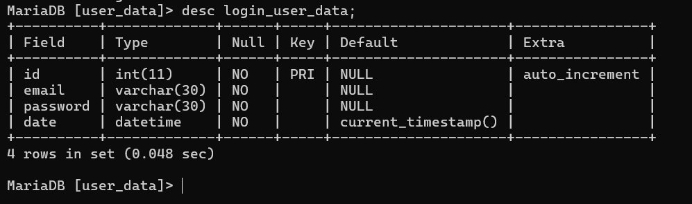

Admin User register_user_data :

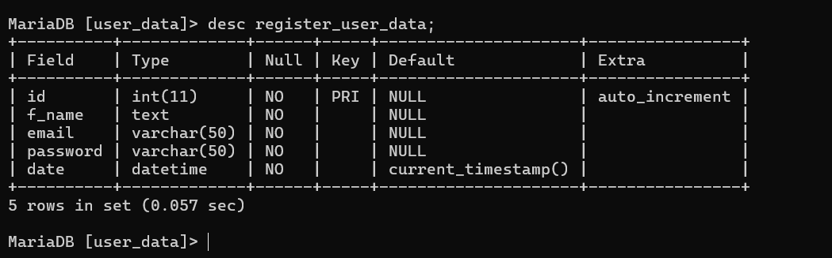

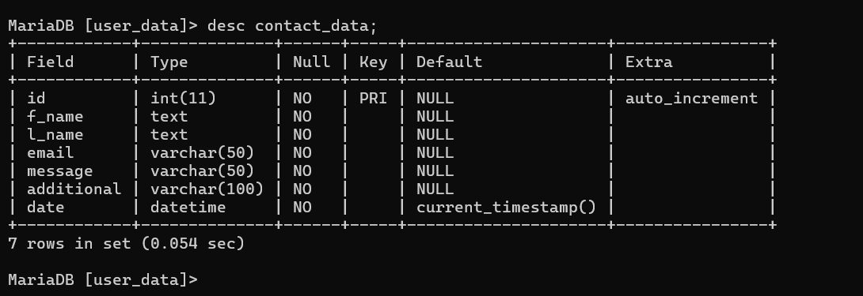Admin User contact_data :

Admin User feedback_data :

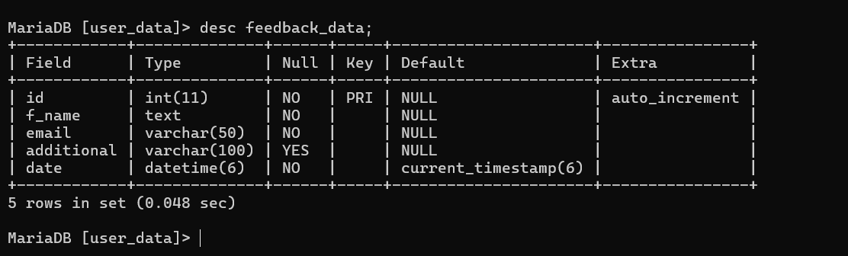

Admin User new_letter_data:

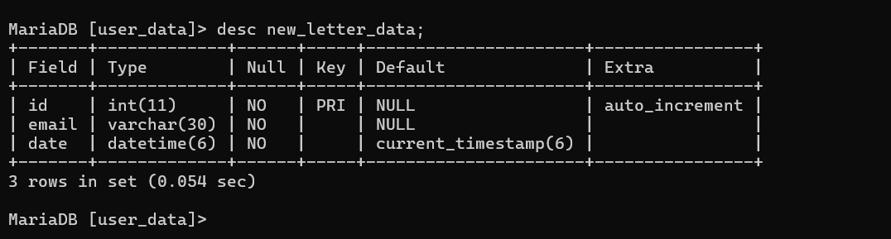

1. **Screenshot of Project**
2. **User Sign Up Page**

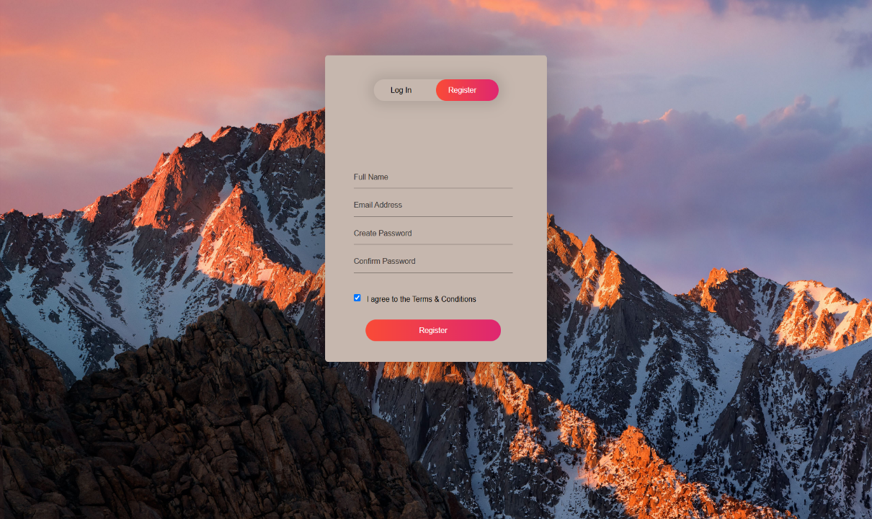

1. 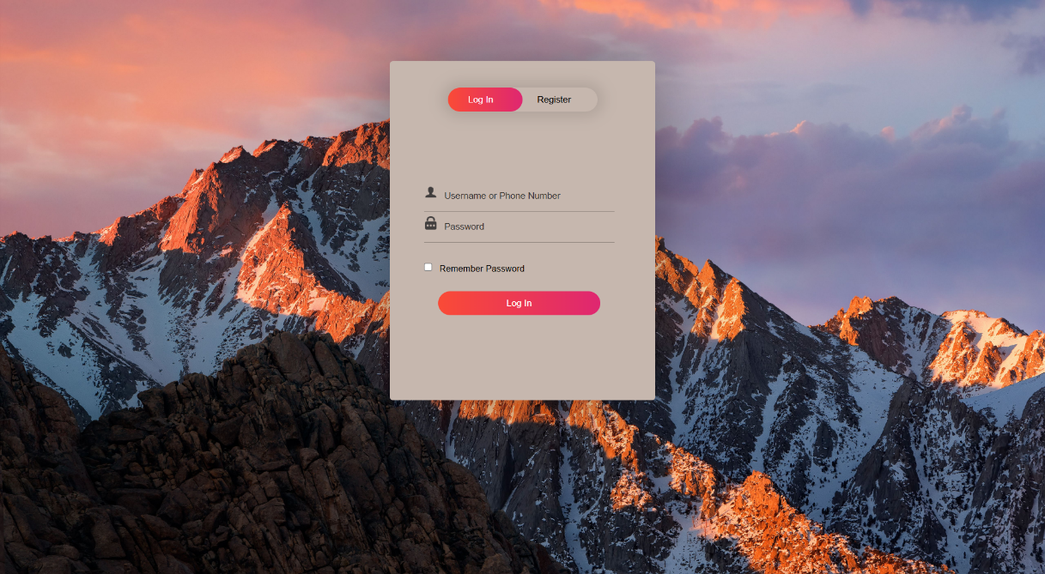**User Sign In page**

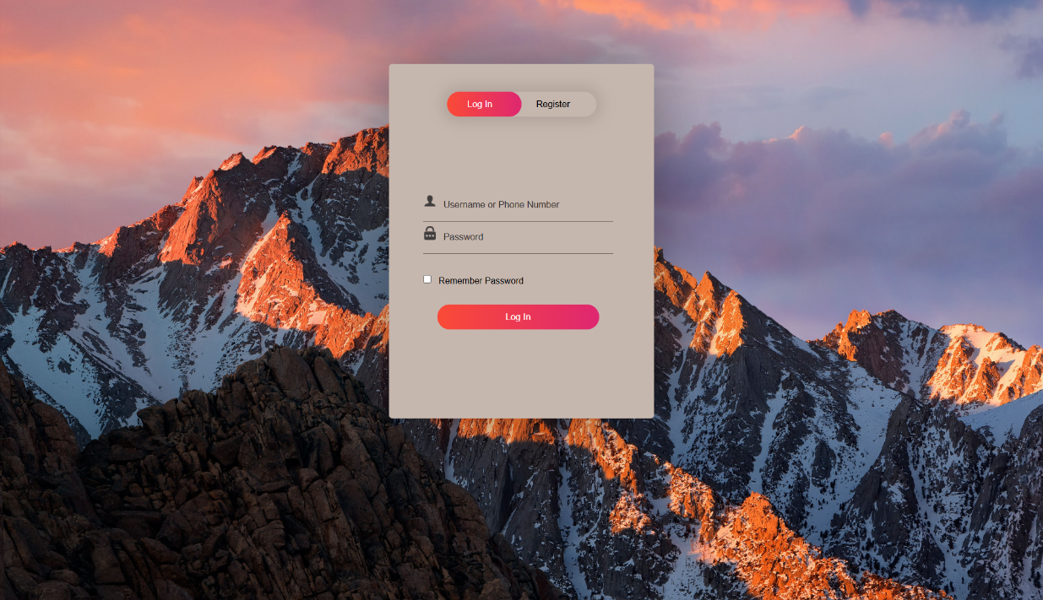

**4.Admin Dashboard Page And Login_User**

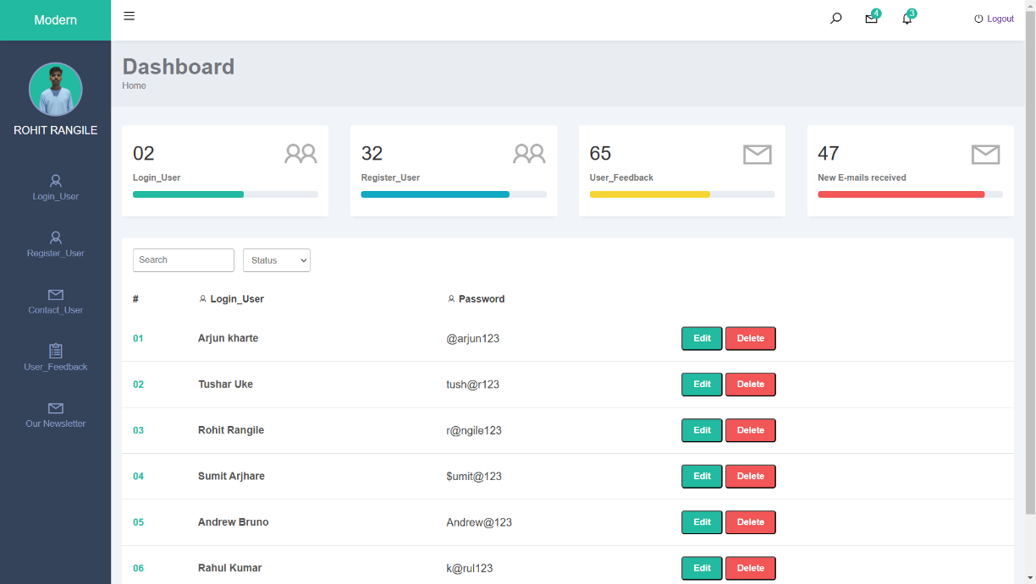

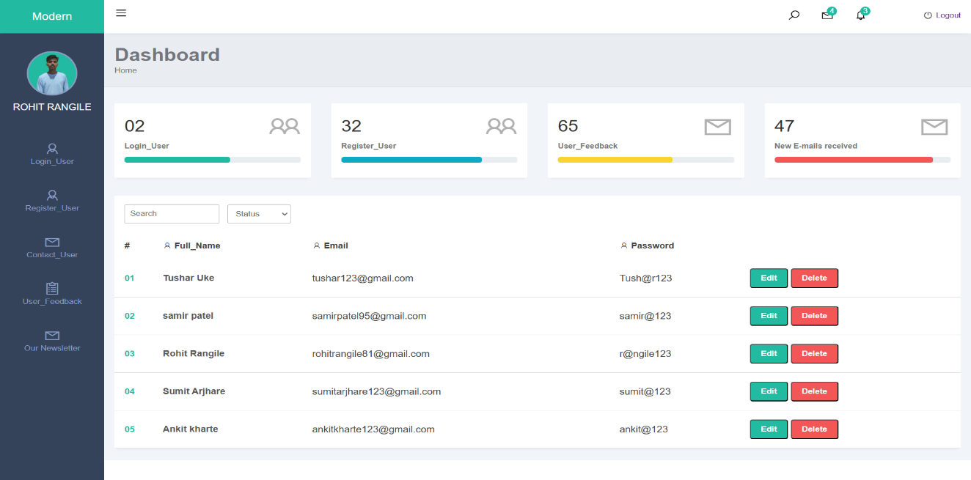

**6.Admin Contact_User**

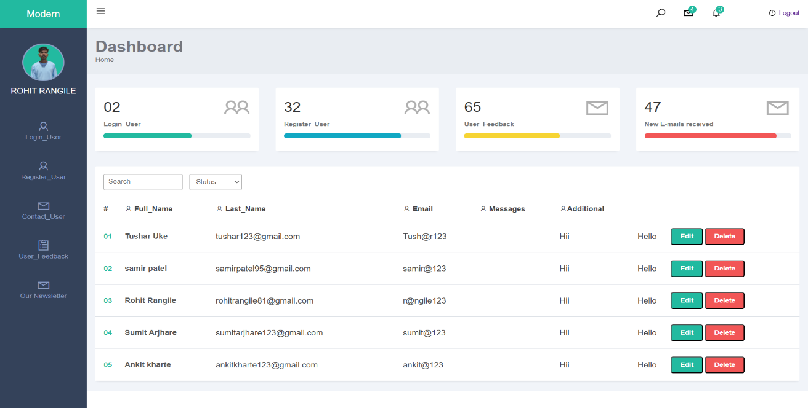

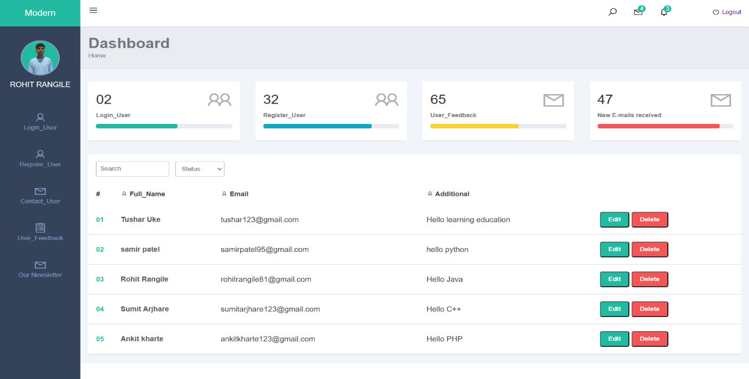

**8.Admin Our Newsletter**

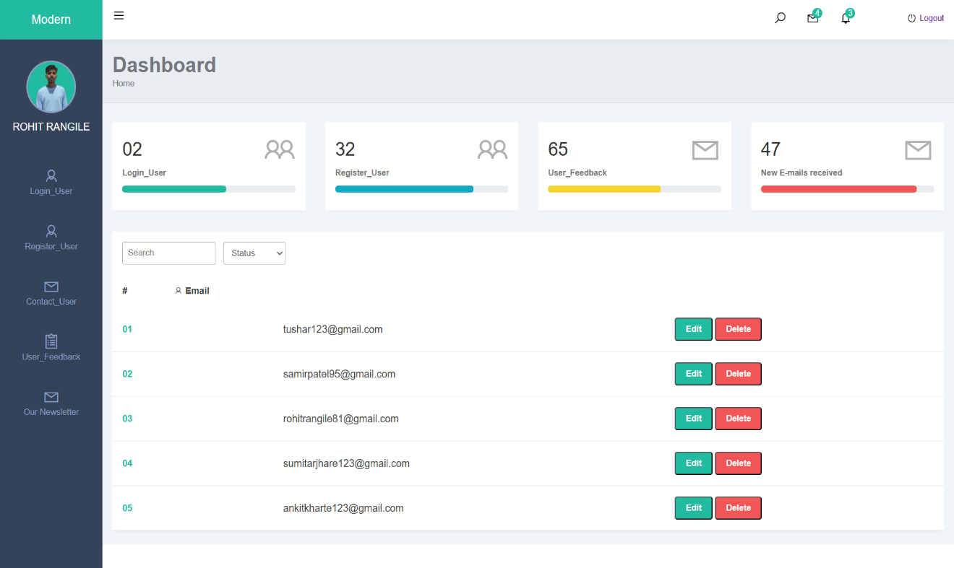

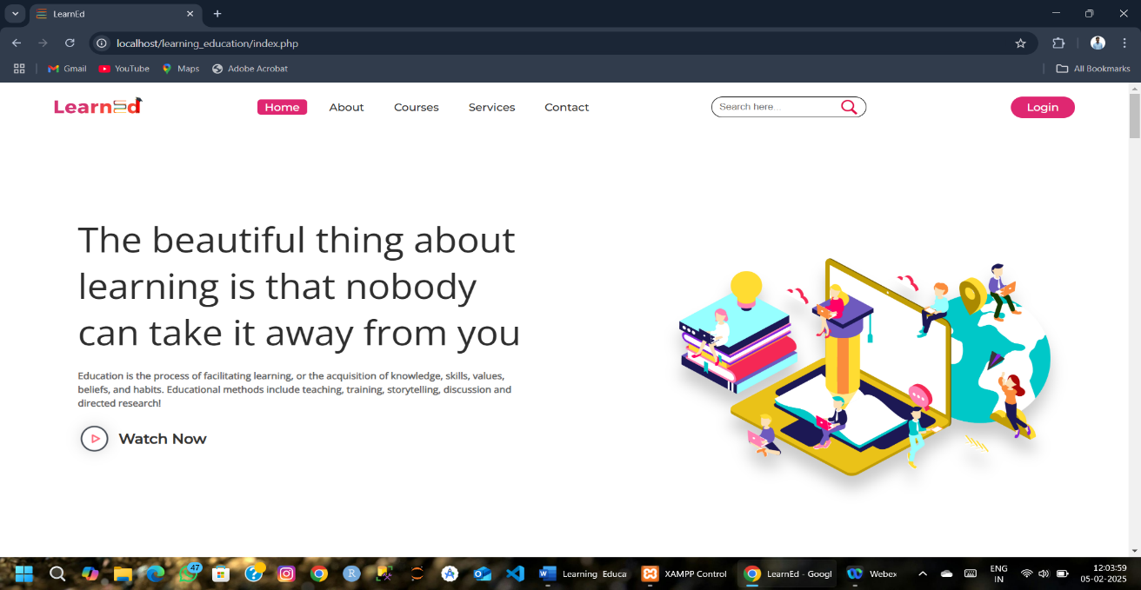

**10.User Contact Us**

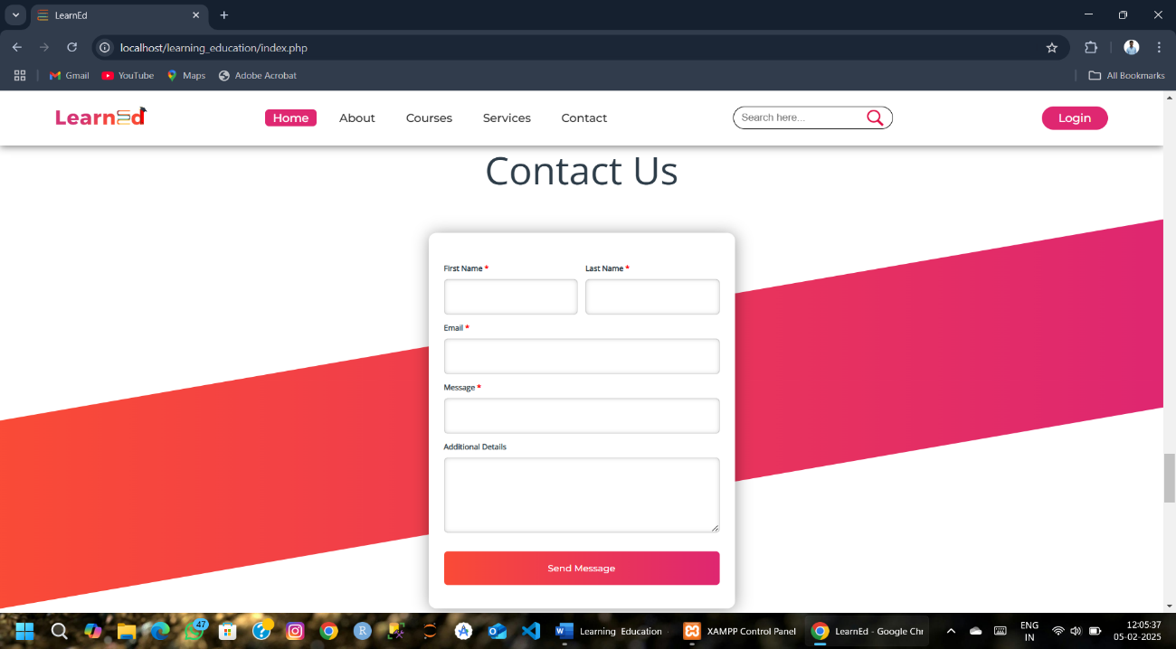

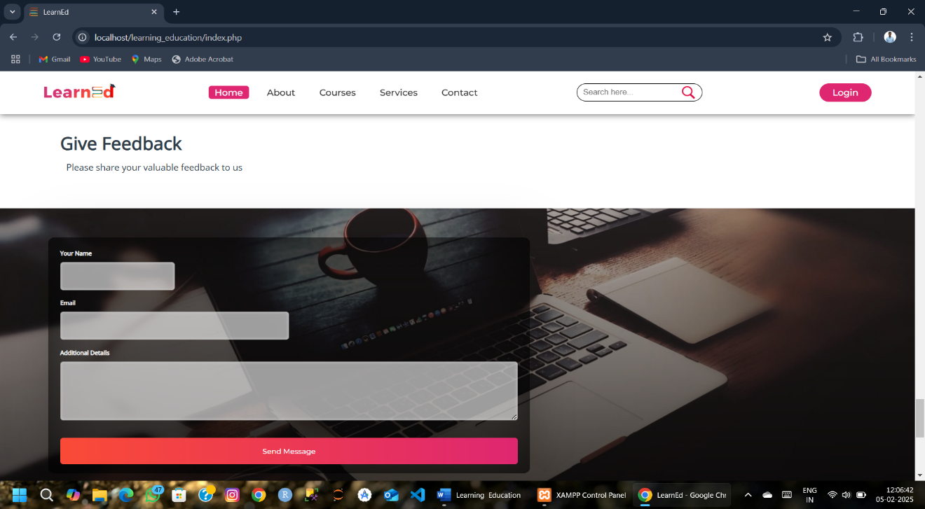

**12.User Newsletter**

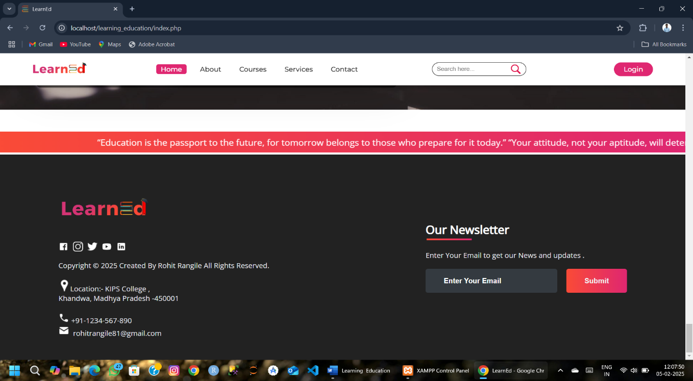

**11.Maintenance & Implementation**

**Maintenance & Implementation**

The maintenance and implementation of educational projects are critical for ensuring effective learning environments and achieving educational goals. The process typically begins with a **needs assessment** to identify gaps and challenges within the educational system, followed by **goal setting** to establish clear, measurable objectives. A comprehensive **project plan** is then developed, detailing activities, timelines, and necessary resources, alongside securing funding and materials through **resource mobilization**.

Once the groundwork is laid, **curriculum development** and **teacher training** are essential to equip educators with the skills needed to deliver quality education. Infrastructure improvements may also be necessary to create conducive learning spaces. During the **implementation phase**, ongoing **monitoring and evaluation** are crucial to assess progress and make adjustments as needed. Finally, successful projects often explore options for **scaling up** and ensuring long-term sustainability through community engagement and policy advocacy. Effective maintenance practices, including regular inspections and a structured maintenance management system, further support these initiatives by preserving facilities and minimizing disruptions to the learning process .

**12.Conclusion**

The learning education project has provided valuable insights into the dynamic nature of modern education, emphasizing the necessity for innovative teaching strategies that engage students and cater to their diverse needs. By integrating technology and adopting student-centered approaches, educators can create interactive learning environments that not only enhance knowledge retention but also foster critical thinking and collaboration among students.

More over, the project highlights the crucial role of digital literacy in today’s educational landscape. As online learning becomes increasingly prevalent, both educators and students must possess the skills to navigate digital platforms effectively. This emphasis on digital competence ensures that learners are well-equipped to access resources, communicate effectively, and engage with content in meaningful ways.

Additionally, the findings underscore the importance of differentiated instruction in promoting inclusivity within classrooms. By tailoring teaching methods to accommodate various learning styles and abilities, educators can ensure that all students have equal opportunities to succeed. This approach not only supports individual learning paths but also cultivates a sense of belonging among students.

Finally, the project advocates for a culture of lifelong learning and self-regulation, encouraging students to take ownership of their educational journeys. Continuous professional development for educators is also essential, as it empowers them to implement innovative practices effectively. In summary, this project emphasizes that by fostering engaging, inclusive, and adaptive learning environments, we can significantly enhance student engagement and achievement in an ever-evolving world.

Education is essential for personal development and self-improvement. It equips individuals with the knowledge, skills, and values needed to navigate the complexities of life and succeed in their chosen endeavors. Through education, individuals develop critical thinking skills, problem-solving abilities, and the capacity for innovation and creativity. Education also fosters emotional intelligence, resilience, and self-awareness, enabling individuals to build meaningful relationships, make informed decisions, and pursue their passions with confidence.

Education is the cornerstone of human progress and social advancement. It empowers individuals to reach their full potential, contribute meaningfully to society, and lead fulfilling lives. By investing in education, we invest in the future of our communities and ensure a brighter tomorrow for generations to come. Therefore, it is imperative that we prioritize education at all levels and strive to create inclusive and equitable learning opportunities for all.

**13.Future Scope & Further Enhancement**

The The future scope and enhancement of learning education projects are poised to be significantly influenced by technological advancements and evolving pedagogical approaches. As we look ahead, several key trends and strategies can be identified to enhance educational outcomes and adapt to the changing landscape of learning.

**Future Scopes**

1. **Integration of Advanced Technologies**: The incorporation of tools like artificial intelligence (AI), virtual reality (VR), and augmented reality (AR) is set to revolutionize education. These technologies can provide personalized learning experiences, allowing for tailored instruction that meets individual student needs. Immersive environments created through VR and AR can enhance engagement and understanding by simulating real-world scenarios .
2. **Personalized Learning Paths**: The shift towards personalized learning is becoming a cornerstone of modern education. Adaptive learning technologies will enable educators to customize content and pacing based on student performance, ensuring that each learner progresses at their own pace. This data-driven approach allows for targeted interventions that address specific learning gaps.
3. **Growth of Online and Blended Learning**: As online education continues to expand, blended learning models that combine traditional classroom instruction with online components will gain prominence. This flexibility allows for greater accessibility and accommodates diverse learning preferences, making education more inclusive.
4. **Collaborative Learning Environments**: The future of education will increasingly emphasize collaborative learning, where students work in groups to solve complex problems. This approach not only enhances social skills but also encourages peer-to-peer learning, fostering a sense of community within the classroom.
5. **Microlearning**: Breaking down complex concepts into smaller, digestible segments will become more prevalent, especially in time-constrained settings. Microlearning facilitates quick knowledge acquisition and retention, making it an effective strategy for both formal education and professional development

**14.References**

[**https://codeastro.com**](https://codeastro.com)

[**https://www.javatpoint.com**](https://www.javatpoint.com/)

[**https://www.w3schools.com**](https://www.w3schools.com)

[**https://www.perplexity.ai**](https://www.perplexity.ai)